|  |
| --- |
|  |
| |  |  |  | | --- | --- | --- | | 75 | Date: | February 2015 | |
| ADL and AML Non-normative Examples    Version: 1.0  **OMG Document Number: health/2015-04-10**  **Standard document URL: http://www.omg.org/spec/AML/1.0**  Original File: N/A |

Copyright © 2014, Mayo Clinic  
Copyright © 2014, Object Management Group, Inc.  
Copyright © 2014, Visumpoint, LLC

USE OF SPECIFICATION - TERMS, CONDITIONS & NOTICES

The material in this document details an Object Management Group specification in accordance with the terms, conditions and notices set forth below. This document does not represent a commitment to implement any portion of this specification in any company's products. The information contained in this document is subject to change without notice.

LICENSES

The companies listed above have granted to the Object Management Group, Inc. (OMG) a nonexclusive, royalty-free, paid up, worldwide license to copy and distribute this document and to modify this document and distribute copies of the modified version. Each of the copyright holders listed above has agreed that no person shall be deemed to have infringed the copyright in the included material of any such copyright holder by reason of having used the specification set forth herein or having conformed any computer software to the specification.

Subject to all of the terms and conditions below, the owners of the copyright in this specification hereby grant you a fully-paid up, non-exclusive, nontransferable, perpetual, worldwide license (without the right to sublicense), to use this specification to create and distribute software and special purpose specifications that are based upon this specification, and to use, copy, and distribute this specification as provided under the Copyright Act; provided that: (1) both the copyright notice identified above and this permission notice appear on any copies of this specification; (2) the use of the specifications is for informational purposes and will not be copied or posted on any network computer or broadcast in any media and will not be otherwise resold or transferred for commercial purposes; and (3) no modifications are made to this specification. This limited permission automatically terminates without notice if you breach any of these terms or conditions. Upon termination, you will destroy immediately any copies of the specifications in your possession or control.

PATENTS

The attention of adopters is directed to the possibility that compliance with or adoption of OMG specifications may require use of an invention covered by patent rights. OMG shall not be responsible for identifying patents for which a license may be required by any OMG specification, or for conducting legal inquiries into the legal validity or scope of those patents that are brought to its attention. OMG specifications are prospective and advisory only. Prospective users are responsible for protecting themselves against liability for infringement of patents.

GENERAL USE RESTRICTIONS

Any unauthorized use of this specification may violate copyright laws, trademark laws, and communications regulations and statutes. This document contains information which is protected by copyright. All Rights Reserved. No part of this work covered by copyright herein may be reproduced or used in any form or by any means--graphic, electronic, or mechanical, including photocopying, recording, taping, or information storage and retrieval systems--without permission of the copyright owner.

DISCLAIMER OF WARRANTY

WHILE THIS PUBLICATION IS BELIEVED TO BE ACCURATE, IT IS PROVIDED "AS IS" AND MAY CONTAIN ERRORS OR MISPRINTS. THE OBJECT MANAGEMENT GROUP AND THE COMPANIES LISTED ABOVE MAKE NO WARRANTY OF ANY KIND, EXPRESS OR IMPLIED, WITH REGARD TO THIS PUBLICATION, INCLUDING BUT NOT LIMITED TO ANY WARRANTY OF TITLE OR OWNERSHIP, IMPLIED WARRANTY OF MERCHANTABILITY OR WARRANTY OF FITNESS FOR A PARTICULAR PURPOSE OR USE. IN NO EVENT SHALL THE OBJECT MANAGEMENT GROUP OR ANY OF THE COMPANIES LISTED ABOVE BE LIABLE FOR ERRORS CONTAINED HEREIN OR FOR DIRECT, INDIRECT, INCIDENTAL, SPECIAL, CONSEQUENTIAL, RELIANCE OR COVER DAMAGES, INCLUDING LOSS OF PROFITS, REVENUE, DATA OR USE, INCURRED BY ANY USER OR ANY THIRD PARTY IN CONNECTION WITH THE FURNISHING, PERFORMANCE, OR USE OF THIS MATERIAL, EVEN IF ADVISED OF THE POSSIBILITY OF SUCH DAMAGES.

The entire risk as to the quality and performance of software developed using this specification is borne by you. This disclaimer of warranty constitutes an essential part of the license granted to you to use this specification.

RESTRICTED RIGHTS LEGEND

Use, duplication or disclosure by the U.S. Government is subject to the restrictions set forth in subparagraph (c) (1) (ii) of The Rights in Technical Data and Computer Software Clause at DFARS 252.227-7013 or in subparagraph (c)(1) and (2) of the Commercial Computer Software - Restricted Rights clauses at 48 C.F.R. 52.227-19 or as specified in 48 C.F.R. 227-7202-2 of the DoD F.A.R. Supplement and its successors, or as specified in 48 C.F.R. 12.212 of the Federal Acquisition Regulations and its successors, as applicable. The specification copyright owners are as indicated above and may be contacted through the Object Management Group, 140 Kendrick Street, Needham, MA 02494, U.S.A.

TRADEMARKS

MDA®, Model Driven Architecture®, UML®, UML Cube logo®, OMG Logo®, CORBA® and XMI® are registered trademarks of the Object Management Group, Inc., and Object Management Group™, OMG™ , Unified Modeling Language™, Model Driven Architecture Logo™, Model Driven Architecture Diagram™, CORBA logos™, XMI Logo™, CWM™, CWM Logo™, IIOP™ , IMM™ , MOF™ , OMG Interface Definition Language (IDL)™ , and OMG SysML™ are trademarks of the Object Management Group. All other products or company names mentioned are used for identification purposes only, and may be trademarks of their respective owners.

COMPLIANCE

The copyright holders listed above acknowledge that the Object Management Group (acting itself or through its designees) is and shall at all times be the sole entity that may authorize developers, suppliers and sellers of computer software to use certification marks, trademarks or other special designations to indicate compliance with these materials.

Software developed under the terms of this license may claim compliance or conformance with this specification if and only if the software compliance is of a nature fully matching the applicable compliance points as stated in the specification. Software developed only partially matching the applicable compliance points may claim only that the software was based on this specification, but may not claim compliance or conformance with this specification. In the event that testing suites are implemented or approved by Object Management Group, Inc., software developed using this specification may claim compliance or conformance with the specification only if the software satisfactorily completes the testing suites.

**Table of Contents**

1. AML and ADL Examples 7

1.1. Basic Structure 8

1.1.1. Mixed Node Types 8

1.2. Attribute Alternatives 12

1.2.1. Quantity Alternatives 12

1.2.2. Multiple Alternatives 17

1.3. ADL Rules 21

1.3.1. Rules Formula 21

1.4. Archetype Inclusion and Exclusion 31

1.4.1. Include Any Archetype 31

1.4.2. Exclude Specific Archetypes 35

1.4.3. Exclude Any Archetype 38

1.4.4. Open Slot - No inclusions or exclusions 41

1.4.5. No inclusion and specific exclusion 44

1.4.6. Include specific values, exclude all 47

1.4.7. Slot Include Non Any Exclude Empty v1 Example 50

1.5. use_archetype 55

1.5.1. External Reference 55

*1.6.* *use_node* 59

1.6.1. Overriding occurrences 59

1.6.2. Path Analysis 63

1.6.3. Apgar Example 70

1.7. Description Annotations Examples 81

1.7.1. Annotations Rm Path v1 Example 81

1.7.2. Annotations 1st Child v1 Example 91

1.7.3. Annotations Only Child v1 Example 97

1.7.4. Annotations Parent v1 Example 102

1.8. Description Identification Examples 107

1.8.1. No Ns Inherit Ns v2 Example 107

1.9. Description Text Examples 112

1.9.1. Quoted Strings v1 Example 112

1.9.2. Unicode Farsi v1 Example 118

1.9.3. Three Languages v1 Example 141

1.10. Flattening Examples 148

1.10.1. Lab Test Panel - Lipid Studies v1 Example 148

1.10.2. Lab Test Panel v1 Example 161

1.10.3. Request - Pathology Test v1 Example 169

1.10.4. Request v1 Example 174

1.10.5. Flat Test Parent 1 - Add Node Use Node v1 Example 180

1.10.6. Flat Test Parent 1 v1 Example 186

1.10.7. Flattening Parent 1 v1 Example 192

1.10.8. Override To Multiple v1 Example 202

1.11. Reference_model Enumeration_types Examples 211

1.11.1. Audiogram v1 Example 211

1.12. Reference_model Generic_types Examples 218

1.12.1. Rm Conforming Rm Subtype v1 Example 218

1.12.2. Rm Correct Non Generic v1 Example 226

1.13. Specialisation Examples 231

1.13.1. Code List Constrained v1 Example 231

1.13.2. Code List Parent v1 Example 236

1.13.3. Body Temp Test v1 Example 243

1.13.4. Ordering Added Nodes v1 Example 255

1.13.5. Ordering Parent v1 Example 262

1.13.6. Redefine 1 Value v1 Example 271

1.13.7. Redefine Cardinality v1 Example 278

1.13.8. Redefine Occurrences v1 Example 284

1.13.9. Spec Test Obs v1 Example 290

1.13.10. Spec Test Parent v1 Example 297

1.13.11. Tuple Redefine To Single v1 Example 304

1.13.12. Simple node identification 309

1.14. 310

1.15. 311

1.15. Terminology Binding 312

1.15.1. Basic Term Bindings Example 312

1.15.2. Term Bindings With Paths 318

1.15.3. Term Bindings Paths Use Refs v1 Example 323

1.16. Terminology Value Sets 343

1.16.1. External Value Definition 343

1.16.2. Combination of internal and external value sets 349

# AML and ADL Examples

The following section gives examples of AML and their ADL equivalents to illustrate the relationship between ADL and AML. These are valid OpenEHR ADL archetypes that have been converted into AML. The samples in this document show the relevant fragments.

## Basic Structure

The following sections include examples of various sorts of AOM structures

### Mixed Node Types

An example of a variety of different ADL node types

#### ADL

archetype (adl_version=2.0.5; rm_release=1.0.2)

openEHR-EHR-EVALUATION.mixed_aom_node_types.v1.0.0

...

EVALUATION[id1] matches { -- Evaluation

data matches {

ITEM_TREE[id14] matches {

items matches {

CLUSTER[id2] matches { -- cluster

items matches {

use_node ELEMENT[id10] /data[id14]/items[id11]/items[id13] -- /data[id14]/items[cluster]/items[element]

allow_archetype CLUSTER[id4] matches { -- element

include

archetype_id/value matches {/.*/}

}

ELEMENT[id3] -- element

}

}

CLUSTER[id11] matches { -- cluster

items matches {

ELEMENT[id13] -- element

}

}

#### ADL Diagram

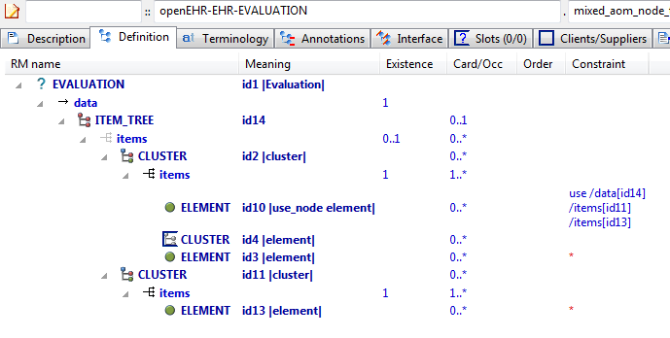

#### AML Diagrams

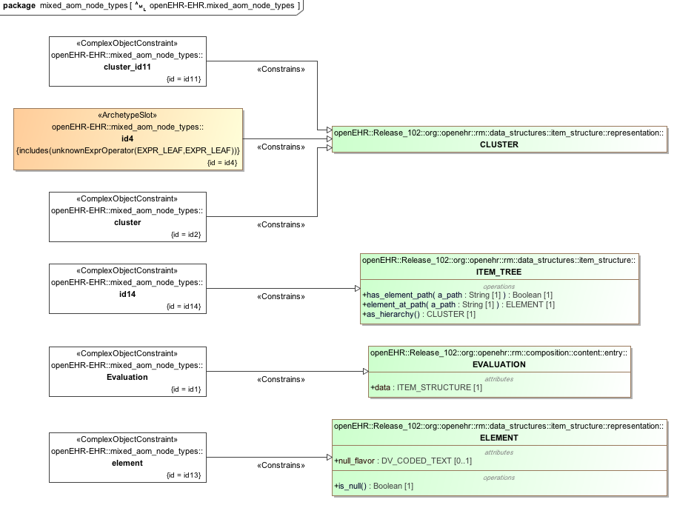

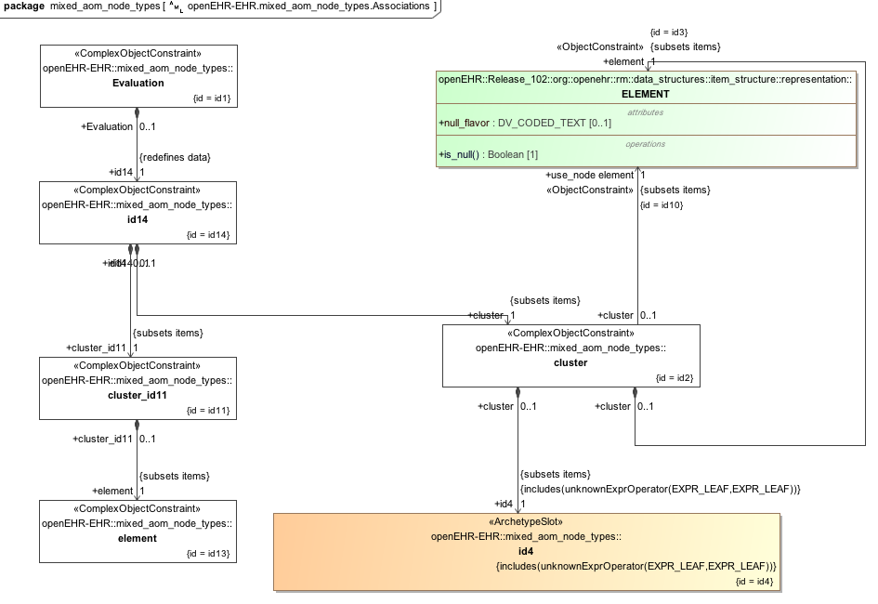

## Attribute Alternatives

### Quantity Alternatives

Demonstrate multiple alternative Quantity expressions.

#### Quantity Alternatives ADL

archetype (adl_version=2.0.5; rm_release=1.0.2; generated)

openEHR-EHR-CLUSTER.quantity_altenatives.v1.0.0

...

definition

CLUSTER[id1] matches { -- Ambient oxygen

items matches {

ELEMENT[id52] occurrences matches {0..1} matches { -- Oxygen flow rate

value matches {

DV_QUANTITY[id55] matches {

property matches {[at1]}

**[magnitude, units, precision] matches {**

**[{|0.0..50.0|}, {"l/m"}, {1}],**

**[{|0.0..50000.0|}, {"ml/min"}, {1}]**

**}**

}

}

}

ELEMENT[id54] occurrences matches {0..1} matches { -- un

value matches {

DV_PROPORTION[id56] matches {

numerator matches {|0.0..1.0|; 0.21}

is_integral matches {False}

type matches {1}

}

DV_PROPORTION[id57] matches {

numerator matches {|0.0..100.0|; 21.0}

is_integral matches {False}

type matches {2}

}

}

}

ELEMENT[id55] occurrences matches {0..1} matches { -- un

value matches {

DV_PROPORTION[id58] matches {

**[numerator, is_integral, type] matches**

**{[{|0.0..1.0|; 0.21}, {False}, {1}],**

**[{|0.0..100.0|; 21.0}, {False}, {2}]}**

**}**

#### ADL Diagram

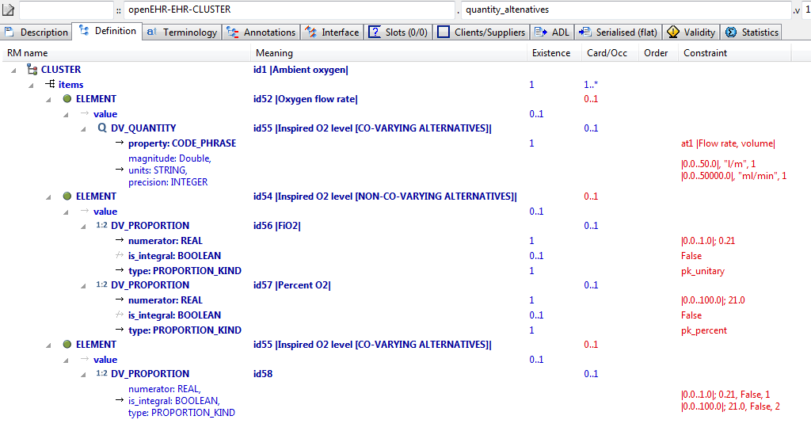

#### AML Diagrams

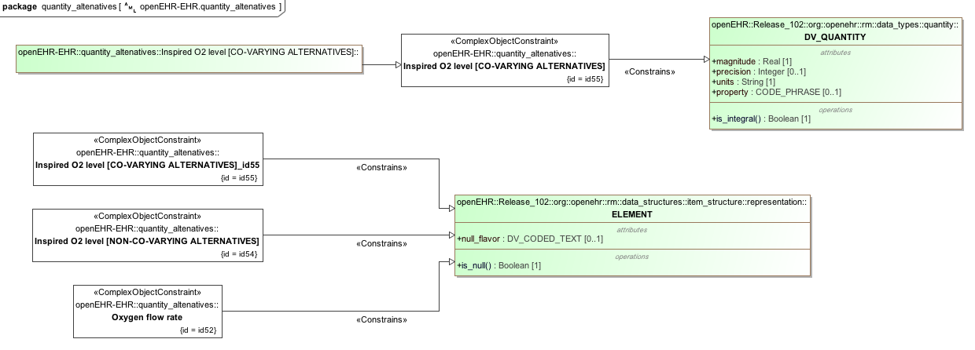

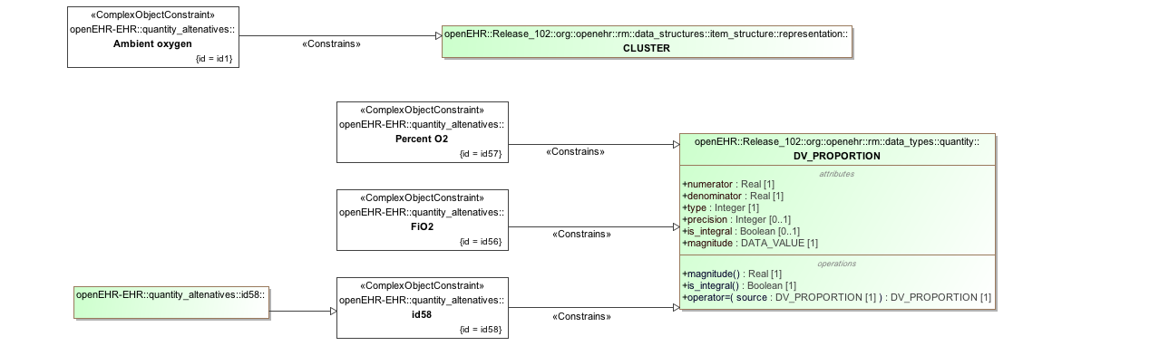

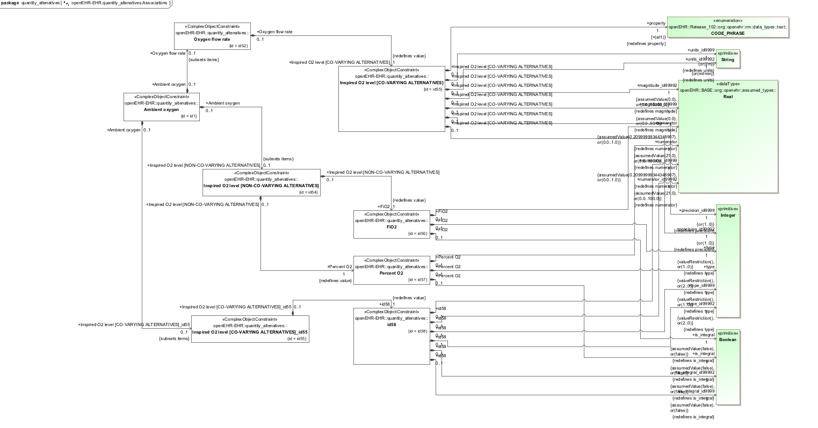

### Multiple Alternatives

Test multiple alternative nodes of single-valued attribute; view in flat mode to see result.

#### ADL

archetype (adl_version=2.0.5; rm_release=1.0.2)

openEHR-EHR-OBSERVATION.multiple_alternatives.v1.0.0

...

definition

OBSERVATION[id1] matches { -- top-level archetype

**protocol matches {**

**ITEM_TREE[id2] -- protocol #1**

**ITEM_TREE[id3] -- protocol #2**

**}**

}

#### ADL Diagram

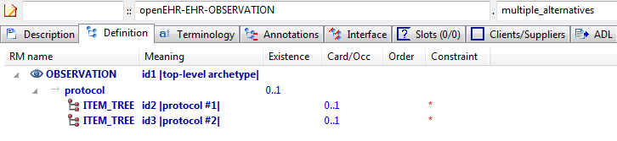

#### AML Diagrams

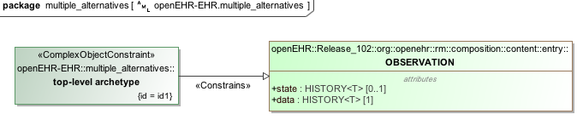

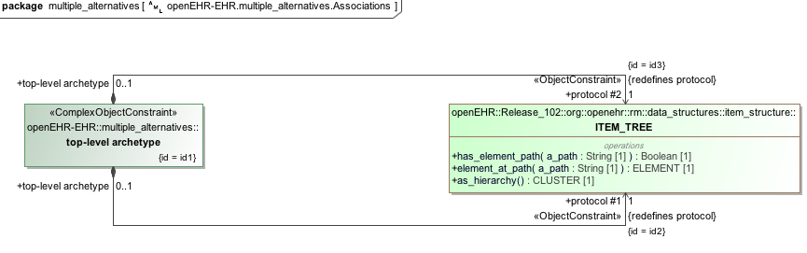

## ADL Rules

### Rules Formula

The example below asserts that the mean arterial pressure *id1007* should be equal to the diastolic pressure *id5* + 1/3 * (systolic *id5* - diastolic *id6*) and that the pulse pressure *id1008* is equal to the systolic pressure *id5* minus the diastolic pressure *id6.* Note that, in the context of ADL and AML, this needs to be interpreted as a predicate -- it doesn't tell *how* to generate a mean arterial pressure or a pulse pressure; it asserts that all instances of the rules_formulae archetype have results that match the formula above.

#### ADL

archetype (adl_version=2.0.5; rm_release=1.0.2)

openEHR-EHR-OBSERVATION.rules_formulae.v1.0.0

...

definition

OBSERVATION[id1] matches { -- Blood Pressure

data matches {

HISTORY[id2] matches { -- history

events cardinality matches {1..*; unordered} matches {

EVENT[id7] occurrences matches {0..*} matches { -- any event

data matches {

ITEM_TREE[id4] matches {

items matches {

ELEMENT[id5] occurrences matches {0..1} matches { -- Systolic

value matches {

DV_QUANTITY[id1054] matches {

property matches {[at1055]}

magnitude matches {|0.0..<1000.0|}

units matches {"mm[Hg]"}

precision matches {0}

}

}

}

ELEMENT[id6] occurrences matches {0..1} matches { -- Diastolic

value matches {

DV_QUANTITY[id1055] matches {

property matches {[at1055]}

magnitude matches {|0.0..<1000.0|}

units matches {"mm[Hg]"}

precision matches {0}

}

}

}

ELEMENT[id1007] occurrences matches {0..1} matches { -- Mean Arterial Pressure

value matches {

DV_QUANTITY[id1056] matches {

property matches {[at1055]}

magnitude matches {|0.0..<1000.0|}

units matches {"mm[Hg]"}

precision matches {0}

}

}

}

ELEMENT[id1008] occurrences matches {0..1} matches { -- Pulse Pressure

value matches {

DV_QUANTITY[id1057] matches {

property matches {[at1055]}

magnitude matches {|0.0..<1000.0|}

units matches {"mm[Hg]"}

precision matches {0}

}

}

}

...

**rules**

**mean_arterial_pressure: /data[id2]/events[id7]/data[id4]/items[id1007]/value/magnitude = /data[id2]/events[id7]/data[id4]/items[id6]/value/magnitude + 0.33 * (/data[id2]/events[id7]/data[id4]/items[id5]/value/magnitude - /data[id2]/events[id7]/data[id4]/items[id6]/value/magnitude)**

**pulse_pressure: /data[id2]/events[id7]/data[id4]/items[id1008]/value/magnitude = /data[id2]/events[id7]/data[id4]/items[id5]/value/magnitude - /data[id2]/events[id7]/data[id4]/items[id6]/value/magnitude**

#### ADL Diagram

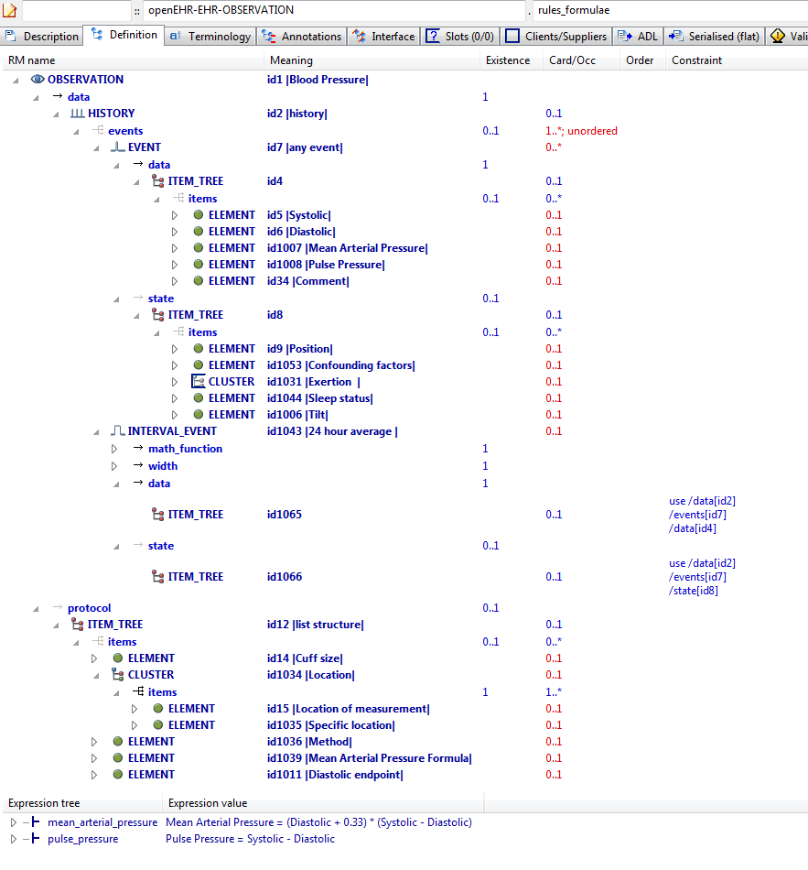

#### AML Diagrams

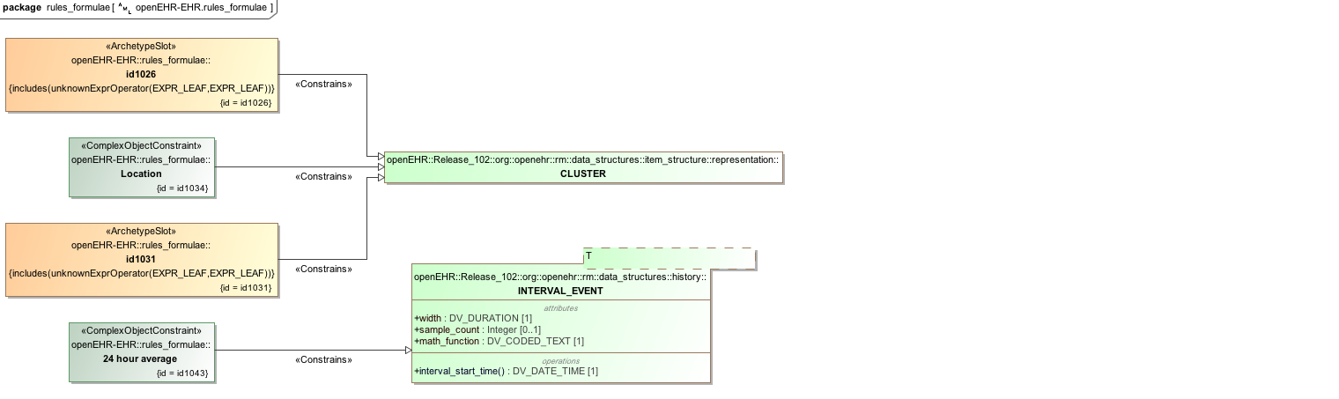

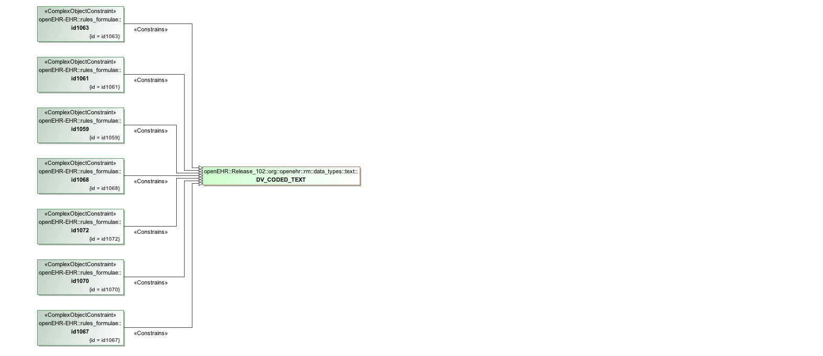

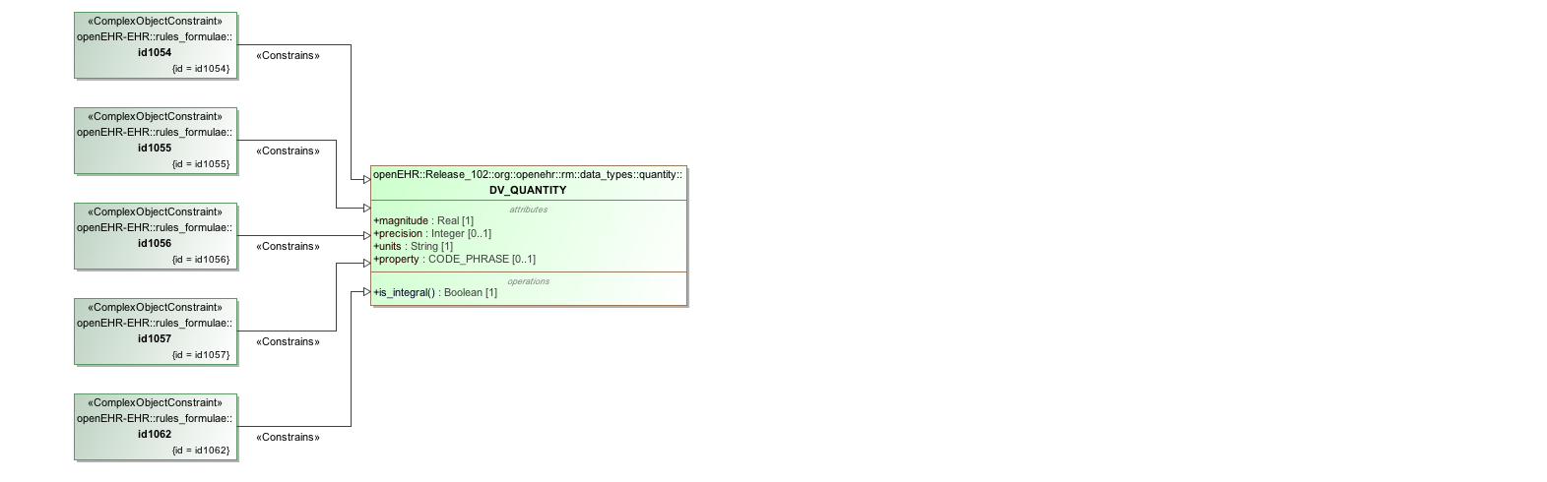

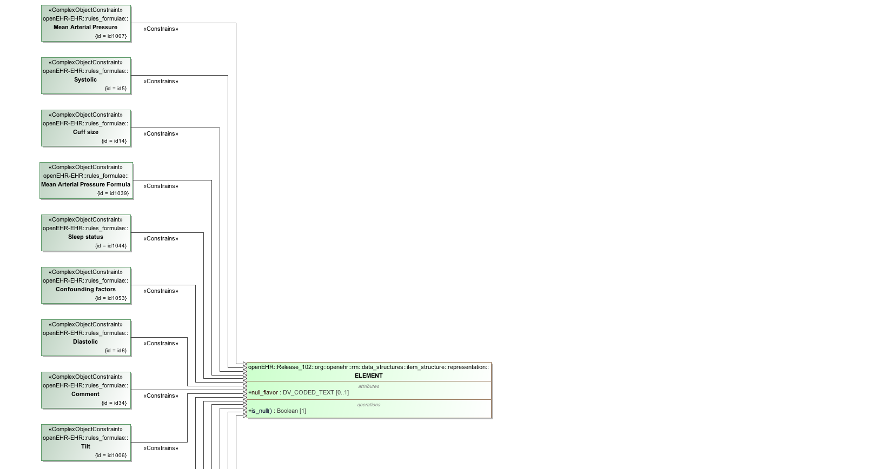

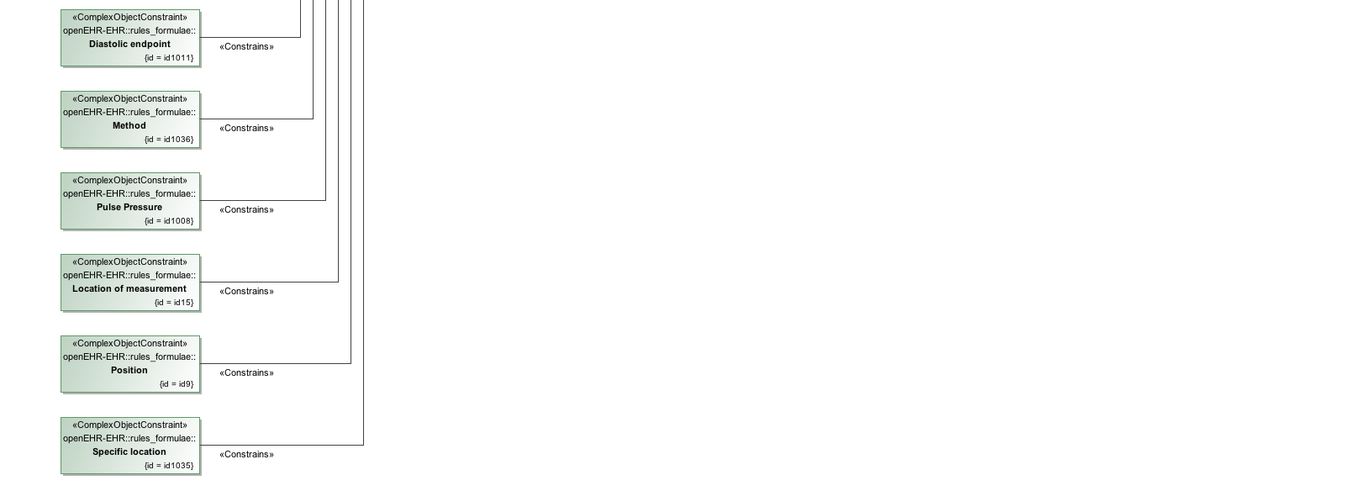

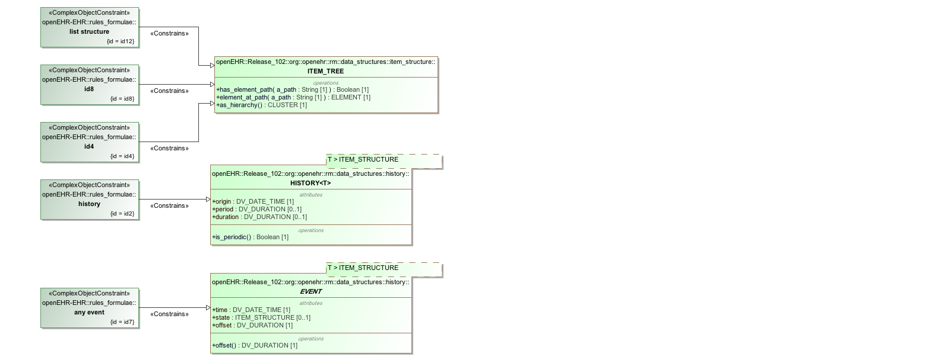

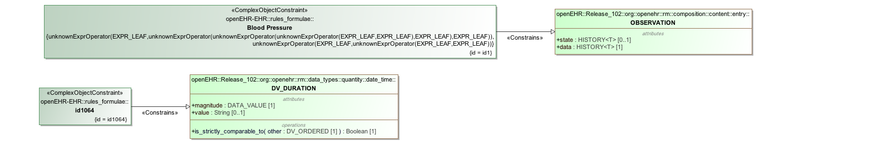

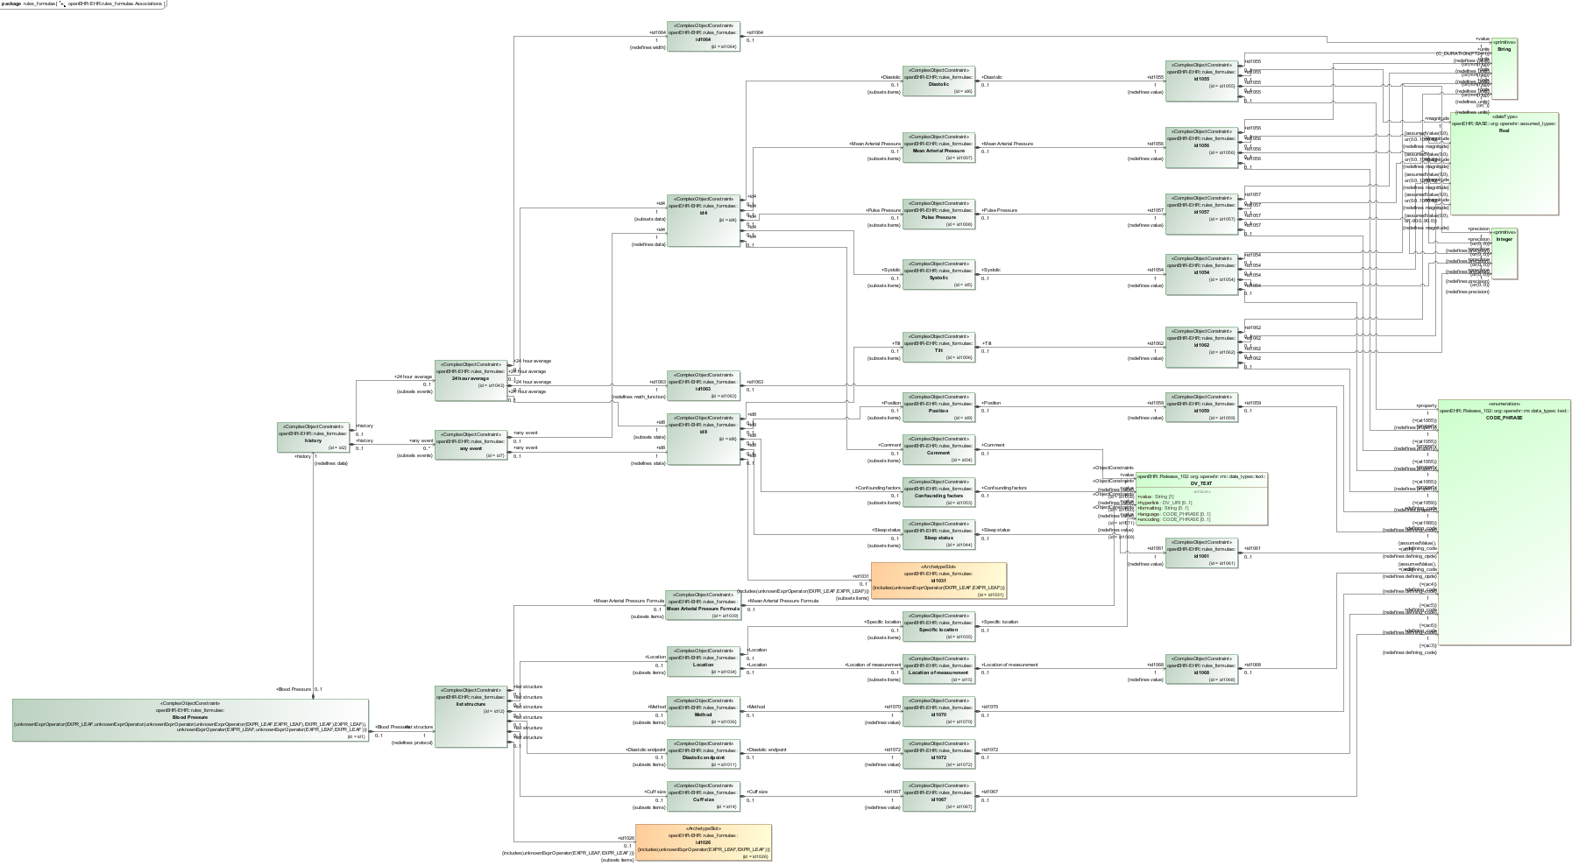

## Archetype Inclusion and Exclusion

### Include Any Archetype

This is an example of an ADL slot that allows any single OBSERVATION archetype to fill the slot with *id2*.

#### ADL

archetype (adl_version=2.0.5; rm_release=1.0.2)

openEHR-EHR-SECTION.slot_include_any_exclude_empty.v1.0.0

...

definition

SECTION[id1] matches { -- Slot section

items cardinality matches {1..*; unordered} matches {

allow_archetype OBSERVATION[id2] occurrences matches {0..1} matches { -- Vital signs

include archetype_id/value matches {/.*/}

}

}

}

#### ADL Diagram

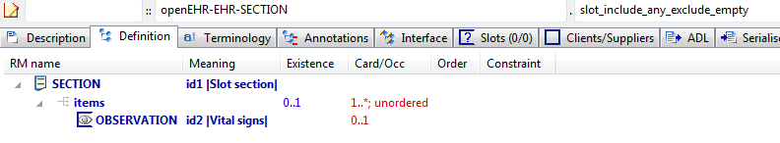

#### AML Diagrams

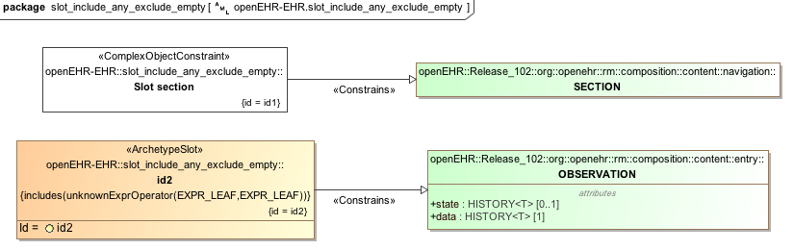

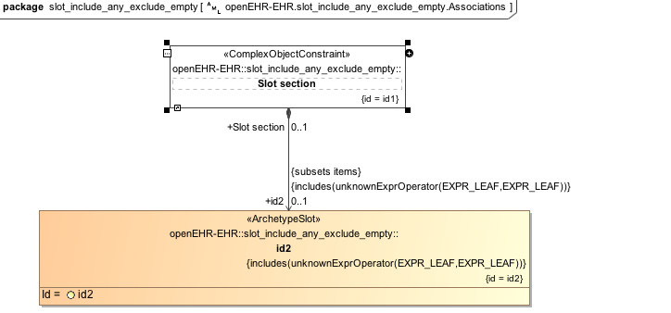

### Exclude Specific Archetypes

This example allows any archetype to fill an OBSERVATION slot as long as isn't a blood pressure archetype of version "v1".

#### Slot Include Any Exclude Non Any v1 ADL

archetype (adl_version=2.0.5; rm_release=1.0.2)

openEHR-EHR-SECTION.slot_include_any_exclude_non_any.v1.0.0

...

definition

SECTION[id1] matches { -- Slot section

items cardinality matches {1..*; unordered} matches {

allow_archetype OBSERVATION[id2] occurrences matches {0..1} matches { -- Vital signs

include

archetype_id/value matches {/.*/}

exclude

archetype_id/value matches {/openEHR-EHR-OBSERVATION\.blood_pressure([a-zA-Z0-9_]+)*\.v1/}

}

}

}

#### ADL Diagram

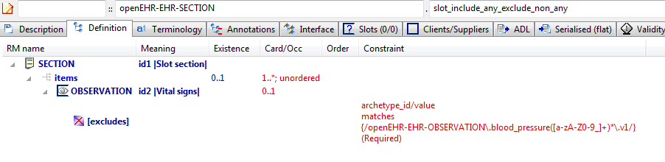

#### AML Diagrams

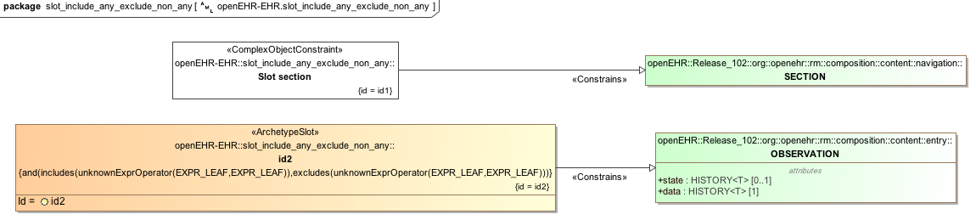

#### Slot Include Any Exclude Non Any v1 AML Associations Diagram

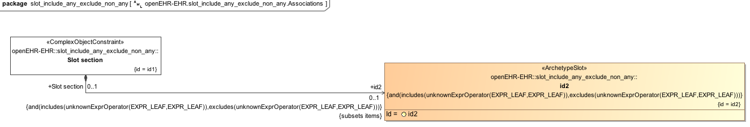

### Exclude Any Archetype

Prevent a slot from being filled by excluding all archetypes

#### ADL

archetype (adl_version=2.0.5; rm_release=1.0.2)

openEHR-EHR-SECTION.slot_include_empty_exclude_any.v1.0.0

...

definition

SECTION[id1] matches { -- Slot section

items cardinality matches {1..*; unordered} matches {

allow_archetype OBSERVATION[id2] occurrences matches {0..1} matches { -- Vital signs

exclude

archetype_id/value matches {/.*/}

}

}

}

#### ADL Diagrams

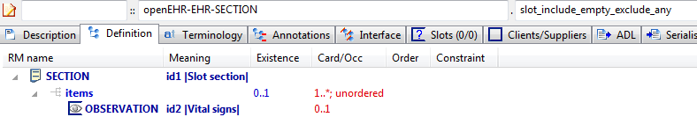

#### AML Diagrams

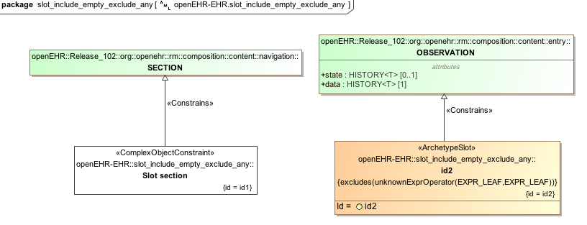

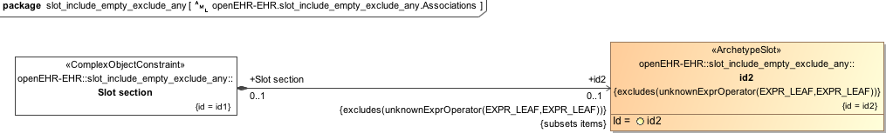

### Open Slot - No inclusions or exclusions

Open slot with no inclusions or exclusions

#### ADL

archetype (adl_version=2.0.5; rm_release=1.0.2)

openEHR-EHR-SECTION.slot_include_empty_exclude_empty.v1.0.0

...

definition

SECTION[id1] matches { -- Slot section

items cardinality matches {1..*; unordered} matches {

allow_archetype OBSERVATION[id2] occurrences matches {0..1} -- Vital signs

}

}

#### ADL Diagrams

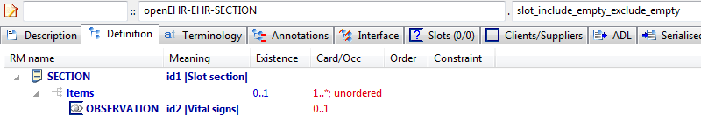

#### AML Diagrams

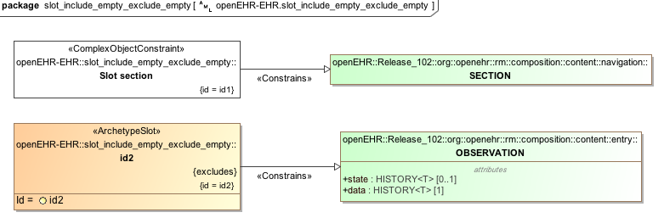

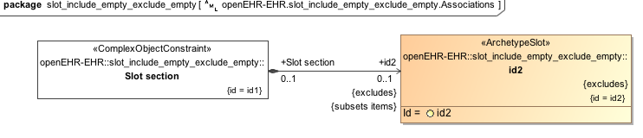

### No inclusion and specific exclusion

The example below *recommends* that version 1 of openEHR blood pressure archetypes not be allowed in the Vital signs (*id2*) observation.

#### ADL

archetype (adl_version=2.0.5; rm_release=1.0.2)

openEHR-EHR-SECTION.slot_include_empty_exclude_non_any.v1.0.0

...

definition

SECTION[id1] matches { -- Slot section

items cardinality matches {1..*; unordered} matches {

**allow_archetype** OBSERVATION[id2] occurrences matches {0..1} matches { -- Vital signs

**exclude**

archetype_id/value matches {/openEHR-EHR-OBSERVATION\.blood_pressure([a-zA-Z0-9_]+)*\.v1/}

}

}

}

#### ADL Diagram

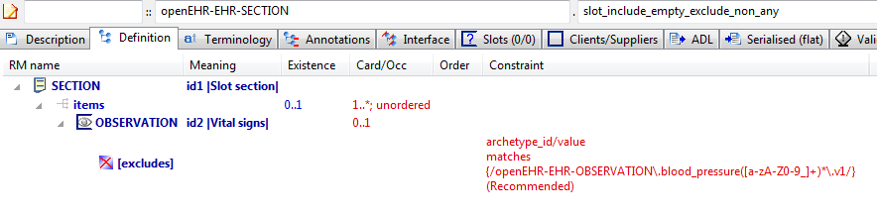

#### AML Diagrams

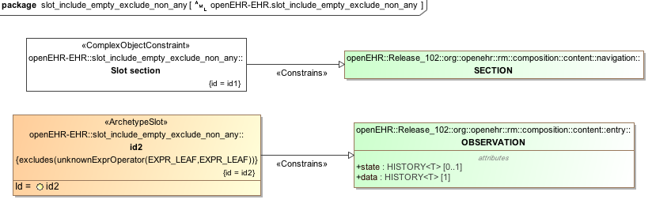

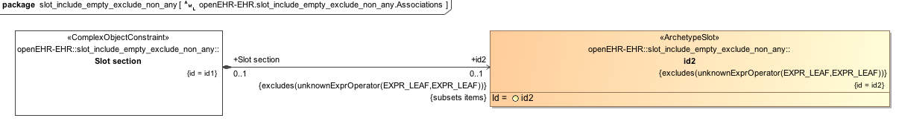

### Include specific values, exclude all

This archetype includes specific values and excludes all others, which makes it a "hard" inclusion -- *only* archetypes that match the include pattern are allowed.

#### Slot Include Non Any Exclude Any v1 ADL

archetype (adl_version=2.0.5; rm_release=1.0.2)

openEHR-EHR-SECTION.slot_include_non_any_exclude_any.v1.0.0

...

definition

SECTION[id1] matches { -- Slot section

items cardinality matches {1..*; unordered} matches {

**allow_archetype** OBSERVATION[id2] occurrences matches {0..1} matches { -- Vital signs

**include**

archetype_id/value matches {/openEHR-EHR-OBSERVATION\.blood_pressure([a-zA-Z0-9_]+)*\.v1/}

**exclude**

archetype_id/value matches {/.*/}

}

}

}

#### ADL Diagram

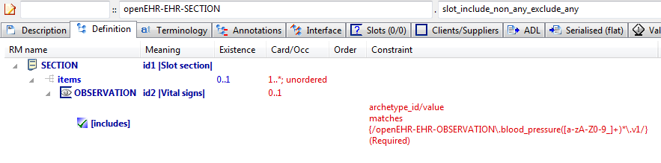

#### AML Diagrams

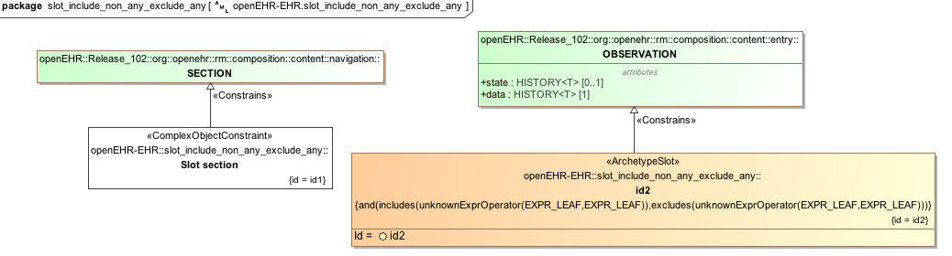

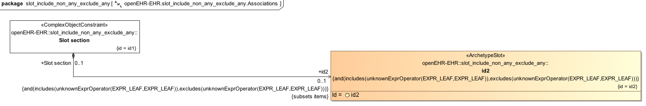

### Slot Include Non Any Exclude Empty v1 Example

Test slot archetype with non-any include and no excludes, which means the includes are taken as recommendations.

#### Slot Include Non Any Exclude Empty v1 ADL

archetype (adl_version=2.0.5; rm_release=1.0.2)

openEHR-EHR-SECTION.slot_include_non_any_exclude_empty.v1.0.0

language

original_language = <[ISO_639-1::en]>

description

custodian_namespace = <"org.openehr">

custodian_organisation = <"openEHR Foundation <http://www.openEHR.org>">

original_author = <

["name"] = <"Thomas Beale">

["email"] = <"thomas.beale@openEHR.org">

["organisation"] = <"openEHR Foundation <http://www.openEHR.org>">

["date"] = <"2010-03-14">

>

details = <

["en"] = <

language = <[ISO_639-1::en]>

purpose = <"Test slot archetype with non-any include and no excludes, which means the includes are taken as recommendations.">

keywords = <"ADL", "test", "slots">

>

>

lifecycle_state = <"published">

other_details = <

["regression"] = <"PASS">

>

copyright = <"Copyright © 2010 openEHR Foundation <http://www.openEHR.org>">

licence = <"Creative Commons CC-BY-SA <https://creativecommons.org/licenses/by-sa/3.0/>">

definition

SECTION[id1] matches { -- Slot section

items cardinality matches {1..*; unordered} matches {

allow_archetype OBSERVATION[id2] occurrences matches {0..1} matches { -- Vital signs

include

archetype_id/value matches {/openEHR-EHR-OBSERVATION\.blood_pressure([a-zA-Z0-9_]+)*\.v1|openEHR-EHR-OBSERVATION\.body_temperature([a-zA-Z0-9_]+)*\.v1|openEHR-EHR-OBSERVATION\.heart_rate([a-zA-Z0-9_]+)*\.v1|openEHR-EHR-OBSERVATION\.indirect_oximetry([a-zA-Z0-9_]+)*\.v1|openEHR-EHR-OBSERVATION\.respiration([a-zA-Z0-9_]+)*\.v1/}

}

}

}

terminology

term_definitions = <

["en"] = <

["id1"] = <

text = <"Slot section">

description = <"Slot section">

>

["id2"] = <

text = <"Vital signs">

description = <"Vital signs observations.">

>

>

>

#### Slot Include Non Any Exclude Empty v1 ADL Diagram

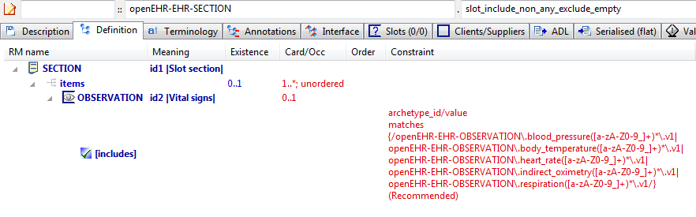

#### Slot Include Non Any Exclude Empty v1 AML Diagram

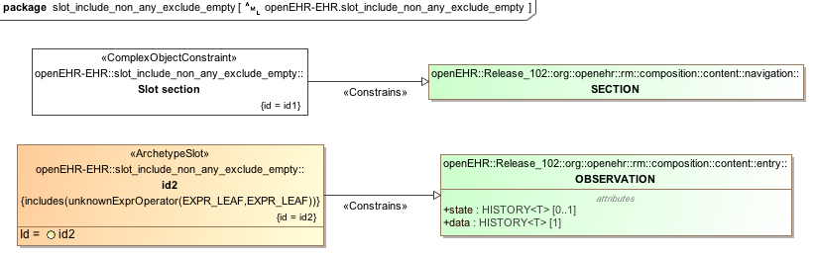

#### Slot Include Non Any Exclude Empty v1 AML Associations Diagram

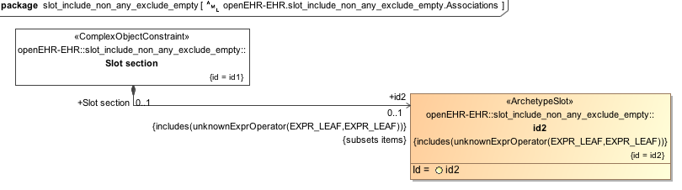

## 

## use_archetype

### External Reference

Example of an external reference, expressed using the 'use_archetype' keyword. This defines a direct association between the archetypes, without the need for a slot, and a corresponding association (which may be an aggregation or composition) of Reference Model structures. The constraint below says concretely that the COMPOSITION object contains SECTION and OBSERVATION objects under its content attribute.

#### ADL

archetype (adl_version=2.0.5; rm_release=1.0.2)

openEHR-EHR-COMPOSITION.ext_ref.v1.0.0

...

definition

COMPOSITION[id1] matches { -- Composition

content matches {

**use_archetype** SECTION[id2, openEHR-EHR-SECTION.section_parent.v1] occurrences matches {0..1}

**use_archetype** OBSERVATION[id3, openEHR-EHR-OBSERVATION.spec_test_obs.v1] occurrences matches {1}

}

}

#### ADL Diagram

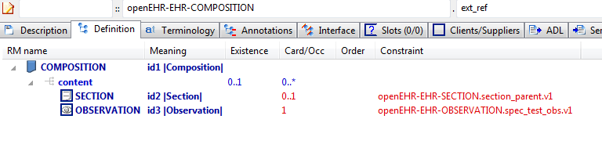

#### AML Diagrams

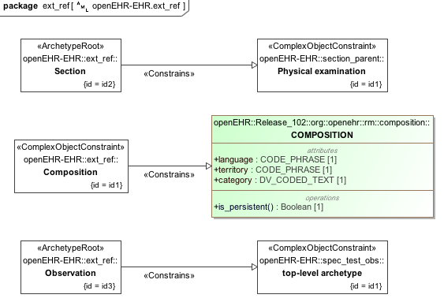

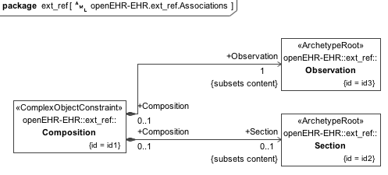

## *use_node*

The *use_node* construct in ADL allows the structure of an archetype defined elsewhere within an archetype to be re-used to define a different node.

### Overriding occurrences

Example showing override of occurrences at source end of *use_node*. With no occurrences stated on a *use_node* node, the occurrences at target of the reference are used. This can be overridden as in this example with an occurrences at the source end.

#### ADL

archetype (adl_version=2.0.5; rm_release=1.0.2)

openEHR-DEMOGRAPHIC-PERSON.use_node_occurrences.v1.0.

...

definition

PERSON[id1] matches { -- person demographics

contacts matches {

CONTACT[id6] matches { -- home contact

addresses matches {

ADDRESS[id7] occurrences matches {0..1} -- home phone number

ADDRESS[id8] occurrences matches {0..2} -- home fax number

ADDRESS[id9] -- home email address

}

}

CONTACT[id10] matches { -- work contact

addresses matches {

**use_node** ADDRESS[id11] /contacts[id6]/addresses[id7] -- /contacts[home contact]/addresses[home phone number]

**use_node** ADDRESS[id12] /contacts[id6]/addresses[id8] -- /contacts[home contact]/addresses[home fax number]

**use_node** ADDRESS[id13] **occurrences matches {1..3}** /contacts[id6]/addresses[id9] -- /contacts[home contact]/addresses[home email address]

}

}

}

}

#### ADL Diagram

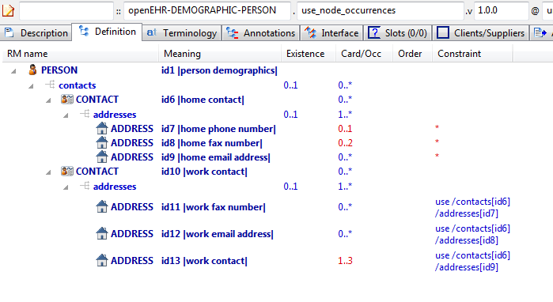

#### AML Diagrams

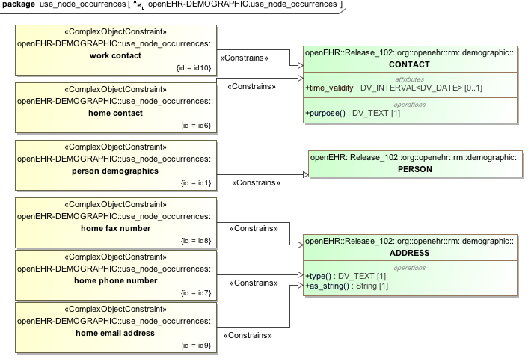

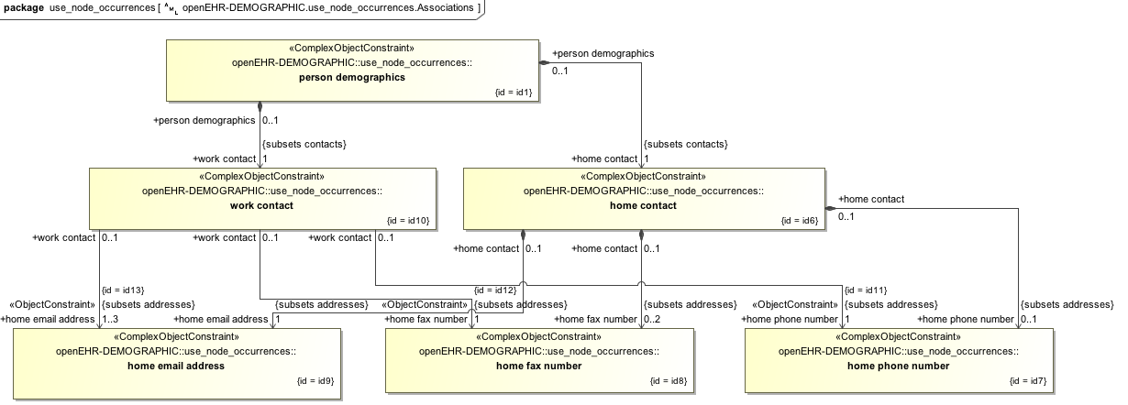

### Path Analysis

Illustrate path set created by multiple *use_node* references. Three paths should be visible that end in [*id14*] in the path analysis.

#### ADL

archetype (adl_version=2.0.5; rm_release=1.0.2)

openEHR-EHR-OBSERVATION.path_analysis_use_nodes.v1.0.0

...

definition

OBSERVATION[id1] matches { -- Laboratory result

data matches {

HISTORY[id2] matches {

events cardinality matches {1..*; unordered} matches {

EVENT[id3] occurrences matches {0..*} matches { -- Any event

data matches {

ITEM_TREE[id4] matches {

items matches {

CLUSTER[id12] matches { -- level 1

name matches {

DV_CODED_TEXT[id23] matches {

defining_code matches {[ac1]} -- =LOINC::Battery_name

}

}

items matches {

CLUSTER[id13] matches { -- level 2

name matches {

DV_CODED_TEXT[id24] matches {

defining_code matches {[ac2]} -- =LOINC::Battery_name

}

}

items matches {

**use_node ELEMENT[id21] /data[id2]/events[id3]/data[id4]/items[id14]**

}

}

**use_node ELEMENT[id22] /data[id2]/events[id3]/data[id4]/items[id14]**

}

}

**ELEMENT[id14]** -- Any result

}

}

}

}

}

}

}

}

#### ADL Diagram

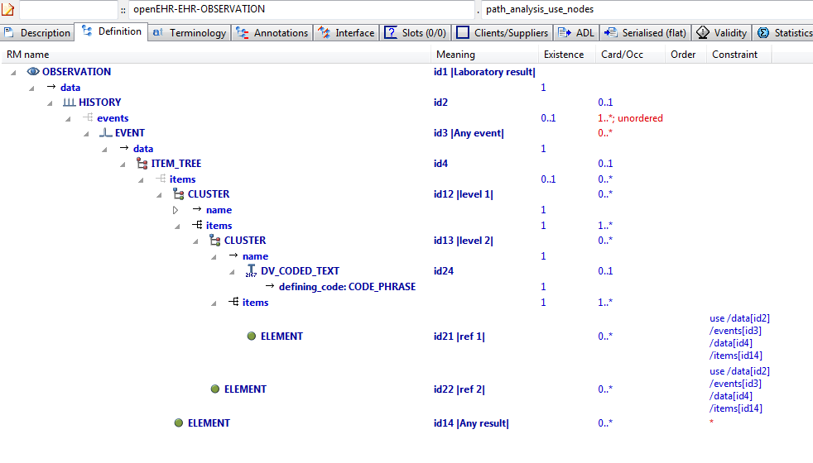

#### AML Diagrams

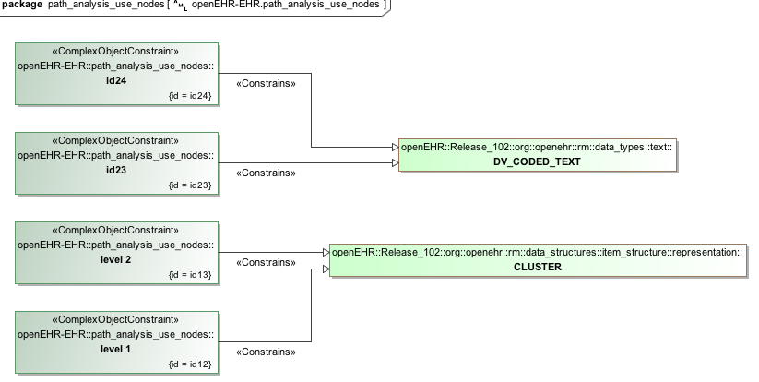

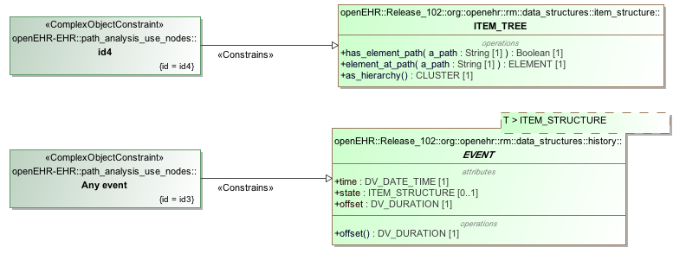

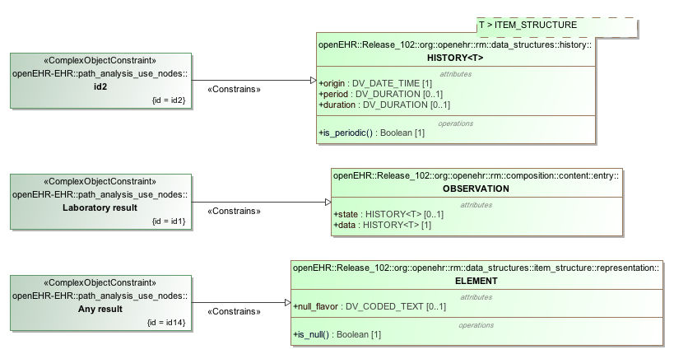

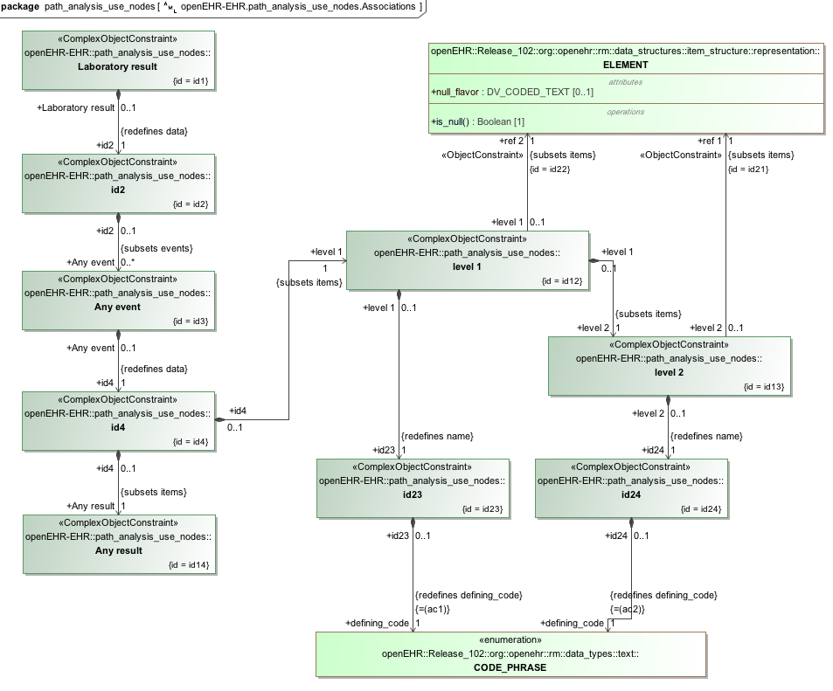

### Apgar Example

This example, based on the openEHR Apgar archetype, shows the use of internal references (keyword 'use_node') to re-use a subtree constraint structure repeatedly elsewhere in the archetype.

#### ADL

archetype (adl_version=2.0.5; rm_release=1.0.2)

openEHR-EHR-OBSERVATION.apgar.v1.0.0

...

definition

OBSERVATION[id1] matches { -- Apgar score

data matches {

HISTORY[id3] matches {

events cardinality matches {1..*; unordered} matches {

POINT_EVENT[id4] occurrences matches {0..1} matches { -- 1 minute

offset matches {

DV_DURATION[id46] matches {

value matches {PT1M}

}

}

data matches {

ITEM_LIST[id2] matches {

items cardinality matches {1..6; ordered} matches {

ELEMENT[id10] occurrences matches {0..1} matches { -- Respiratory effort

value matches {

DV_ORDINAL[id47] matches {

[value, symbol] matches {

[{0}, {[at11]}],

[{1}, {[at12]}],

[{2}, {[at13]}]

}

}

}

}

ELEMENT[id6] occurrences matches {0..1} matches { -- Heart Rate

value matches {

DV_ORDINAL[id48] matches {

[value, symbol] matches {

[{0}, {[at7]}],

[{1}, {[at8]}],

[{2}, {[at9]}]

}

}

}

}

ELEMENT[id14] occurrences matches {0..1} matches { -- Muscle tone

value matches {

DV_ORDINAL[id49] matches {

[value, symbol] matches {

[{0}, {[at15]}],

[{1}, {[at16]}],

[{2}, {[at17]}]

}

}

}

}

ELEMENT[id18] occurrences matches {0..1} matches { -- Reflex irritability

value matches {

DV_ORDINAL[id50] matches {

[value, symbol] matches {

[{0}, {[at19]}],

[{1}, {[at20]}],

[{2}, {[at21]}]

}

}

}

}

ELEMENT[id22] occurrences matches {0..1} matches { -- Skin colour

value matches {

DV_ORDINAL[id51] matches {

[value, symbol] matches {

[{0}, {[at23]}],

[{1}, {[at24]}],

[{2}, {[at25]}]

}

}

}

}

ELEMENT[id26] occurrences matches {0..1} matches { -- Total

value matches {

DV_COUNT[id52] matches {

magnitude matches {|0..10|}

}

}

}

}

}

}

}

POINT_EVENT[id27] occurrences matches {0..1} matches { -- 2 minute

offset matches {

DV_DURATION[id53] matches {

value matches {PT2M}

}

}

data matches {

**use_node ITEM_LIST[id41] /data[id3]/events[id4]/data[id2]** -- /data[id3]/events[1 minute]/data[id2]

}

}

POINT_EVENT[id28] occurrences matches {0..1} matches { -- 3 minute

offset matches {

DV_DURATION[id54] matches {

value matches {PT3M}

}

}

data matches {

**use_node ITEM_LIST[id42] /data[id3]/events[id4]/data[id2]** -- /data[id3]/events[1 minute]/data[id2]

}

}

POINT_EVENT[id29] occurrences matches {0..1} matches { -- 5 minute

offset matches {

DV_DURATION[id55] matches {

value matches {PT5M}

}

}

data matches {

**use_node ITEM_LIST[id43] /data[id3]/events[id4]/data[id2]** -- /data[id3]/events[1 minute]/data[id2]

}

}

POINT_EVENT[id32] occurrences matches {0..1} matches { -- 10 minute

offset matches {

DV_DURATION[id56] matches {

value matches {PT10M}

}

}

data matches {

**use_node ITEM_LIST[id44] /data[id3]/events[id4]/data[id2]** -- /data[id3]/events[1 minute]/data[id2]

}

}

EVENT[id38] occurrences matches {0..*} matches { -- Any event

data matches {

**use_node ITEM_LIST[id45] /data[id3]/events[id4]/data[id2]**  -- /data[id3]/events[1 minute]/data[id2]

}

}

}

}

}

protocol matches {

ITEM_LIST[id30] matches {

items matches {

ELEMENT[id31] occurrences matches {0..1} matches { -- Notes on measurement

value matches {

DV_TEXT[id57]

}

}

#### ADL Diagram

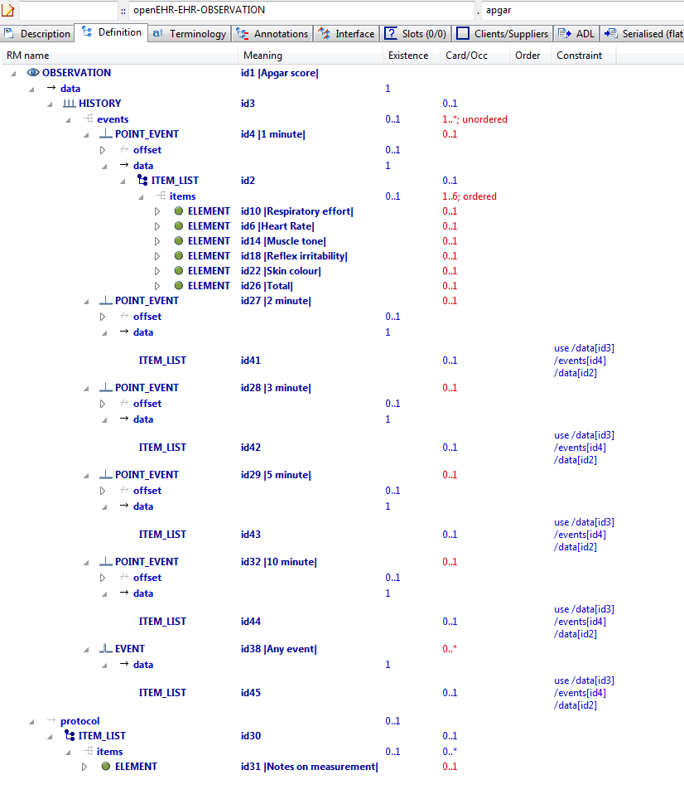

#### AML Diagrams

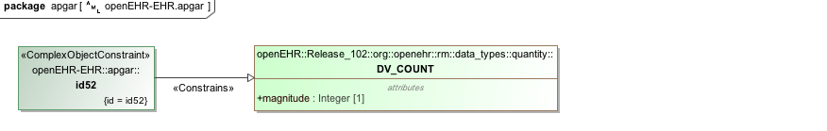

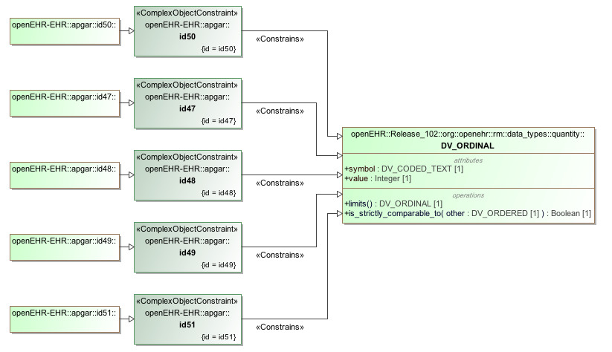

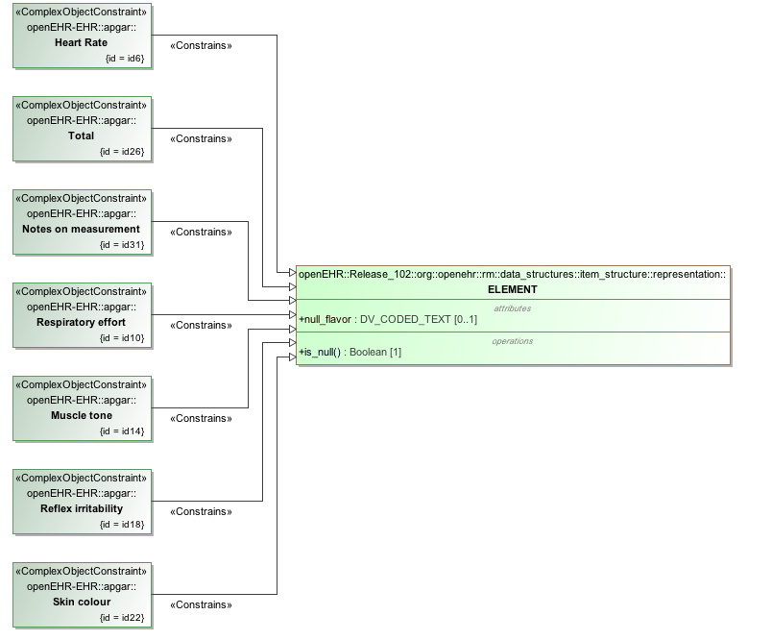

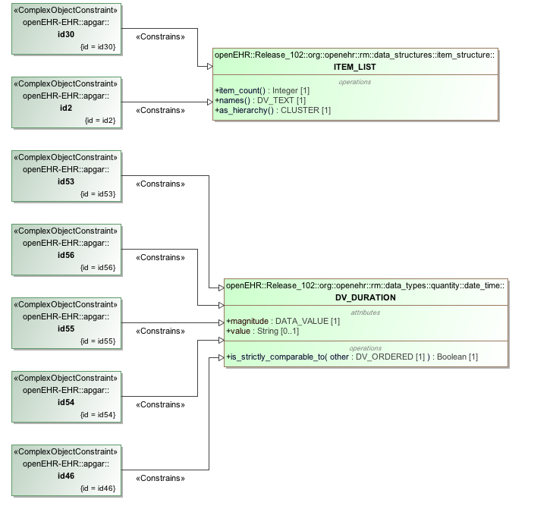

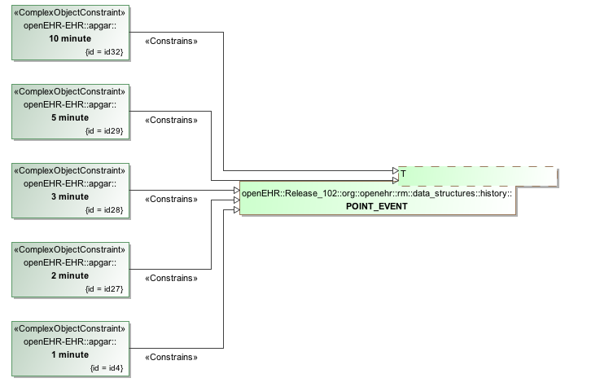

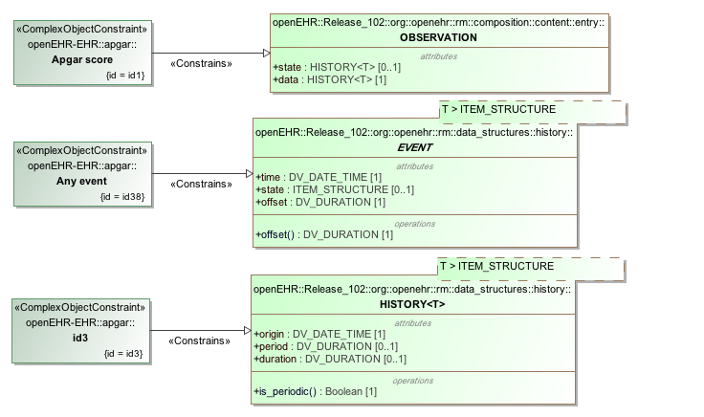

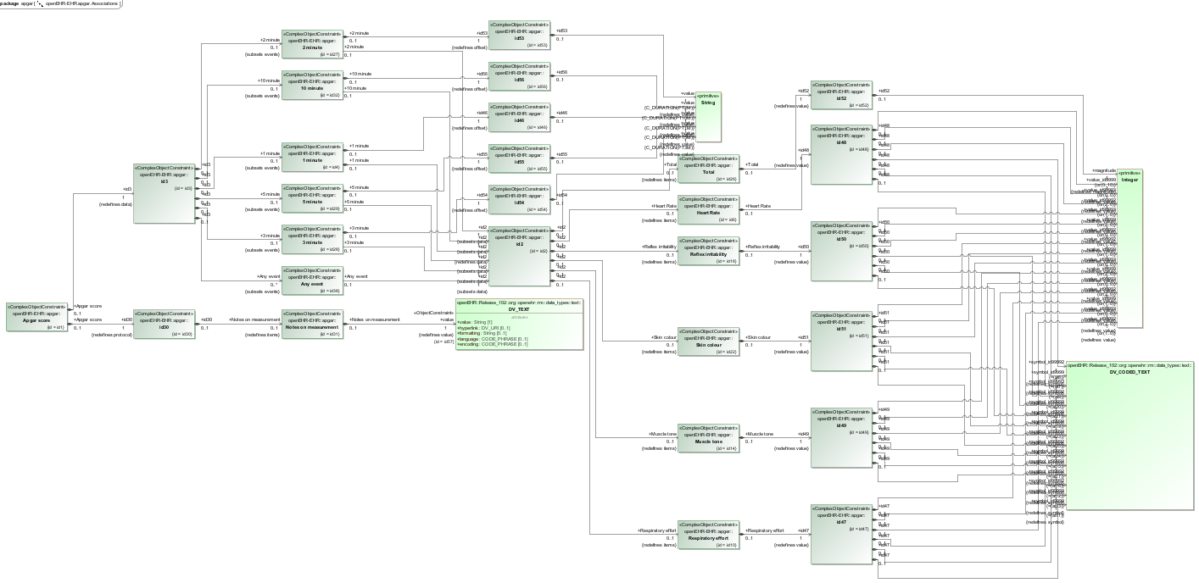

## Description Annotations Examples

### Annotations Rm Path v1 Example

Demonstrate annotations on pure Reference Model paths, i.e. paths that must be valid, but have not been archetyped. They are thus still valid for annotations.

#### Annotations Rm Path v1 ADL

archetype (adl_version=2.0.5; rm_release=1.0.2)

openEHR-EHR-COMPOSITION.annotations_rm_path.v1.0.0

language

original_language = <[ISO_639-1::en]>

description

original_author = <

["name"] = <"Thomas Beale">

["email"] = <"thomas.beale@openEHR.org">

["organisation"] = <"openEHR Foundation <http://www.openEHR.org>">

["date"] = <"2010-11-09">

>

details = <

["en"] = <

language = <[ISO_639-1::en]>

purpose = <"Demonstrate annotations on pure Reference Model paths, i.e. paths that must be valid, but have not been archetyped. They are thus still valid for annotations.">

use = <"The typical use is to add design notes about RM data items that are not archetyped (i.e. don't specifically need to be constrained) but whose meaning is specific to the archetype.">

keywords = <"ADL", "test">

>

>

lifecycle_state = <"published">

other_details = <

["regression"] = <"PASS">

>

copyright = <"Copyright © 2010 openEHR Foundation <http://www.openEHR.org>">

licence = <"Creative Commons CC-BY-SA <https://creativecommons.org/licenses/by-sa/3.0/>">

definition

COMPOSITION[id1] matches { -- Prescription

category matches {

DV_CODED_TEXT[id10] matches {

defining_code matches {[at1]}

}

}

context matches {

EVENT_CONTEXT[id11] matches {

other_context matches {

ITEM_TREE[id2] matches {

items matches {

CLUSTER[id3] occurrences matches {0..*} matches { -- Qualification

items matches {

ELEMENT[id4] occurrences matches {0..1} matches { -- OrderID

value matches {

DV_EHR_URI[id12]

DV_IDENTIFIER[id13]

}

}

ELEMENT[id5] occurrences matches {0..*} matches { -- Endorsement

value matches {

DV_TEXT[id14]

}

}

ELEMENT[id6] occurrences matches {0..*} matches { -- AuthorisationID

value matches {

DV_IDENTIFIER[id15]

}

}

ELEMENT[id7] occurrences matches {0..*} matches { -- Comment

value matches {

DV_TEXT[id16]

}

}

}

}

}

}

}

}

}

content cardinality matches {1..*; unordered} matches {

allow_archetype INSTRUCTION[id8] occurrences matches {1..*} matches { -- Medication instruction

include

archetype_id/value matches {/openEHR-EHR-INSTRUCTION\.medication\.v1/}

}

allow_archetype ENTRY[id9] occurrences matches {0..*} matches { -- Other data

include

archetype_id/value matches {/.*/}

}

}

}

terminology

term_definitions = <

["en"] = <

["id1"] = <

text = <"Prescription">

description = <"A document authorising supply and administration of one or more medicines, vaccines or other therapeutic goods (as a collection of medication instrations) to be communicated to a dispensing or administration provider.">

>

["id3"] = <

text = <"Qualification">

description = <"Qualifications on any medication order included in the prescription.">

>

["id4"] = <

text = <"OrderID">

description = <"The path or ID of the order referenced. If there is no OrderID then the endorsement relates to the entire prescription.">

>

["id5"] = <

text = <"Endorsement">

description = <"Asserting that a special condition applies such as approval for enhanced subsidy or concurrent supply. Australian examples include Regulation 24 (PBS), Hardship Conditions (RPBS) or CTG for 'close the gap'.">

>

["id6"] = <

text = <"AuthorisationID">

description = <"An identifier authorising prescription, dispensing or reimbursement for this medication order.">

>

["id7"] = <

text = <"Comment">

description = <"Comment on any qualification.">

>

["id8"] = <

text = <"Medication instruction">

description = <"Contains one or more medication instructions to be supplied.">

>

["id9"] = <

text = <"Other data">

description = <"Other observational or relevant data.">

>

["at1"] = <

text = <"event">

description = <"event">

>

>

>

term_bindings = <

["openehr"] = <

["at1"] = <http://openehr.org/id/433>

>

>

annotations

items = <

["en"] = <

["/context/start_time"] = <

["test"] = <"XXXX">

["local_name"] = <"consultation start time">

>

["/context/location"] = <

["design note"] = <"Note on use of the non-archteyped context/location RM element in this data">

>

["/context/health_care_facility/name"] = <

["design note"] = <"Note on use of non-archteyped context/health_care_facility/name RM element in this data">

>

>

>

#### Annotations Rm Path v1 ADL Diagram

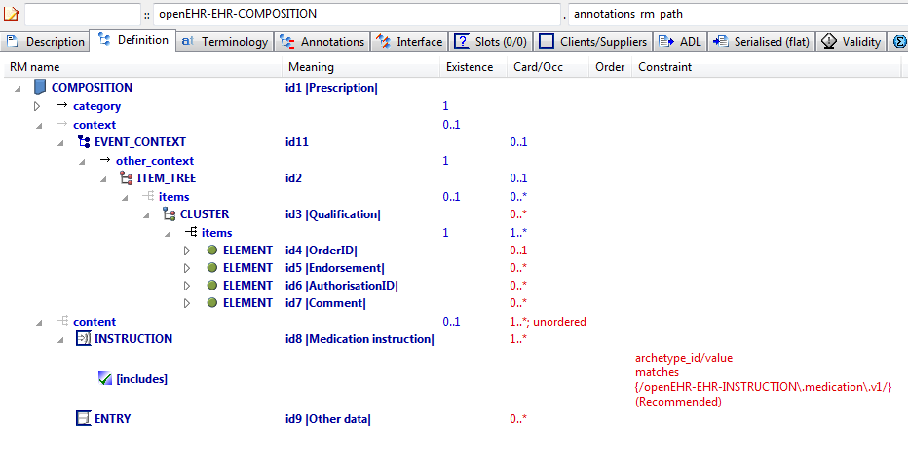

#### Annotations Rm Path v1 AML Diagram

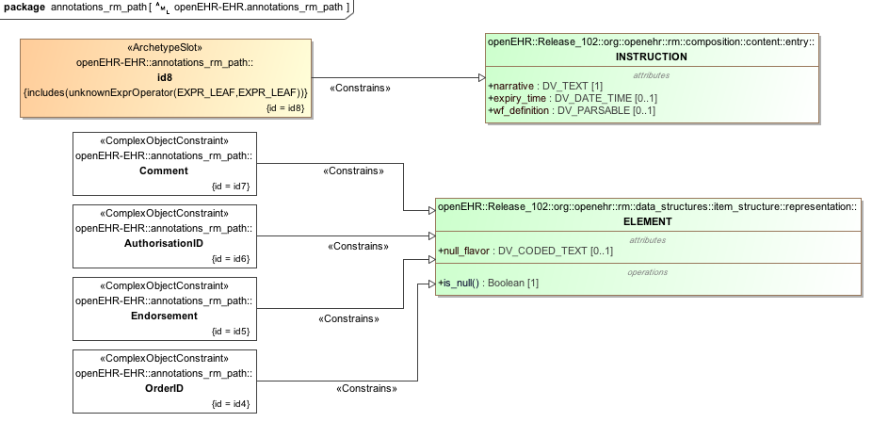

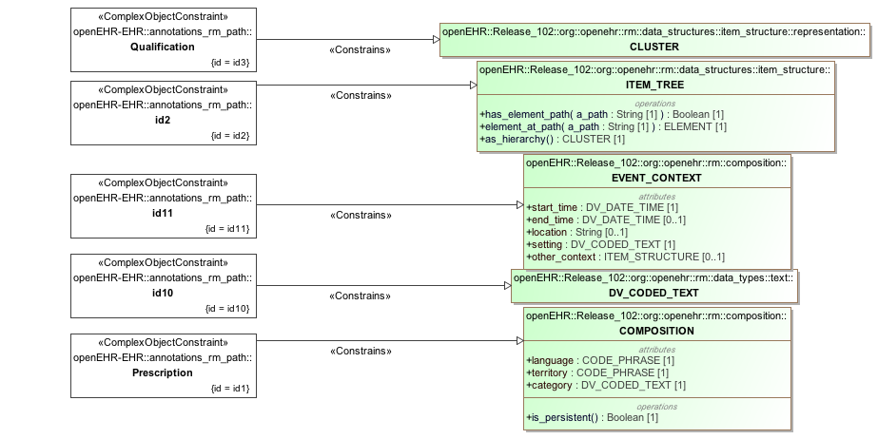

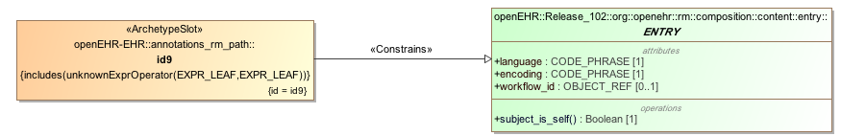

#### Annotations Rm Path v1 AML Associations Diagram

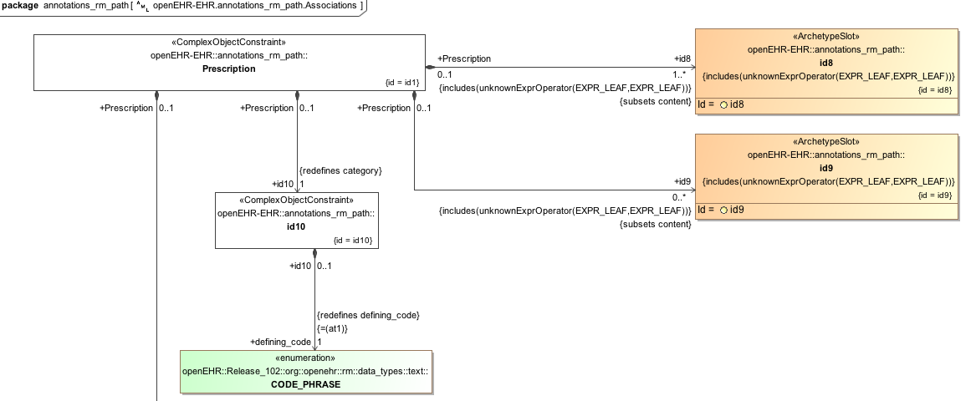

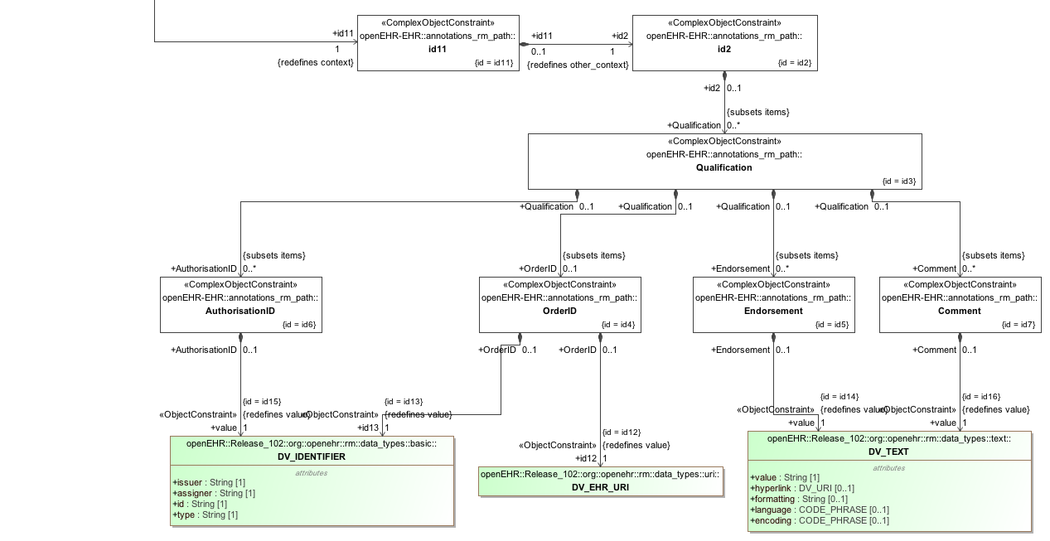

### Annotations 1st Child v1 Example

Test use of annotations in a specialised archetype, on specialised paths.

#### Annotations 1st Child v1 ADL

archetype (adl_version=2.0.5; rm_release=1.0.2)

openEHR-EHR-EVALUATION.annotations_1st_child.v1.0.0

specialize

openEHR-EHR-EVALUATION.annotations_parent.v1

language

original_language = <[ISO_639-1::en]>

description

original_author = <

["name"] = <"Thomas Beale">

["email"] = <"thomas.beale@openEHR.org">

["organisation"] = <"openEHR Foundation <http://www.openEHR.org>">

["date"] = <"2010-12-12">

>

details = <

["en"] = <

language = <[ISO_639-1::en]>

purpose = <"Test use of annotations in a specialised archetype, on specialised paths.">

keywords = <"ADL", "test">

>

>

lifecycle_state = <"published">

other_details = <

["regression"] = <"PASS">

>

copyright = <"Copyright © 2010 openEHR Foundation <http://www.openEHR.org>">

licence = <"Creative Commons CC-BY-SA <https://creativecommons.org/licenses/by-sa/3.0/>">

definition

EVALUATION[id1.1] matches { -- Exclusion statement - Adverse Reaction

/data[id2]/items matches {

ELEMENT[id0.7] occurrences matches {0..1} matches { -- No known adverse reaction to

value matches {

DV_TEXT[id0.5]

}

}

ELEMENT[id0.8] occurrences matches {0..1} matches { -- No known allergic reaction to

value matches {

DV_TEXT[id0.6]

}

}

ELEMENT[id0.9] occurrences matches {0..1} matches { -- No known hypersensitivity reaction to

value matches {

DV_TEXT[id0.7] -- No known adverse reaction to

}

}

ELEMENT[id0.10] occurrences matches {0..1} matches { -- No known intolerance to

value matches {

DV_TEXT[id0.8] -- No known allergic reaction to

}

}

}

}

terminology

term_definitions = <

["en"] = <

["id1.1"] = <

text = <"Exclusion statement - Adverse Reaction">

description = <"Statements about Adverse Reactions that need to be positively recorded as absent or excluded.">

>

["id0.10"] = <

text = <"No known intolerance to">

description = <"Positive statement about intolerances to substances that are explicitly known to have not been identified at the time of recording.">

>

["id0.7"] = <

text = <"No known adverse reaction to">

description = <"Positive statement about adverse reactions to substances that are explicitly known to have not been identified at the time of recording.">

>

["id0.8"] = <

text = <"No known allergic reaction to">

description = <"Positive statement about allergic reactions to substances that are explicitly known to have not been identified at the time of recording.">

>

["id0.9"] = <

text = <"No known hypersensitivity reaction to">

description = <"Positive statement about hypersensitivity reactions to substances that are explicitly known to have not been identified at the time of recording.">

>

>

>

annotations

items = <

["en"] = <

["/data[id2]/items[id0.8]"] = <

["design note"] = <"this is a design note on allergic reaction">

["requirements note"] = <"this is a requirements note on allergic reaction">

["medline ref"] = <"this is a medline ref on allergic reaction">

>

["/data[id2]/items[id0.10]"] = <

["design note"] = <"this is a design note on intelerance">

["requirements note"] = <"this is a requirements note on intolerance">

["national data dictionary"] = <"NDD ref for intolerance">

>

["/data[id2]/items[id3]"] = <

["design note"] = <"this is a SPECIALISED design note on Statement">

["NEW TAG"] = <"this is a SPECIALISED design note on Statement">

>

>

>

#### Annotations 1st Child v1 ADL Diagram

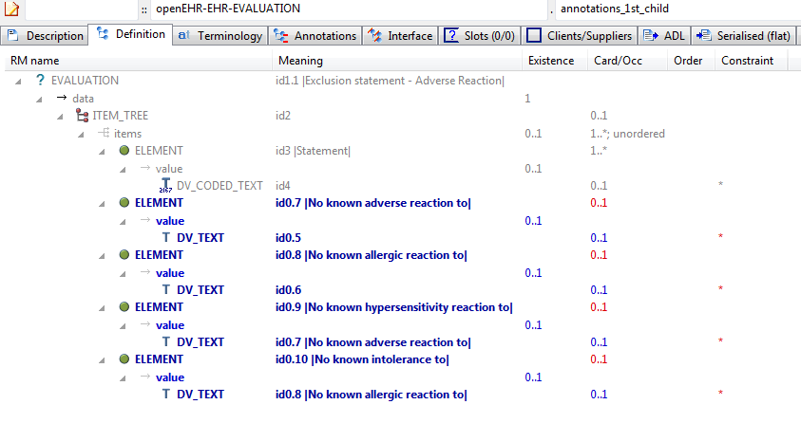

#### Annotations 1st Child v1 AML Diagram

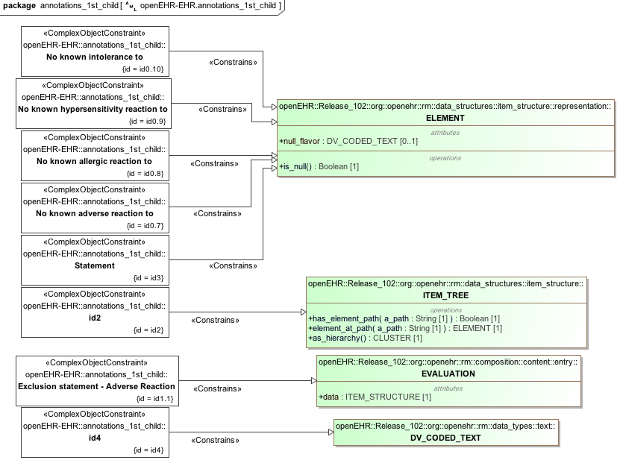

#### Annotations 1st Child v1 AML Associations Diagram

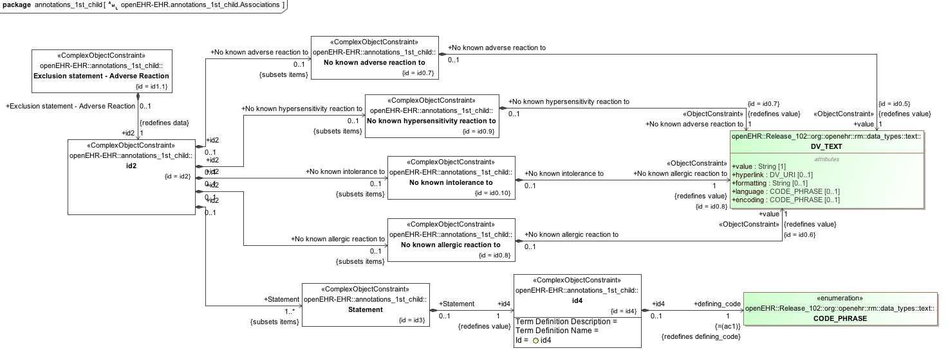

### Annotations Only Child v1 Example

Test use of specialisation that adds only annotations, i.e. no other changes.

#### Annotations Only Child v1 ADL

archetype (adl_version=2.0.5; rm_release=1.0.2)

openEHR-EHR-EVALUATION.annotations_only_child.v1.0.0

specialize

openEHR-EHR-EVALUATION.annotations_parent.v1

language

original_language = <[ISO_639-1::en]>

description

original_author = <

["name"] = <"Thomas Beale">

["email"] = <"thomas.beale@openEHR.org">

["organisation"] = <"openEHR Foundation <http://www.openEHR.org>">

["date"] = <"2010-12-12">

>

details = <

["en"] = <

language = <[ISO_639-1::en]>

purpose = <"Test use of specialisation that adds only annotations, i.e. no other changes.">

keywords = <"ADL", "test">

>

>

lifecycle_state = <"published">

other_details = <

["regression"] = <"PASS">

>

copyright = <"Copyright © 2010 openEHR Foundation <http://www.openEHR.org>">

licence = <"Creative Commons CC-BY-SA <https://creativecommons.org/licenses/by-sa/3.0/>">

definition

EVALUATION[id1.1] -- Annotations specialisation

terminology

term_definitions = <

["en"] = <

["id1.1"] = <

text = <"Annotations specialisation">

description = <"Annotations specialisation">

>

>

>

annotations

items = <

["en"] = <

["/data[id2]/items[id3]"] = <

["design note"] = <"this is a SPECIALISED design note on Statement">

["NEW TAG"] = <"this is a SPECIALISED design note on Statement">

>

>

>

#### Annotations Only Child v1 ADL Diagram

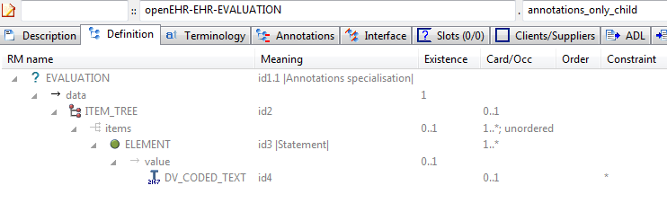

#### Annotations Only Child v1 AML Diagram

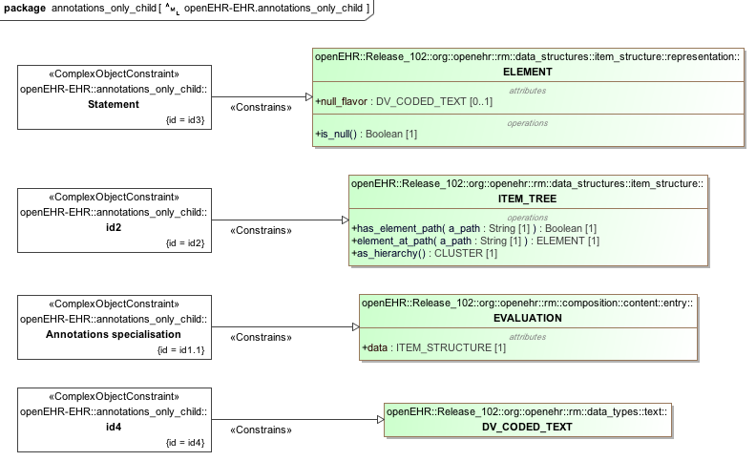

#### Annotations Only Child v1 AML Associations Diagram

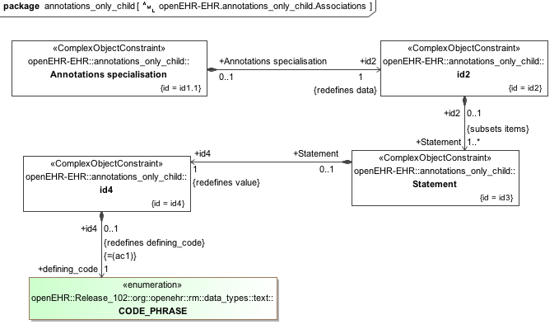

### Annotations Parent v1 Example

Archetype containing various kinds of annotation, including notes, requirements and UI processing hints.

#### Annotations Parent v1 ADL

archetype (adl_version=2.0.5; rm_release=1.0.2)

openEHR-EHR-EVALUATION.annotations_parent.v1.0.0

language

original_language = <[ISO_639-1::en]>

description

original_author = <

["name"] = <"Thomas Beale">

["email"] = <"thomas.beale@openEHR.org">

["organisation"] = <"openEHR Foundation <http://www.openEHR.org>">

["date"] = <"2010-12-20">

>

details = <

["en"] = <

language = <[ISO_639-1::en]>

purpose = <"Archetype containing various kinds of annotation, including notes, requirements and UI processing hints.">

keywords = <"ADL", "test">

>

>

lifecycle_state = <"published">

other_details = <

["regression"] = <"PASS">

>

copyright = <"Copyright © 2004 openEHR Foundation <http://www.openEHR.org>">

licence = <"Creative Commons CC-BY-SA <https://creativecommons.org/licenses/by-sa/3.0/>">

definition

EVALUATION[id1] matches { -- General statement of exclusions or states

data matches {

ITEM_TREE[id2] matches {

items cardinality matches {1..*; unordered} matches {

ELEMENT[id3] occurrences matches {1..*} matches { -- Statement

value matches {

DV_CODED_TEXT[id4]

}

}

}

}

}

}

terminology

term_definitions = <

["en"] = <

["id1"] = <

text = <"General statement of exclusions or states">

description = <"A category of conditions or states which have been excluded">

>

["id3"] = <

text = <"Statement">

description = <"The statement about what is excluded">

>

>

>

annotations

items = <

["en"] = <

["/data[id2]"] = <

["ui"] = <"passthrough">

>

["/data[id2]/items[id3]"] = <

["design note"] = <"this is a design note on Statement">

["requirements note"] = <"this is a requirements note on Statement">

["medline ref"] = <"this is a medline ref on Statement">>>>

#### Annotations Parent v1 ADL Diagram

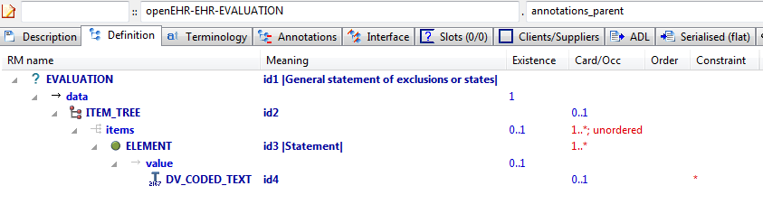

#### Annotations Parent v1 AML Diagram

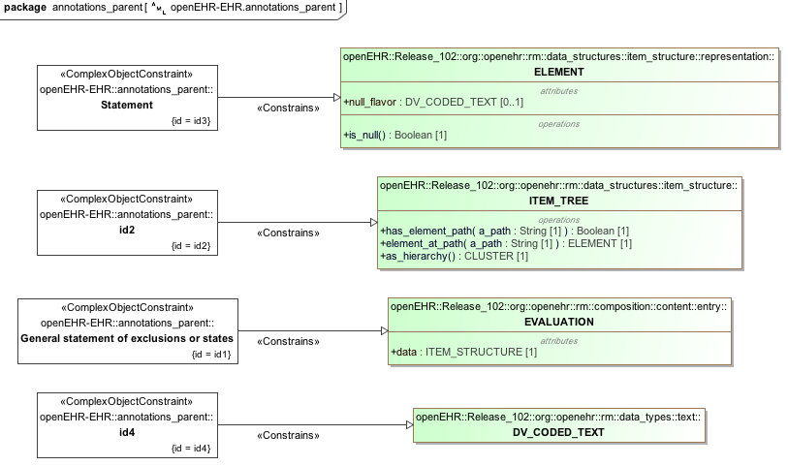

#### Annotations Parent v1 AML Associations Diagram

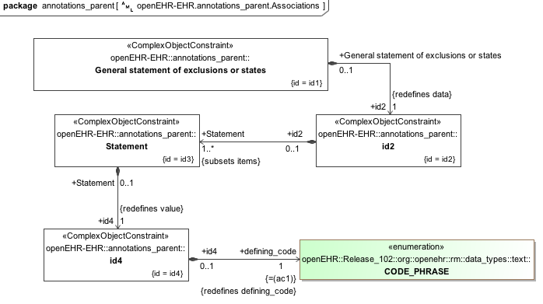

## Description Identification Examples

### No Ns Inherit Ns v2 Example

Test full namespaced published versioned archetype identifier containing semver.org style 'rc' qualifier at end (release candidate).

#### No Ns Inherit Ns v2 ADL

archetype (adl_version=2.0.0; rm_release=1.0.2)

openEHR-EHR-OBSERVATION.no_ns_inherit_ns.v2.8.0-rc.57

specialize

org.openehr::openEHR-EHR-OBSERVATION.full_id_1.v1

language

original_language = <[ISO_639-1::en]>

description

custodian_namespace = <"org.openehr">

custodian_organisation = <"openEHR Foundation <http://www.openEHR.org>">

original_author = <

["name"] = <"Thomas Beale">

["email"] = <"thomas.beale@openEHR.org">

["organisation"] = <"openEHR Foundation <http://www.openEHR.org>">

["date"] = <"2013-08-11">

>

details = <

["en"] = <

language = <[ISO_639-1::en]>

purpose = <"Test full namespaced published versioned archetype identifier containing semver.org style 'rc' qualifier at end (release candidate).">

keywords = <"ADL", "identifiers", "test">

>

>

lifecycle_state = <"published">

other_details = <

["regression"] = <"PASS">

>

copyright = <"Copyright © 2013 openEHR Foundation <http://www.openEHR.org>">

licence = <"Creative Commons CC-BY-SA <https://creativecommons.org/licenses/by-sa/3.0/>">

definition

OBSERVATION[id1.1] matches { -- specialised archetype

data matches {

HISTORY[id0.2]

}

}

terminology

term_definitions = <

["en"] = <

["id1.1"] = <

text = <"specialised archetype">

description = <"specialised child archetype">

>

>

>

#### No Ns Inherit Ns v2 ADL Diagram

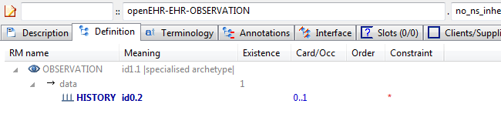

#### No Ns Inherit Ns v2 AML Diagram

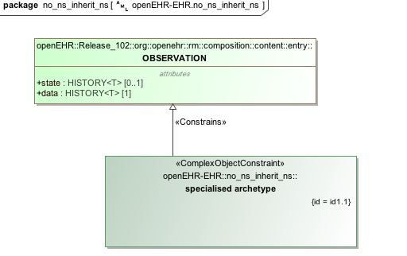

#### No Ns Inherit Ns v2 AML Associations Diagram

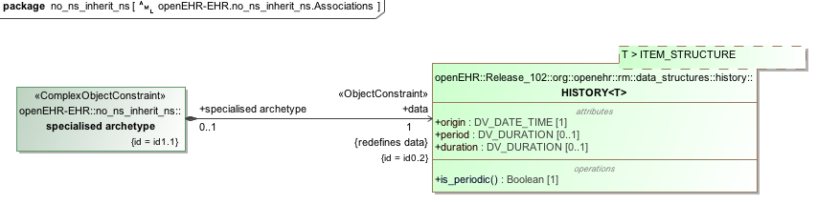

## 

## Description Text Examples

### Quoted Strings v1 Example

This archetype should parse fine, and when saved and reparsed, no changes should occur in the strings of the at0001 term, i.e. the quoted slash and quoted double quote should remain as they are. However, both should display in the GUI without the backslash symbol.

#### Quoted Strings v1 ADL

archetype (adl_version=2.0.5; rm_release=1.0.2)

openEHR-EHR-CLUSTER.quoted_strings.v1.0.0

language

original_language = <[ISO_639-1::en]>

description

custodian_namespace = <"org.openehr">

custodian_organisation = <"openEHR Foundation <http://www.openEHR.org>">

original_author = <

["organisation"] = <"a\"x'c\\d">

["name"] = <"Peter Gummer">

["email"] = <"a\"x'c\\d">

>

details = <

["en"] = <

language = <[ISO_639-1::en]>

purpose = <"This archetype should parse fine, and when saved and reparsed, no changes should occur in the strings of the at0001 term, i.e. the quoted slash and quoted double quote should remain as they are. However, both should display in the GUI without the backslash symbol.">

use = <"\\">

keywords = <"a\"x'c\\d", "p\"q\\s\"">

>

>

lifecycle_state = <"published">

other_contributors = <"a\"x'c\\d", ...>

other_details = <

["regression"] = <"PASS">

>

copyright = <"Copyright © 2012 openEHR Foundation <http://www.openEHR.org>">

licence = <"Creative Commons CC-BY-SA <https://creativecommons.org/licenses/by-sa/3.0/>">

definition

CLUSTER[id1] matches { -- unknown

items matches {

ELEMENT[id2] occurrences matches {0..1} matches { -- a\b

value matches {

DV_CODED_TEXT[id4] matches {

defining_code matches {[ac1]} -- a\b

}

}

}

ELEMENT[id3] occurrences matches {0..1} matches { -- \a\

value matches {

DV_TEXT[id5] matches {

value matches {"No quoting should happen here"}

}

}

}

}

}

terminology

term_definitions = <

["en"] = <

["id1"] = <

text = <"unknown">

description = <"unknown">

>

["id2"] = <

text = <"a\\b">

description = <"a\"b">

>

["id3"] = <

text = <"\\a\\">

description = <"\"a\"">

>

["at11"] = <

text = <"\\">

description = <"xxx">

>

["at12"] = <

text = <"\\\\">

description = <"xxx">

>

["ac1"] = <

text = <"a\\b">

description = <"a\"b">

>

>

>

value_sets = <

["ac1"] = <

id = <"ac1">

members = <"at11", "at12">

>

>

#### Quoted Strings v1 ADL Diagram

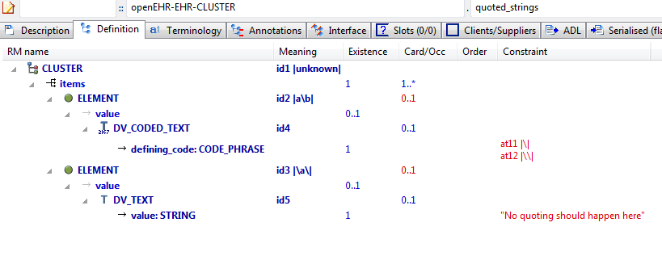

#### Quoted Strings v1 AML Diagram

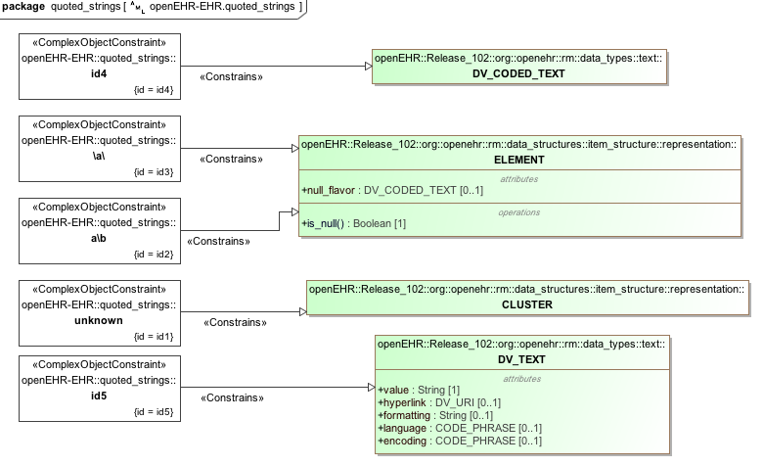

#### Quoted Strings v1 AML Associations Diagram

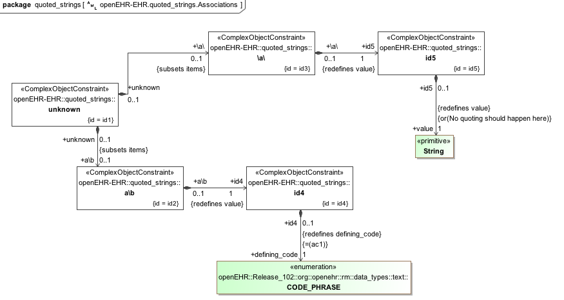

### Unicode Farsi v1 Example

Test unicode language archetype with Farsi translation.

ثبت احتمال خطرداشتن و یا ایجاد شرایط ارزیابی شده به دلیل بروز در اقوام

#### Unicode Farsi v1 ADL

archetype (adl_version=2.0.5; rm_release=1.0.2)

openEHR-EHR-EVALUATION.unicode_farsi.v1.0.0

language

original_language = <[ISO_639-1::en]>

translations = <

["fa"] = <

language = <[ISO_639-1::fa]>

author = <

["name"] = <"unknown">

>

>

>

description

custodian_namespace = <"org.openehr">

custodian_organisation = <"openEHR Foundation <http://www.openEHR.org>">

original_author = <

["name"] = <"Thomas Beale">

["email"] = <"thomas.beale@openEHR.org">

["organisation"] = <"openEHR Foundation <http://www.openEHR.org>">

["date"] = <"2006-04-23">

>

details = <

["en"] = <

language = <[ISO_639-1::en]>

purpose = <"Test unicode language archetype with Farsi translation.">

use = <"For recording information about the prevalence of the condition in relatives and quantifying risk to the subject of care.">

misuse = <"Not for recording problems of individual relatives - use 'openEHR-EHR-EVALUATION.problem' and 'openEHR-EHR-EVALUATION.problem-diagnosis' and set the subject of data to the relative.">

>

["fa"] = <

language = <[ISO_639-1::fa]>

purpose = <"ثبت احتمال خطرداشتن و یا ایجاد شرایط ارزیابی شده به دلیل بروز در اقوام ">

use = <"برای ثبت اطلاعات درباره بروز شرایط در اقوام و احتمال خطر برای موضوع مراقبت ">

misuse = <"برای ثبت مشکلات اقوام فرد -از مشکل و مشکل_تشخیص و مجموعه ای از داده های مربوطه استفاده کنید">

>

>

lifecycle_state = <"published">

other_details = <

["regression"] = <"PASS">

>

copyright = <"Copyright © 2006 openEHR Foundation <http://www.openEHR.org>">

licence = <"Creative Commons CC-BY-SA <https://creativecommons.org/licenses/by-sa/3.0/>">

definition

EVALUATION[id1] matches { -- Risk of condition based on family history

data matches {

ITEM_TREE[id2] matches {

items cardinality matches {1..*; ordered} matches {

ELEMENT[id3] matches { -- Index condition

value matches {

DV_TEXT[id131]

}

}

ELEMENT[id5] occurrences matches {0..1} matches { -- Assessed risk

value matches {

DV_CODED_TEXT[id132] matches {

defining_code matches {[ac2]} -- Assessed risk

}

}

}

CLUSTER[id102] occurrences matches {0..1} matches { -- Affected relatives

items matches {

CLUSTER[id103] occurrences matches {0..*} matches { -- Relative

name matches {

DV_CODED_TEXT[id133] matches {

defining_code matches {[ac1]} -- Relationship

}

}

items matches {

ELEMENT[id104] occurrences matches {0..1} matches { -- Name

value matches {

DV_TEXT[id134]

}

}

ELEMENT[id105] occurrences matches {0..1} matches { -- Age at onset

value matches {

DV_QUANTITY[id135] matches {

property matches {[at127]}

[units, magnitude] matches {

[{"yr"}, {|0.0..200.0|}],

[{"mth"}, {|0.0..36.0|}],

[{"wk"}, {|0.0..52.0|}],

[{"day"}, {|0.0..56.0|}]

}

}

}

}

ELEMENT[id128] occurrences matches {0..1} matches { -- Date of onset

value matches {

DV_DATE[id136] matches {

value matches {yyyy-??-??}

}

}

}

ELEMENT[id106] occurrences matches {0..1} matches { -- Age at death

value matches {

DV_QUANTITY[id137] matches {

property matches {[at128]}

units matches {"yr"}

magnitude matches {|0.0..200.0|}

}

}

}

ELEMENT[id107] occurrences matches {0..1} matches { -- Date of death

value matches {

DV_DATE[id138] matches {

value matches {yyyy-??-??}

}

}

}

ELEMENT[id108] occurrences matches {0..1} matches { -- Index condition was cause of death

value matches {

DV_BOOLEAN[id139] matches {

value matches {True, False}

}

}

}

ELEMENT[id109] occurrences matches {0..1} matches { -- Severity

value matches {

DV_ORDINAL[id140] matches {

[value, symbol] matches {

[{1}, {[at110]}],

[{4}, {[at111]}],

[{7}, {[at112]}]

}

}

}

}

ELEMENT[id129] occurrences matches {0..1} matches { -- More specific condition

value matches {

DV_TEXT[id141]

}

}

ELEMENT[id113] occurrences matches {0..1} matches { -- Clinical description

value matches {

DV_TEXT[id142]

}

}

ELEMENT[id114] occurrences matches {0..1} matches { -- Genetic relative

value matches {

DV_BOOLEAN[id143] matches {

value matches {True, False}

}

}

}

}

}

}

}

CLUSTER[id115] occurrences matches {0..*} matches { -- Affected ratio

items cardinality matches {1..4; ordered} matches {

ELEMENT[id116] occurrences matches {0..1} matches { -- Degree

value matches {

DV_CODED_TEXT[id144] matches {

defining_code matches {[ac3]} -- Degree

}

}

}

ELEMENT[id123] occurrences matches {0..1} matches { -- Gender

value matches {

DV_CODED_TEXT[id145] matches {

defining_code matches {[ac4]} -- Gender

}

}

}

ELEMENT[id127] occurrences matches {0..1} matches { -- Number unaffected

value matches {

DV_COUNT[id146] matches {

magnitude matches {|0..100|}

}

}

}

ELEMENT[id130] matches { -- Number affected

value matches {

DV_COUNT[id147] matches {

magnitude matches {|0..100|}

}

}

}

}

}

}

}

}

protocol matches {

ITEM_LIST[id11] matches {

items matches {

ELEMENT[id12] occurrences matches {0..1} matches { -- Risk calculation

value matches {

DV_TEXT[id148]

}

}

}

}

}

}

terminology

term_definitions = <

["en"] = <

["id102"] = <

text = <"Affected relatives">

description = <"The family members affected by the condition">

>

["at111"] = <

text = <"Moderate">

description = <"Significant morbidity and reduced capability">

>

["at112"] = <

text = <"Severe">

description = <"Major morbidity with significant social impact">

>

["id113"] = <

text = <"Clinical description">

description = <"A clinical description of the affected relatives condition">

>

["id114"] = <

text = <"Genetic relative">

description = <"A genetic relative of the data subject - not an adoptive relative">

>

["id115"] = <

text = <"Affected ratio">

description = <"A ratio of the affected to non-affected relatives of a particular type">

>

["id116"] = <

text = <"Degree">

description = <"The proximity or line of the relatives">

>

["at117"] = <

text = <"First degree relatives">

description = <"Relatives with 50% genetic share - parent, sibling, child">

>

["at118"] = <

text = <"Second degree relatives">

description = <"Relatives with 25% genetic share - grand parent, aunts and uncles, nieces and nephews, grand children">

>

["at119"] = <

text = <"Third degree relatives">

description = <"Relatives with 12.5% genetic share, great grand parents, great aunts and uncles, first cousins, children of neices and nephews, great grand children">

>

["at120"] = <

text = <"Maternal relatives">

description = <"Related through mother">

>

["id103"] = <

text = <"Relative">

description = <"Details about the affected relative">

>

["at121"] = <

text = <"Paternal relatives">

description = <"Related through father">

>

["at122"] = <

text = <"Family">

description = <"Entire family">

>

["id123"] = <

text = <"Gender">

description = <"The gender of the relatives included in the affected ratio">

>

["at124"] = <

text = <"Male">

description = <"Male gender">

>

["at125"] = <

text = <"Female">

description = <"Female gender">

>

["at126"] = <

text = <"Male and female">

description = <"Male and female relatives">

>

["id127"] = <

text = <"Number unaffected">

description = <"The number of relatives in this group unaffected by the index condition">

>

["id128"] = <

text = <"Date of onset">

description = <"Date of onset">

>

["id129"] = <

text = <"More specific condition">

description = <"A coded entry which is more specific than the index condition">

>

["id130"] = <

text = <"Number affected">

description = <"The number affected by the index condition">

>

["id104"] = <

text = <"Name">

description = <"Optional name of the person for future reference">

>

["id105"] = <

text = <"Age at onset">

description = <"The age at which the condition was apparent">

>

["id106"] = <

text = <"Age at death">

description = <"The age at which this relative died">

>

["id107"] = <

text = <"Date of death">

description = <"The year or date of death">

>

["id108"] = <

text = <"Index condition was cause of death">

description = <"Indication that the index was a significant factor in the death of this relative">

>

["id109"] = <

text = <"Severity">

description = <"The severity of the condition for this relative">

>

["at110"] = <

text = <"Mild">

description = <"Little affect on lifestyle">

>

["id1"] = <

text = <"Risk of condition based on family history">

description = <"Evaluation to indicate that there is, or is not, a significant risk of this subject of care having, now or in the future, a condition due to prior occurrence in a family member.">

>

["id3"] = <

text = <"Index condition">

description = <"The condition on which the risk assessment is focussed">

>

["at4"] = <

text = <"Significance of risk">

description = <"The likelihood that this person will develop this condition or suffer in this way in the future">

>

["id5"] = <

text = <"Assessed risk">

description = <"The degree of risk conferred on the subject by the presence of this condition amongst relatives">

>

["at7"] = <

text = <"Not significant">

description = <"The person is not assessed at being at higher risk than the general population">

>

["at8"] = <

text = <"Minimal significance">

description = <"The person may be of somewhat greater risk of developing the condition ">

>

["at9"] = <

text = <"Significant">

description = <"The person is considered to be more likely to develop the condition than the general population">

>

["at10"] = <

text = <"Highly significant">

description = <"The person is considered to be likely to develop the condition">

>

["id12"] = <

text = <"Risk calculation">

description = <"The means of calculating the risk">

>

["ac1"] = <

text = <"Relationship">

description = <"The relationship of this relative to the subject">

>

["ac2"] = <

text = <"Assessed risk">

description = <"The degree of risk conferred on the subject by the presence of this condition amongst relatives">

>

["ac3"] = <

text = <"Degree">

description = <"The proximity or line of the relatives">

>

["ac4"] = <

text = <"Gender">

description = <"The gender of the relatives included in the affected ratio">

>

["at127"] = <

text = <"Time">

description = <"Time">

>

["at128"] = <

text = <"Time">

description = <"Time">

>

["ac5"] = <

text = <"Severity">

description = <"The severity of the condition for this relative">

>

["ac6"] = <

text = <"Severity (synthesised)">

description = <"The severity of the condition for this relative (synthesised)">

>

>

["fa"] = <

["id102"] = <

text = <"اقوام تاثیر پذیرنده">

description = <"اعضا خانواده که تحت تاثیر شرایط قرار می گیرند">

>

["at111"] = <

text = <"متوسط">

description = <"بیماری مهم و کاهش دهنده توانایی">

>

["at112"] = <

text = <"شدید">

description = <"بیماری عمده با تاثیر اجتماعی عمده">

>

["id113"] = <

text = <"شرح بالینی">

description = <"شرح بالینی از شرایط اقوام تاثیر پذیر">

>

["id114"] = <

text = <"اقوام وابسته از نظر ژنتیکی">

description = <" اقوام وابسته از نظر ژنتیکی و موضوع داده ها -منظور اقوام وابسته نیست">

>

["id115"] = <

text = <"نسبت تاثیر پذیری">

description = <"نسبتی از تاثیر پذیری به اقوام تاثیر نپذیرفته ا ز شرایط خاص">

>

["id116"] = <

text = <"درجه">

description = <"نزدیکی اقوام">

>

["at117"] = <

text = <"اقوام درجه یک">

description = <"نسبت ژنتیکی-والدین ، خواهر، فرزند 50% اقوام با">

>

["at118"] = <

text = <"اقوام درجه دو">

description = <"نسبت ژنتیکی-مادربزرگ یا پدر بزرگ ، امه و عمو، خواهر یا برادر زاده ،نوه 25% اقوام با">

>

["at119"] = <

text = <"اقوام درجه سه">

description = <"نسبت ژنتیکی-جد ، امه و عمو مادری یا پدری،اولین پسر عمو یا دختر عمو ، فرزند خواهر زاده یا برادر زاده،فرزند نوه 12.5% اقوام با">

>

["at120"] = <

text = <"اقوام مادری">

description = <"مربوط به مادر">

>

["id103"] = <

text = <"نسبت">

description = <"جزییات در مورد اقوام تاثیر پذیر">

>

["at121"] = <

text = <"اقوام والدین">

description = <"مربوط به پدر">

>

["at122"] = <

text = <"خانواده">

description = <"کل خانواده">

>

["id123"] = <

text = <"جنس">

description = <"جنس اقوام که شامل نسبت تاثیر پذیری نیز می باشد">

>

["at124"] = <

text = <"مذکر">

description = <"جنس مذکر">

>

["at125"] = <

text = <"مونث">

description = <"جنس مونث">

>

["at126"] = <

text = <"مذکر و مونث">

description = <"اقوام مذکر و مونث">

>

["id127"] = <

text = <"تعداد افراد تاثیر نپذیرنده">

description = <"تعداد اقوامی که در این گروه توسط شرایط ایندکس شده تحتا تاثیر قرار گرفته اند">

>

["id128"] = <

text = <"تاریخ بروز">

description = <"تاریخ بروز">

>

["id129"] = <

text = <"شرایط خاص تر">

description = <"موارد وارد کرده شده که نسبت به شرایط ایندکس خاص تر هستند">

>

["id130"] = <

text = <"تعداد موارد تاثیر پذیرفته">

description = <"تعداد موارد تاثیر پذیرفته توسط شرایط ایندکس">

>

["id104"] = <

text = <"نام">

description = <"نام اختیاری فرد برای ارجاع در آینده">

>

["id105"] = <

text = <"سن در زمان بروز">

description = <"سنی که شرایط ظاهر شده است ">

>

["id106"] = <

text = <"سن در زمان فوت">

description = <"سنی که این اقوام فوت کرده است">

>

["id107"] = <

text = <"تاریخ فوت">

description = <"سال یا تاریخ فوت">

>

["id108"] = <

text = <"شرایط ایندکس باعث فوت شده اند">

description = <"ایندکاسیونی که ایندکس ، فاکتور مهمی درفوت این اقوام بوده است ">

>

["id109"] = <

text = <"شدت">

description = <"شدت شرایط این اقوام">

>

["at110"] = <

text = <"خفیف">

description = <"تاثیر اندک بر شیوه زندگی">

>

["id1"] = <

text = <"احتمال خطر شرایط بر اساس سابقه خانوادگی">

description = <"ارزشیابی برای مشخص کردن اینکه احتمال خطر مهمی در مورد این موضوع اکنون یا در آینده وجود دارد، شرایطی به دلیل رخداد قبلی شرایط در اعضا خانواده فرد ">

>

["id3"] = <

text = <"ایندکس شرایط">

description = <"شرایطی که احتمال خطر بر آن متمرکز شده است">

>

["at4"] = <

text = <"اهمیت احتمال خطر">

description = <"احتمال اینکه این شرایط برای فرد ایجاد شود یا به طریقی در آینده رنج ببرد">

>

["id5"] = <

text = <"احتمال خطر ارزیابی شده">

description = <"درجه ای از احتمال خطر بر موضوع توسط حضور این شرایط در میان اقوام">

>

["at7"] = <

text = <"مهم نیست">

description = <"فرد برای مشخص شدن اینکه در احتمال خطر بالایی نسبت به جمعیت معمول قرار دارد ارزیابی نشده است ">

>

["at8"] = <

text = <"اهمیت اندک">

description = <"فرد ممکن است احتمال خطر بیشتری برای ایجاد شرایط داشته باشد">

>

["at9"] = <

text = <"مهم">

description = <"فرد در احتمال خطر ببیشتری برای ایجاد شرایط نسبت به جمعیت معمول قرار دارد ">

>

["at10"] = <

text = <"اهمیت بالا">

description = <"فرد در احتمال خطر بالایی برای ایجاد شرایط نسبت به جمعیت معمول قرار دارد">

>

["id12"] = <

text = <"Risk calculation">

description = <"The means of calculating the risk">

>

["ac1"] = <

text = <"ارتباط">

description = <"ارتباط این اقوام با موضوع">

>

["ac2"] = <

text = <"*Assessed risk(en)">

description = <"*The degree of risk conferred on the subject by the presence of this condition amongst relatives(en)">

>

["ac3"] = <

text = <"*Degree(en)">

description = <"*The proximity or line of the relatives(en)">

>

["ac4"] = <

text = <"*Gender(en)">

description = <"*The gender of the relatives included in the affected ratio(en)">

>

["at127"] = <

text = <"*Time (en)">

description = <"*Time (en)">

>

["at128"] = <

text = <"*Time (en)">

description = <"*Time (en)">

>

["ac5"] = <

text = <"*Severity(en)">

description = <"*The severity of the condition for this relative(en)">

>

["ac6"] = <

text = <"شدت (synthesised)">

description = <"شدت شرایط این اقوام (synthesised)">

>

>

>

term_bindings = <

["openehr"] = <

["at127"] = <http://openehr.org/id/128>

["at128"] = <http://openehr.org/id/128>

>

>

value_sets = <

["ac2"] = <

id = <"ac2">

members = <"at7", "at8", "at9", "at10">

>

["ac3"] = <

id = <"ac3">

members = <"at117", "at118", "at119", "at120", "at121", "at122">

>

["ac4"] = <

id = <"ac4">

members = <"at124", "at125", "at126">

>

["ac5"] = <

id = <"ac5">

members = <"at110", "at111", "at112">

>

["ac6"] = <

id = <"ac6">

members = <"at110", "at111", "at112">

>

>

#### Unicode Farsi v1 ADL Diagram

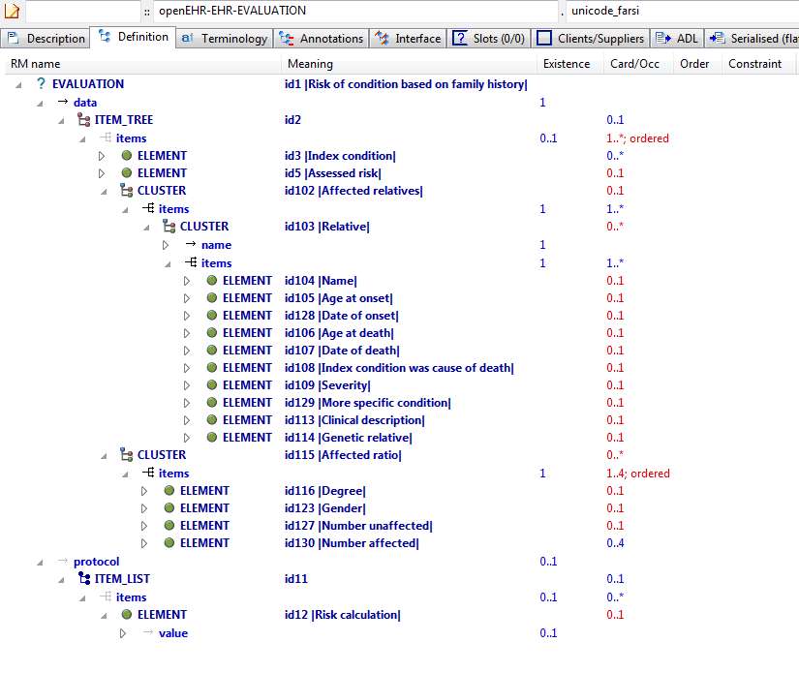

#### Unicode Farsi v1 AML Diagram

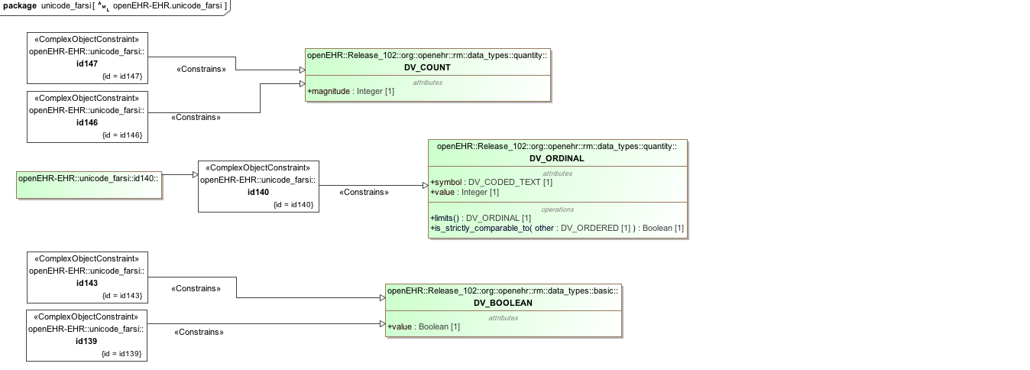

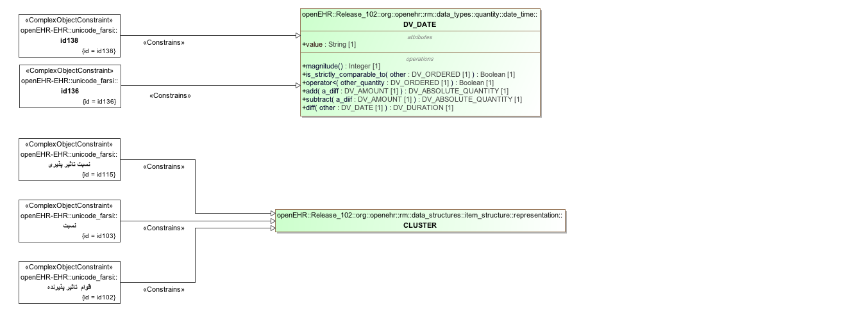

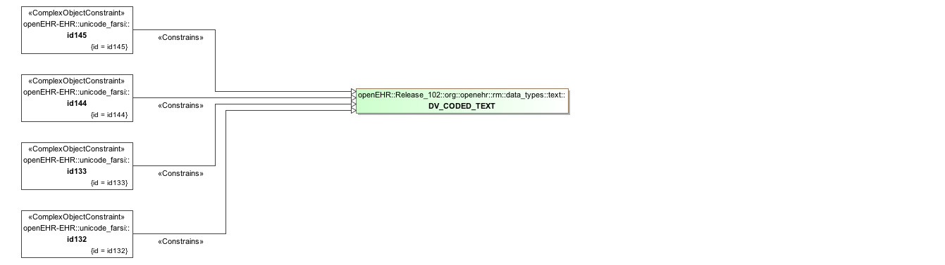

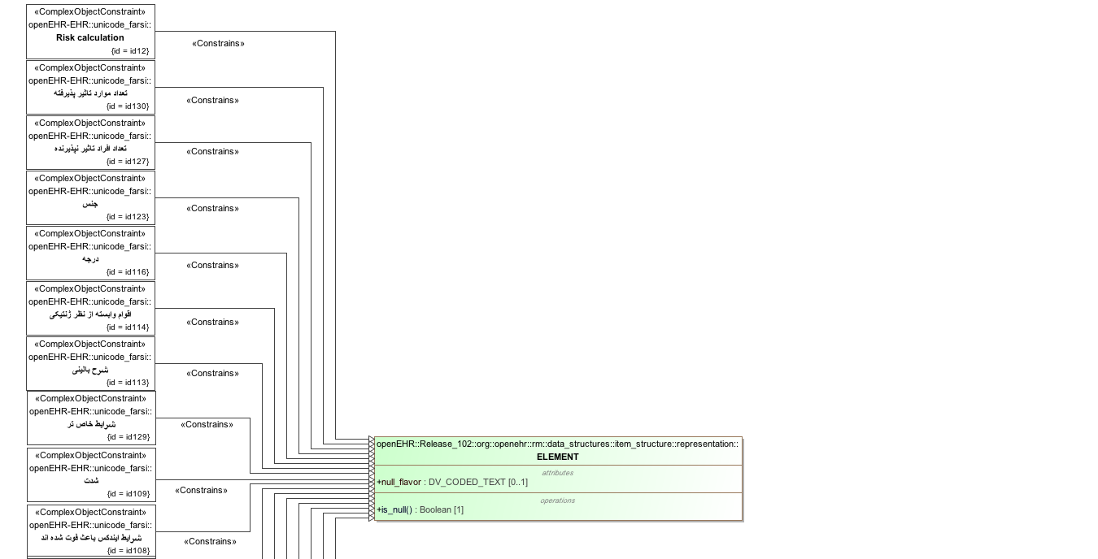

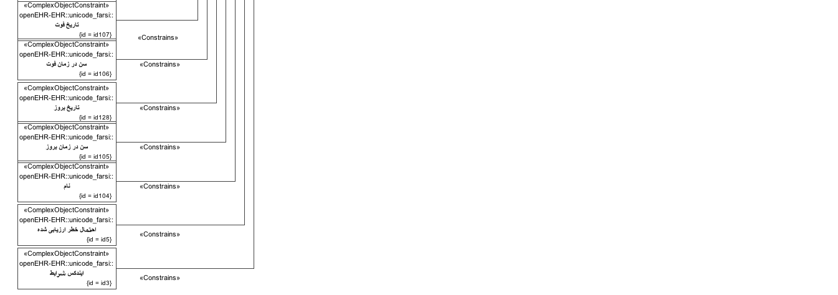

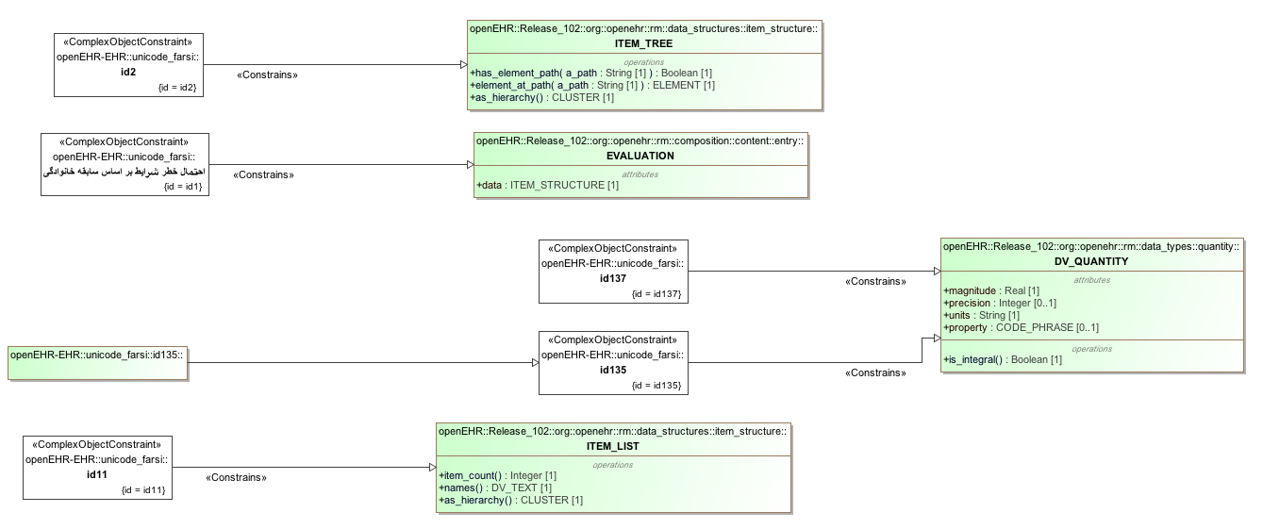

#### Unicode Farsi v1 AML Associations Diagram

### Three Languages v1 Example

a quoi ça sert

what this is for

funktsiia

#### Three Languages v1 ADL

archetype (adl_version=2.0.5; rm_release=1.0.2)

openEHR-EHR-OBSERVATION.three_languages.v1.0.0

language

original_language = <[ISO_639-1::en]>

translations = <

["fr"] = <

language = <[ISO_639-1::fr]>

author = <

["name"] = <"Frederik Tyler">

["email"] = <"freddy@something.somewhere.co.uk">

>

accreditation = <"British Medical Translator id 00400595">

>

["ru"] = <

language = <[ISO_639-1::ru]>

author = <

["name"] = <"Nina Alexandrovna">

["organisation"] = <"Dostoevsky Media Services">

["email"] = <"nina@translation.dms.ru">

>

accreditation = <"Russian Translator id 892230-3A">

>

>

description

custodian_namespace = <"org.openehr">

custodian_organisation = <"openEHR Foundation <http://www.openEHR.org>">

original_author = <

["name"] = <"Thomas Beale">

["email"] = <"thomas.beale@openEHR.org">

["organisation"] = <"openEHR Foundation <http://www.openEHR.org>">

["date"] = <"2012-10-21">

>

details = <

["fr"] = <

language = <[ISO_639-1::fr]>

purpose = <"a quoi ça sert">

use = <"ceçi explique la fonction de l'archetype">

keywords = <"ceçi", "est", "une", "liste", "de", "mots", "clés">

misuse = <"les interdictions de l'utilisation de cet archetype">

original_resource_uri = <

["ligne guide"] = <"http://guidelines.are.us/wherever/fr">

["medline"] = <"http://some%20medline%20ref">

>

>

["en"] = <

language = <[ISO_639-1::en]>

purpose = <"what this is for">

use = <"this explains the usage of the archetype">

keywords = <"this", "is", "a", "list", "of", "keywords">

misuse = <"this is not what it is used for">

original_resource_uri = <

["guideline"] = <"http://guidelines.are.us/wherever/en">

["medline"] = <"http://some%20medline%20ref">

>

>

["ru"] = <

language = <[ISO_639-1::ru]>

purpose = <"funktsiia">

use = <"v kakih sluchaiah ispol'zuetsia dannii arkhetip">

keywords = <"eto", "spisok", "kliuchevih", "slov">

misuse = <"Eto ob'iasniaet, pochemu etot arkhetip bil ispol'zovan ne po prednaznacheniiu">

original_resource_uri = <

["guideline"] = <"http://guidelines.are.us/wherever/ru">

["medline"] = <"http://some%20medline%20ref">

>

>

>

other_contributors = <"friend 1", "friend 2", "friend 3">

lifecycle_state = <"published">

other_details = <

["regression"] = <"PASS">

>

copyright = <"Copyright © 2003 openEHR Foundation <http://www.openEHR.org>">

licence = <"Creative Commons CC-BY-SA <https://creativecommons.org/licenses/by-sa/3.0/>">

definition

OBSERVATION[id1] matches { -- most minimal

data

}

terminology

term_definitions = <

["fr"] = <

["id1"] = <

text = <"le plus minimal">

description = <"le plus minimal">

>

>

["en"] = <

["id1"] = <

text = <"most minimal">

description = <"most minimal">

>

>

["ru"] = <

["id1"] = <

text = <"le plus minimal">

description = <"le plus minimal">

>

>

>

#### Three Languages v1 ADL Diagram

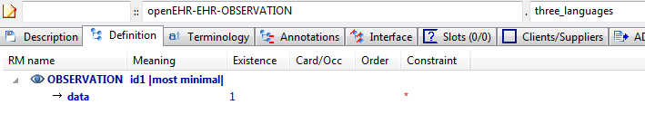

#### Three Languages v1 AML Diagram

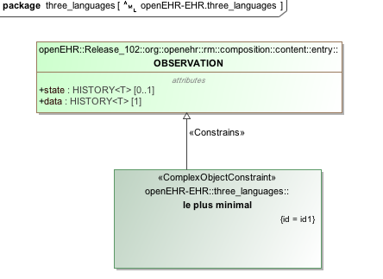

#### Three Languages v1 AML Associations Diagram

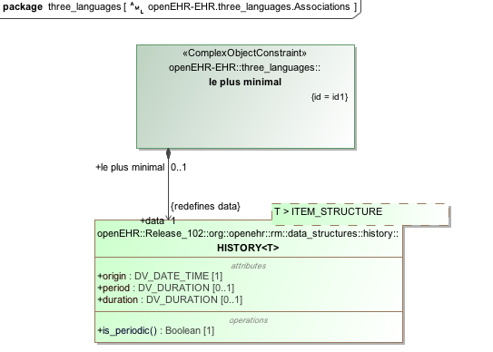

## Flattening Examples

### Lab Test Panel - Lipid Studies v1 Example

Test flattening of overlays of new elements onto cloned structures. This archetype overlays one changed element on a repeated cloning of a structure with 4 elements. The flattened result will show all clones of those structures, with each being made up of the unchanged (inherited) elements, and the overridden elements defined in this archetype.

#### Lab Test Panel - Lipid Studies v1 ADL

archetype (adl_version=2.0.5; rm_release=1.0.2)

openEHR-EHR-CLUSTER.lab_test_panel-lipid_studies.v1.0.0

specialize

openEHR-EHR-CLUSTER.lab_test_panel.v1

language

original_language = <[ISO_639-1::en]>

description

custodian_namespace = <"org.openehr">

custodian_organisation = <"openEHR Foundation <http://www.openEHR.org>">

original_author = <

["name"] = <"Ian McNicoll">

["email"] = <"ian@freshehr.com">

["organisation"] = <"freshEHR Clinical Informatics, UK">

["date"] = <"2014-04-18">

>

details = <

["en"] = <

language = <[ISO_639-1::en]>

purpose = <"Test flattening of overlays of new elements onto cloned structures. This archetype overlays one changed element on a repeated cloning of a structure with 4 elements. The flattened result will show all clones of those structures, with each being made up of the unchanged (inherited) elements, and the overridden elements defined in this archetype.">

keywords = <"ADL", "flattening", "test">

>

>

lifecycle_state = <"published">

other_details = <

["regression"] = <"PASS">

>

copyright = <"Copyright © 2014 openEHR Foundation <http://www.openEHR.org>">

licence = <"Creative Commons CC-BY-SA <https://creativecommons.org/licenses/by-sa/3.0/>">

definition

CLUSTER[id1.1] matches { -- Lipid studies panel

/items matches {

CLUSTER[id3.1] matches { -- LDL Cholesterol Result

items matches {

ELEMENT[id2.1] matches { -- LDL Cholesterol

value matches {

DV_QUANTITY[id0.1] matches {

property matches {[at0.1]}

magnitude matches {|>=0.0|}

units matches {"mmol/l"}

}

}

}

}

}

CLUSTER[id3.2] matches { -- HDL Cholesterol Result

items matches {

ELEMENT[id2.2] matches { -- HDL Cholesterol

value matches {

DV_QUANTITY[id0.2] matches {

property matches {[at0.1]}

magnitude matches {|>=0.0|}

units matches {"mmol/l"}

}

}

}

}

}

CLUSTER[id3.3] matches { -- Ratio Result

items matches {

ELEMENT[id2.3] matches { -- Ratio

value matches {

DV_QUANTITY[id0.3] matches {

property matches {[at0.1]}

magnitude matches {|>=0.0|}

units matches {"mmol/l"}

}

}

}

}

}

CLUSTER[id3.4] matches { -- Triglyceride Result

items matches {

ELEMENT[id2.4] matches { -- Triglyceride

value matches {

DV_QUANTITY[id0.4] matches {

property matches {[at0.1]}

magnitude matches {|>=0.0|}

units matches {"mosmol/l"}

}

}

}

}

}

CLUSTER[id3.5] matches { -- Total Result

items matches {

ELEMENT[id2.5] matches { -- Total cholesterol

value matches {

DV_QUANTITY[id0.5] matches {

property matches {[at0.1]}

magnitude matches {|>=0.0|}

units matches {"mosmol/l"}

}

}

}

}

}

CLUSTER[id3.6] -- ! - Laboratory Result

}

}

terminology

term_definitions = <

["en"] = <

["id1.1"] = <

text = <"Lipid studies panel">

description = <"Laboratory test results as a single value or in a panel/battery format common to clinical pathology testing.!">

>

["id2.1"] = <

text = <"LDL Cholesterol">

description = <"Actual value of the result.">

>

["id2.2"] = <

text = <"HDL Cholesterol">

description = <"Actual value of the result.">

>

["id2.3"] = <

text = <"Ratio">

description = <"Actual value of the result.">

>

["id2.4"] = <

text = <"Triglyceride">

description = <"Actual value of the result.">

>

["id2.5"] = <

text = <"Total cholesterol">

description = <"Actual value of the result.">

>

["id3.1"] = <

text = <"LDL Cholesterol Result">

description = <"Specific detailed result, including both the value of the result item, and additional information that may be useful for clinical interpretation.">

>

["id3.2"] = <

text = <"HDL Cholesterol Result">

description = <"Specific detailed result, including both the value of the result item, and additional information that may be useful for clinical interpretation.">

>

["id3.3"] = <

text = <"Ratio Result">

description = <"Specific detailed result, including both the value of the result item, and additional information that may be useful for clinical interpretation.">

>

["id3.4"] = <

text = <"Triglyceride Result">

description = <"Specific detailed result, including both the value of the result item, and additional information that may be useful for clinical interpretation.">

>

["id3.5"] = <

text = <"Total Result">

description = <"Specific detailed result, including both the value of the result item, and additional information that may be useful for clinical interpretation.">

>

["id3.6"] = <

text = <"! - Laboratory Result">

description = <"Specific detailed result, including both the value of the result item, and additional information that may be useful for clinical interpretation.">

>

["at0.1"] = <

text = <"(added by post-parse processor)">

description = <"(added by post-parse processor)">

>

>

>

#### Lab Test Panel - Lipid Studies v1 ADL Diagram

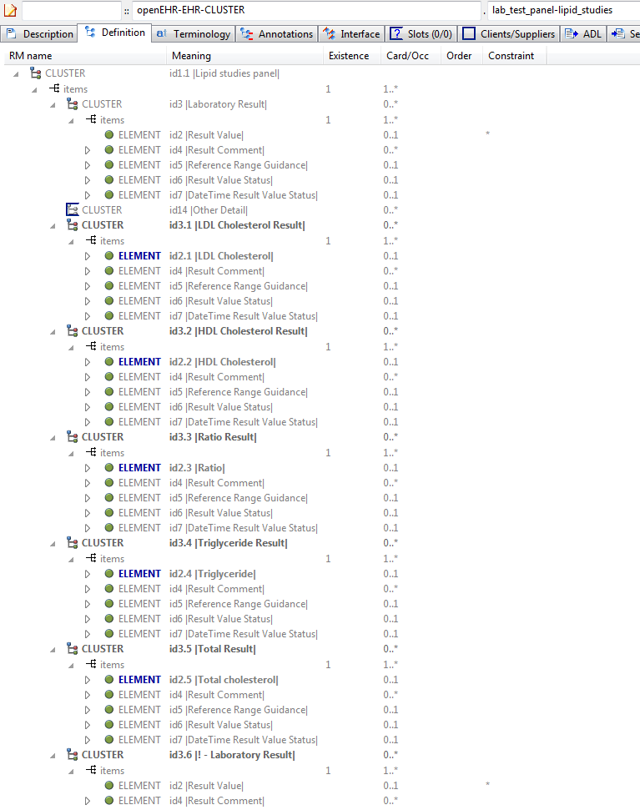

#### Lab Test Panel - Lipid Studies v1 AML Diagram

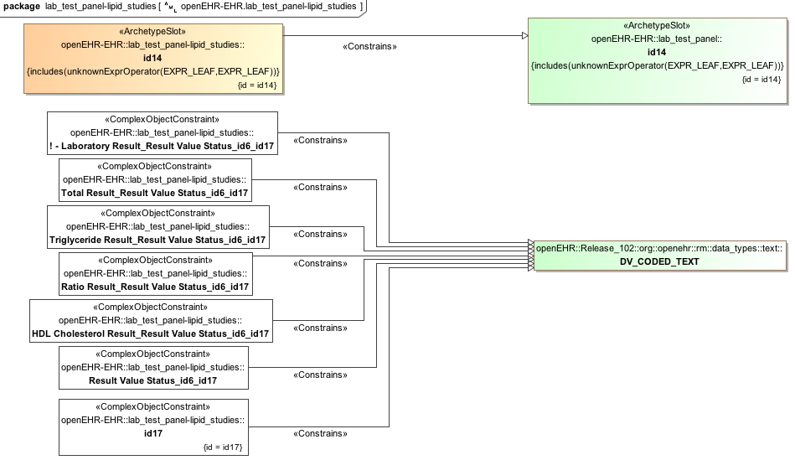

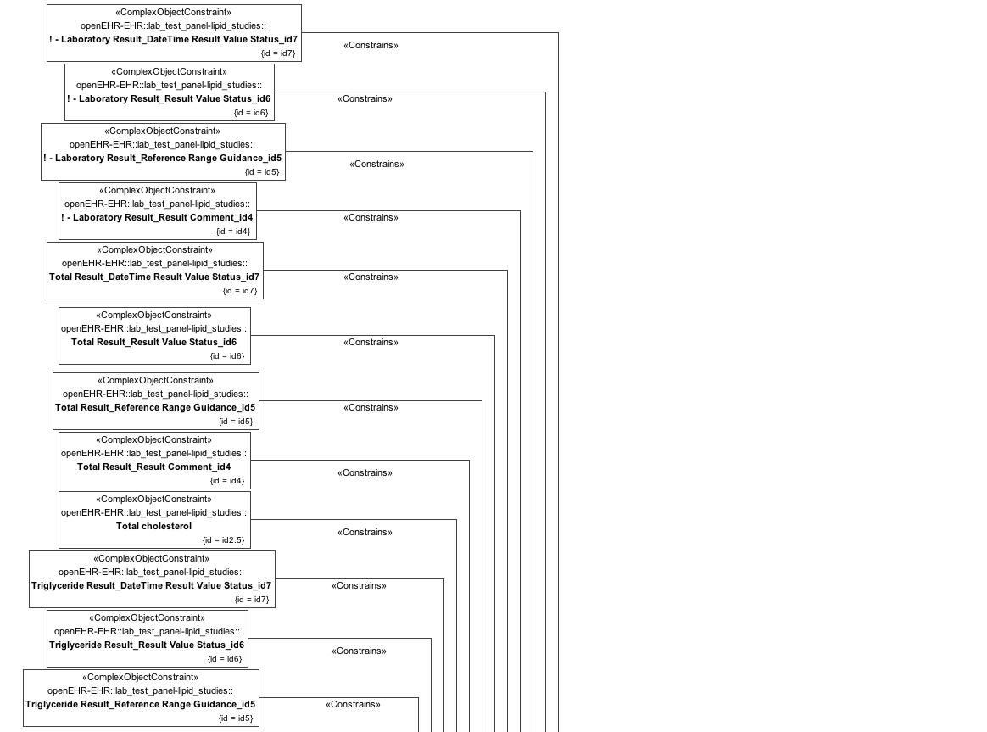

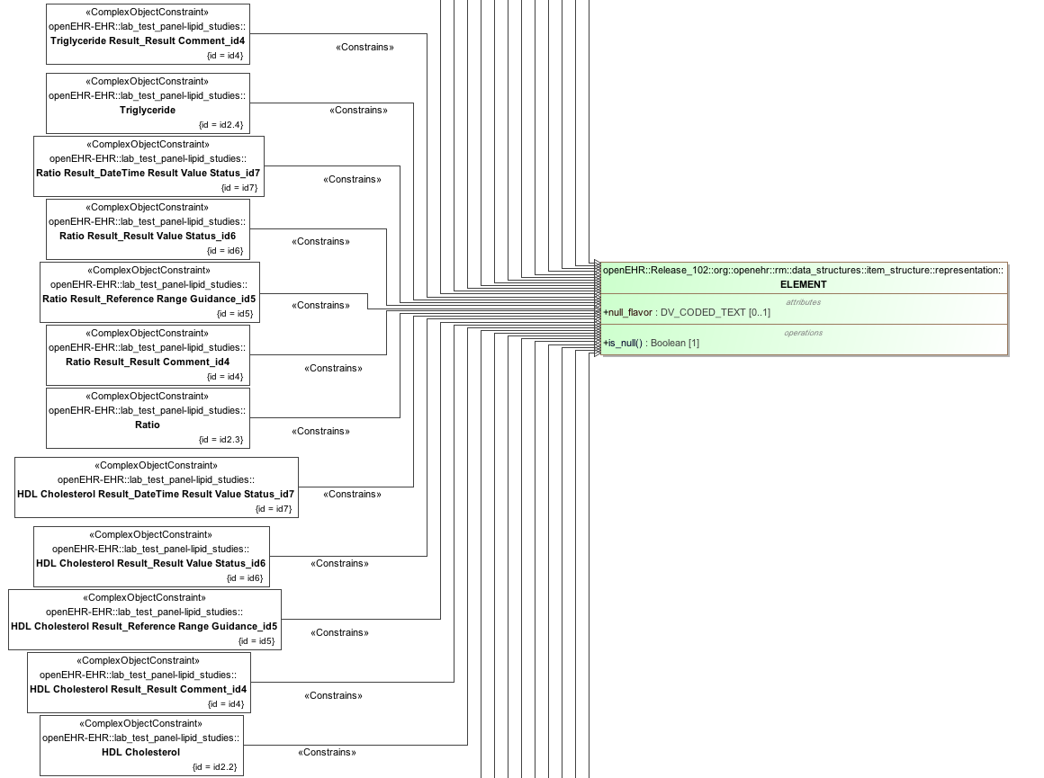

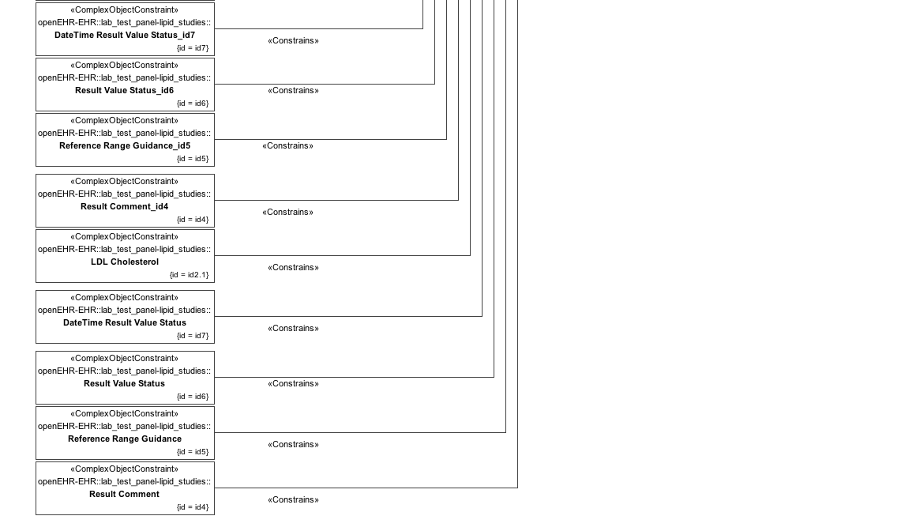

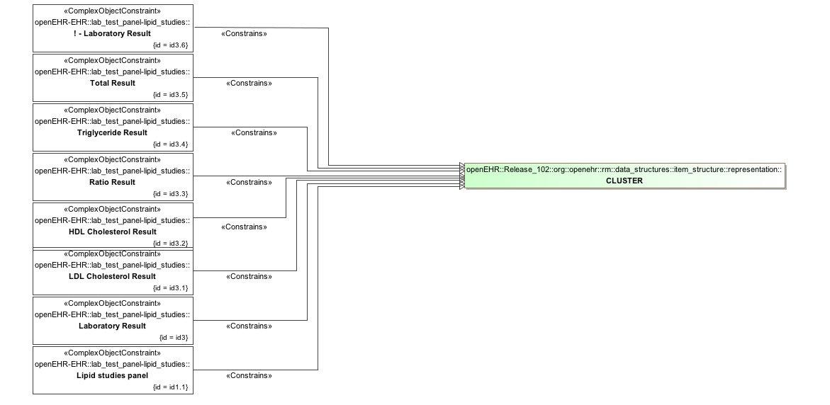

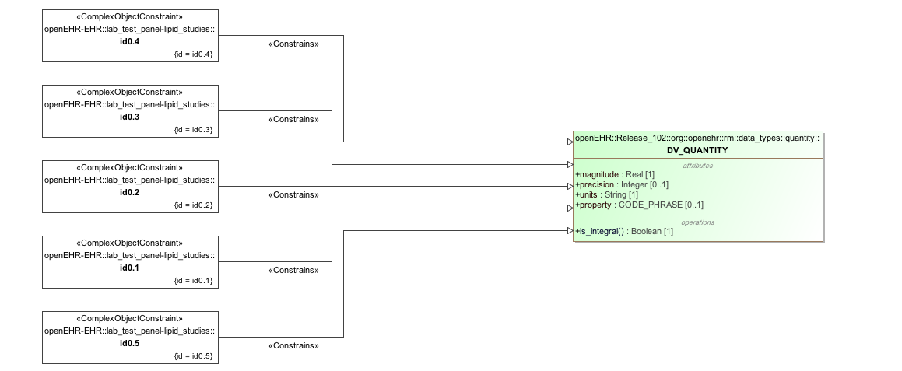

#### Lab Test Panel - Lipid Studies v1 AML Associations Diagram

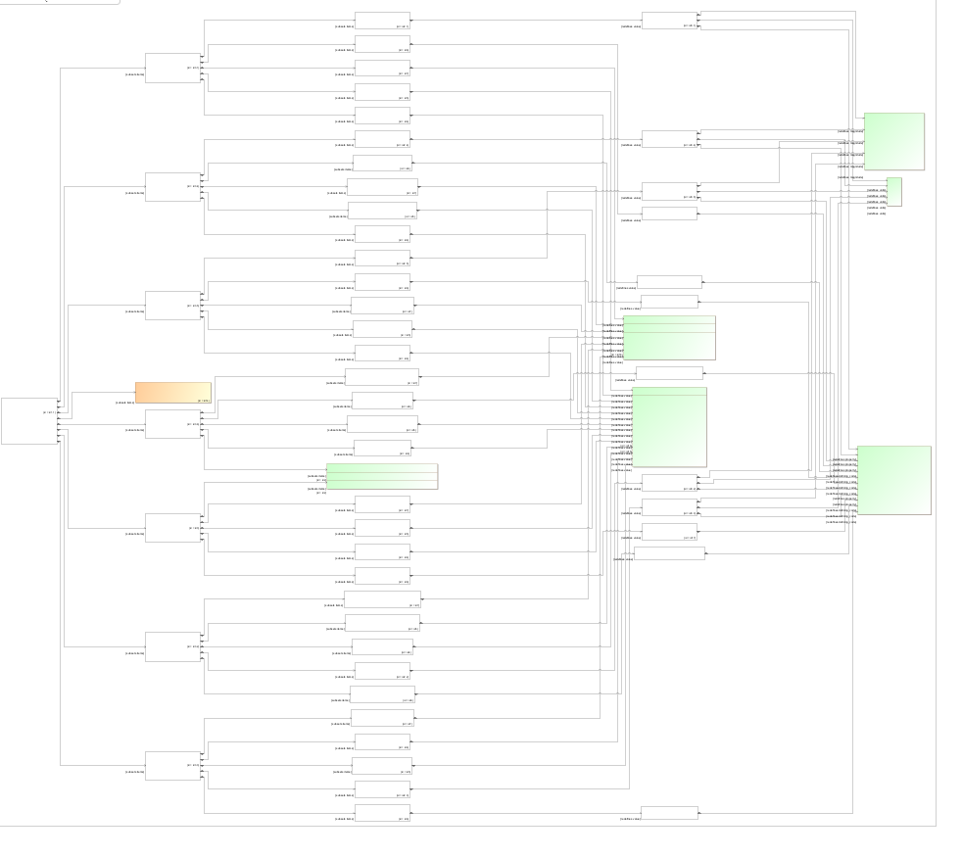

### Lab Test Panel v1 Example

Parent for flattening tests on lab-style archetypes.

#### Lab Test Panel v1 ADL

archetype (adl_version=2.0.5; rm_release=1.0.2)

openEHR-EHR-CLUSTER.lab_test_panel.v1.0.0

language

original_language = <[ISO_639-1::en]>

description

custodian_namespace = <"org.openehr">

custodian_organisation = <"openEHR Foundation <http://www.openEHR.org>">

original_author = <

["name"] = <"Ian McNicoll">

["email"] = <"ian@freshehr.com">

["organisation"] = <"freshEHR Clinical Informatics, UK">

["date"] = <"2014-04-18">

>

details = <

["en"] = <

language = <[ISO_639-1::en]>

purpose = <"Parent for flattening tests on lab-style archetypes.">

keywords = <"ADL", "flattening", "test">

>

>

lifecycle_state = <"published">

other_details = <

["regression"] = <"PASS">

>

copyright = <"Copyright © 2014 openEHR Foundation <http://www.openEHR.org>">

licence = <"Creative Commons CC-BY-SA <https://creativecommons.org/licenses/by-sa/3.0/>">

definition

CLUSTER[id1] matches { -- Laboratory test panel

items matches {

CLUSTER[id3] matches { -- Laboratory Result

items matches {

ELEMENT[id2] occurrences matches {0..1} -- Result Value

ELEMENT[id4] matches { -- Result Comment

value matches {

DV_TEXT[id15]

}

}

ELEMENT[id5] occurrences matches {0..1} matches { -- Reference Range Guidance

value matches {

DV_TEXT[id16]

}

}

ELEMENT[id6] occurrences matches {0..1} matches { -- Result Value Status

value matches {

DV_CODED_TEXT[id17] matches {

defining_code matches {[ac1]} -- Result Value Status (synthesised)

}

}

}

ELEMENT[id7] occurrences matches {0..1} matches { -- DateTime Result Value Status

value matches {

DV_DATE_TIME[id18]

}

}

}

}

allow_archetype CLUSTER[id14] matches { -- Other Detail

include

archetype_id/value matches {/.*/}

}

}

}

terminology

term_definitions = <

["en"] = <

["id1"] = <

text = <"Laboratory test panel">

description = <"Laboratory test results as a single value or in a panel/battery format common to clinical pathology testing.">

>

["id2"] = <

text = <"Result Value">

description = <"Actual value of the result.">

>

["id3"] = <

text = <"Laboratory Result">

description = <"Specific detailed result, including both the value of the result item, and additional information that may be useful for clinical interpretation.">

>

["id4"] = <

text = <"Result Comment">

description = <"Comment about the Result.">

>

["id5"] = <

text = <"Reference Range Guidance">

description = <"Additional advice on the applicability of the reference range.">

>

["id6"] = <

text = <"Result Value Status">

description = <"The status of the result value.">

>

["id7"] = <

text = <"DateTime Result Value Status">

description = <"The date and/or time that the entire result was issued for the recorded ‘Result value status’.">

>

["at8"] = <

text = <"Registered">

description = <"No result yet available.">

>

["at9"] = <

text = <"Interim">

description = <"This is an initial or interim result: data may be missing or verification not been performed.">

>

["at10"] = <

text = <"Final">

description = <"The result is complete and verified by the responsible pathologist.">

>

["at11"] = <

text = <"Amended">

description = <"The result has been modified subsequent to being Final, and is complete and verified by the responsible pathologist.">

>

["at12"] = <

text = <"Cancelled/Aborted">

description = <"The result is unavailable because the test was not started or not completed.">

>

["at13"] = <

text = <"Not requested">

description = <"The result is not available as the test was not requested.">

>

["id14"] = <

text = <"Other Detail">

description = <"Further details including the specimen for the panel or a further nested panel.">

>

["ac1"] = <

text = <"Result Value Status (synthesised)">

description = <"The status of the result value. (synthesised)">

>

>

>

value_sets = <

["ac1"] = <

id = <"ac1">

members = <"at8", "at9", "at10", "at11", "at12", "at13">

>

>

#### Lab Test Panel v1 ADL Diagram

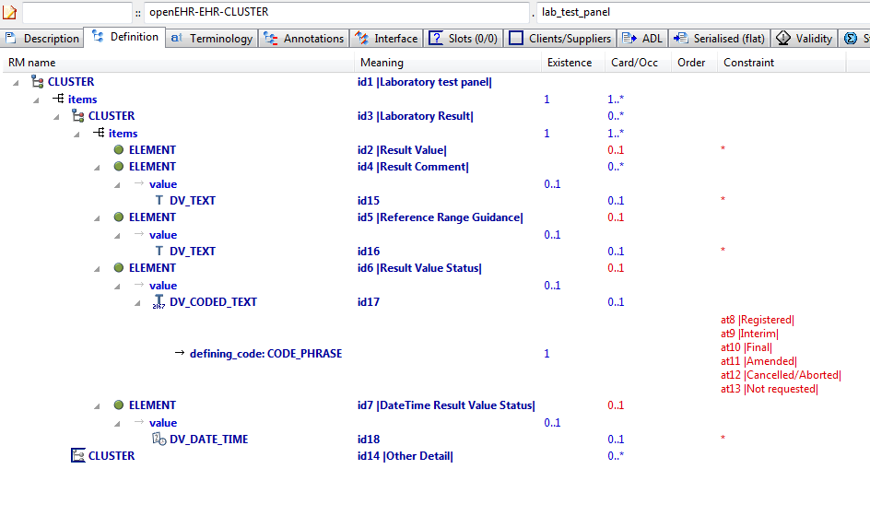

#### Lab Test Panel v1 AML Diagram

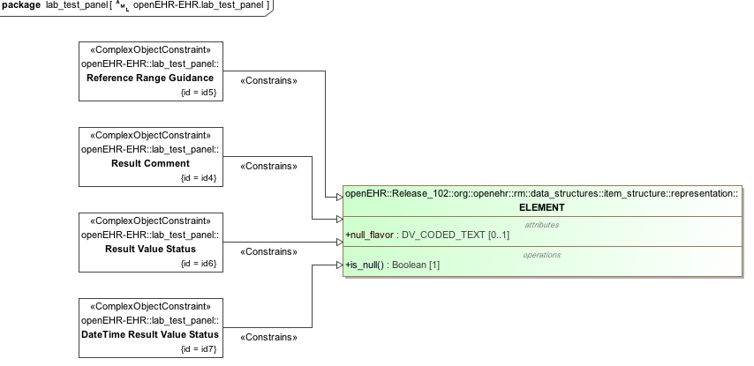

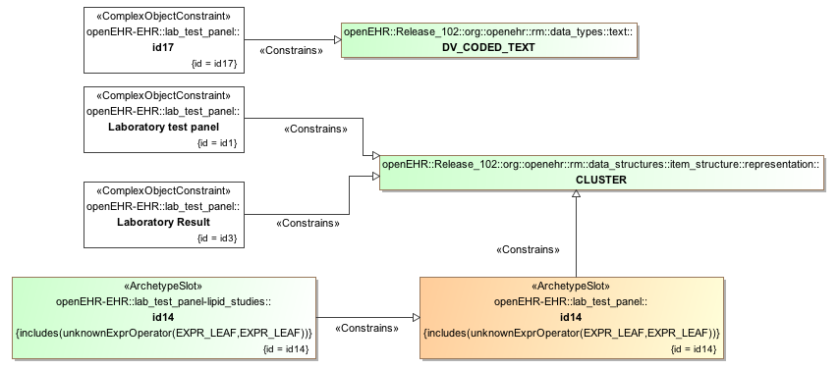

#### Lab Test Panel v1 AML Associations Diagram

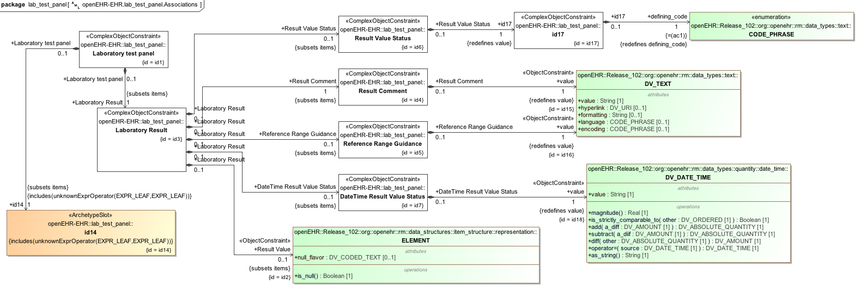

### Request - Pathology Test v1 Example

Test flattening when child archetype contains a differential path that contains an overridden id code midway through (id122.1).

#### Request - Pathology Test v1 ADL

archetype (adl_version=2.0.5; rm_release=1.0.2)

openEHR-EHR-INSTRUCTION.request-pathology_test.v1.0.0

specialize

openEHR-EHR-INSTRUCTION.request.v1

language

original_language = <[ISO_639-1::en]>

description

custodian_namespace = <"org.openehr">

custodian_organisation = <"openEHR Foundation <http://www.openEHR.org>">

original_author = <

["name"] = <"Dr Ian McNicoll">

["email"] = <"ian.mcnicoll@oceaninformatics.com">

["organisation"] = <"Ocean Informatics UK <http://www.oceaninformatics.com>">

["date"] = <"2009-08-12">

>

details = <

["en"] = <

language = <[ISO_639-1::en]>

purpose = <"Test flattening when child archetype contains a differential path that contains an overridden id code midway through (id122.1).">

>

>

lifecycle_state = <"published">

other_details = <

["regression"] = <"PASS">

>

copyright = <"Copyright © 2009 openEHR Foundation <http://www.openEHR.org>">

licence = <"Creative Commons CC-BY-SA <https://creativecommons.org/licenses/by-sa/3.0/>">

definition

INSTRUCTION[id1.1] matches { -- PathologyTest Request

/activities[id2]/description[id10]/items[id122.1]/name matches {

DV_TEXT[id0.146]

}

/activities[id2]/description[id10]/items[id136.1]/name matches {

DV_TEXT[id0.147]

}

}

terminology

term_definitions = <

["en"] = <

["id1.1"] = <

text = <"PathologyTest Request">

description = <"Generic request for a pathology request.">

>

["id122.1"] = <

text = <"Pathology Test Requested">

description = <"Identification of the pathology test requested. This is often coded with an external terminology.">

>

["id136.1"] = <

text = <"Description of Test">

description = <"A detailed narrative description of the pathology test requested.">

>

>

>

#### Request - Pathology Test v1 ADL Diagram

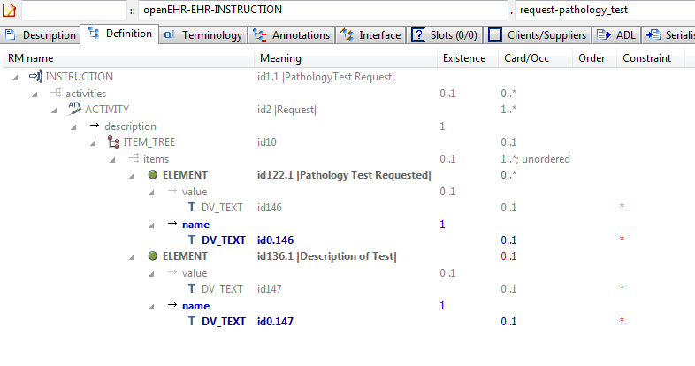

#### Request - Pathology Test v1 AML Diagram

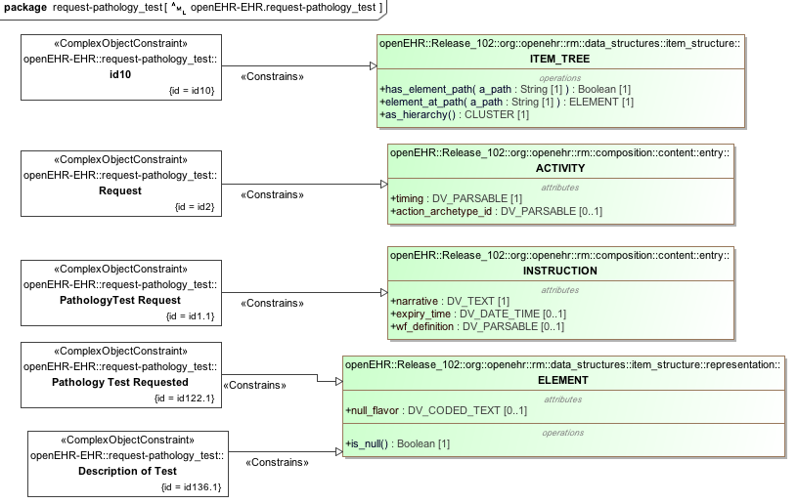

#### Request - Pathology Test v1 AML Associations Diagram

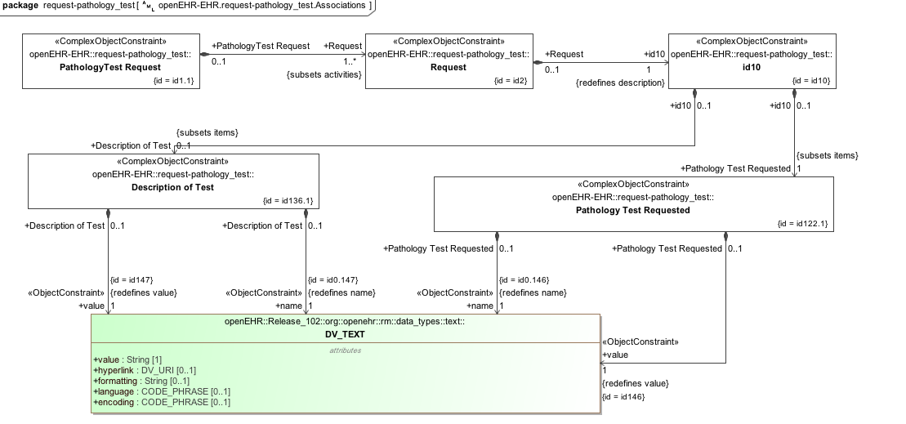

### Request v1 Example

Parent archetype for archetypes testing flattening when child archetype contains a differential path with an overridden id code.

#### Request v1 ADL

archetype (adl_version=2.0.5; rm_release=1.0.2)

openEHR-EHR-INSTRUCTION.request.v1.0.0

language

original_language = <[ISO_639-1::en]>

description

custodian_namespace = <"org.openehr">

custodian_organisation = <"openEHR Foundation <http://www.openEHR.org>">

original_author = <

["name"] = <"Dr Ian McNicoll">

["email"] = <"ian.mcnicoll@oceaninformatics.com">

["organisation"] = <"Ocean Informatics UK <http://www.oceaninformatics.com>">

["date"] = <"2009-08-12">

>

details = <

["en"] = <

language = <[ISO_639-1::en]>

purpose = <"Parent archetype for archetypes testing flattening when child archetype contains a differential path with an overridden id code.">

keywords = <"ADL", "flattening", "test">

>

>

lifecycle_state = <"published">

other_details = <

["regression"] = <"PASS">

>

copyright = <"Copyright © 2009 openEHR Foundation <http://www.openEHR.org>">

licence = <"Creative Commons CC-BY-SA <https://creativecommons.org/licenses/by-sa/3.0/>">

definition

INSTRUCTION[id1] matches { -- Healthcare service request

activities matches {

ACTIVITY[id2] occurrences matches {1..*} matches { -- Request

description matches {

ITEM_TREE[id10] matches {

items cardinality matches {1..*; unordered} matches {

ELEMENT[id122] matches { -- Service requested

value matches {

DV_TEXT[id146]

}

}

ELEMENT[id136] occurrences matches {0..1} matches { -- Description of service

value matches {

DV_TEXT[id147]

}

}

}

}

}

}

}

}

terminology

term_definitions = <

["en"] = <

["id1"] = <

text = <"Healthcare service request">

description = <"Request for a range of different healthcare services, for example, a referral, lab request, equipment request.">

>

["id2"] = <

text = <"Request">

description = <"Current Activity.">

>

["id122"] = <

text = <"Service requested">

description = <"Identification of the service requested. This is often coded with an external terminology.">

>

["id136"] = <

text = <"Description of service">

description = <"A detailed narrative description of the service requested.">

>

>

>

#### Request v1 ADL Diagram

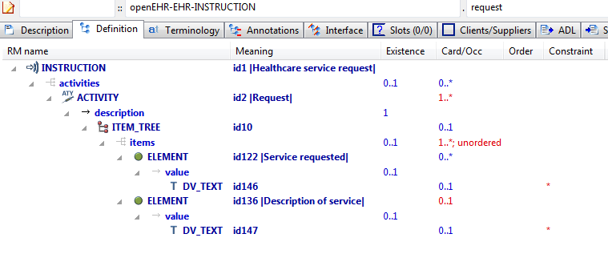

#### Request v1 AML Diagram

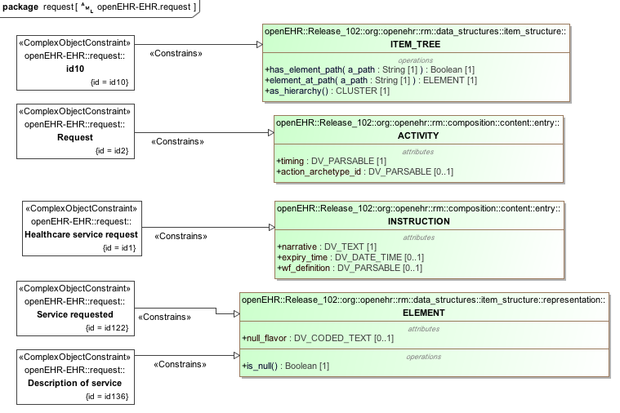

#### Request v1 AML Associations Diagram

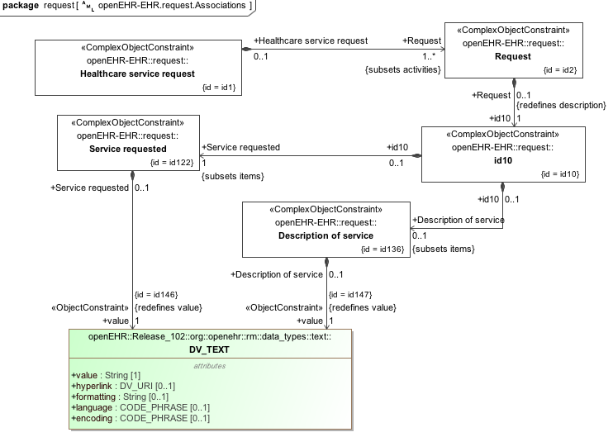

### Flat Test Parent 1 - Add Node Use Node v1 Example

Test flattening of differential path containing terminal attribute not in parent ('state'); test internal references to path in flat parent and path in current archetype.

#### Flat Test Parent 1 - Add Node Use Node v1 ADL

archetype (adl_version=2.0.5; rm_release=1.0.2)

openEHR-EHR-OBSERVATION.flat_test_parent_1-add_node_use_node.v1.0.0

specialize

openEHR-EHR-OBSERVATION.flat_test_parent_1.v1

language

original_language = <[ISO_639-1::en]>

description

custodian_namespace = <"org.openehr">

custodian_organisation = <"openEHR Foundation <http://www.openEHR.org>">

original_author = <

["name"] = <"Ian McNicoll">

["organisation"] = <"Ocean Informatics UK <http://www.oceaninformatics.com>">

["email"] = <"ian.mcnicoll@oceaninformatics.com">

["date"] = <"2009-11-07">

>

details = <

["en"] = <

language = <[ISO_639-1::en]>

purpose = <"Test flattening of differential path containing terminal attribute not in parent ('state'); test internal references to path in flat parent and path in current archetype.">

keywords = <"ADL", "flattening", "test">

>

>

lifecycle_state = <"unmanaged">

other_details = <

["regression"] = <"PASS">

>

copyright = <"Copyright © 2009 openEHR Foundation <http://www.openEHR.org>">

licence = <"Creative Commons CC-BY-SA <https://creativecommons.org/licenses/by-sa/3.0/>">

definition

OBSERVATION[id1.1] matches { -- Blood Glucose Test Result

/data[id2]/events[id3]/state matches {

ITEM_TREE[id0.8] matches {

items matches {

ELEMENT[id0.9] occurrences matches {0..1} matches { -- Fasting state

value matches {

DV_BOOLEAN[id0.17] matches {

value matches {True}

}

}

}

}

}

}

/data[id2]/events matches {

POINT_EVENT[id0.2] occurrences matches {0..1} matches { -- Baseline Measurement

offset matches {

DV_DURATION[id0.21] matches {

value matches {PT0S}

}

}

data matches {

use_node ITEM_TREE[id0.22] /data[id2]/events[id3]/data[id4] -- /data[id2]/events[id3]/data[id4]

}

state matches {

use_node ITEM_TREE[id0.23] /data[id2]/events[id3]/state[id0.8] -- /data[id2]/events[id3]/state[id0.8]

}

}

}

}

terminology

term_definitions = <

["en"] = <

["id0.2"] = <

text = <"Baseline Measurement">

description = <"Specific point in time measurement which provides a reference glucose reading against which subsequent measurements can be compared.">

>

["id0.3"] = <

text = <"1 Hour Measurement">

description = <"Specific point in time measurement taken 1 hour after the Baseline Measurement and subsequent glucose/insulin challenge.">

>

["id0.5"] = <

text = <"2 Hour Measurement">

description = <"Specific point in time measurement taken 2 hours after the Baseline Measurement and subsequent glucose/insulin challenge.">

>

["id0.9"] = <

text = <"Fasting state">

description = <"Fasting state">

>

["id1.1"] = <

text = <"Blood Glucose Test Result">

description = <"The findings and interpretation of glucose tests performed on plasma, serum or whole blood.">

>

>

>

#### Flat Test Parent 1 - Add Node Use Node v1 ADL Diagram

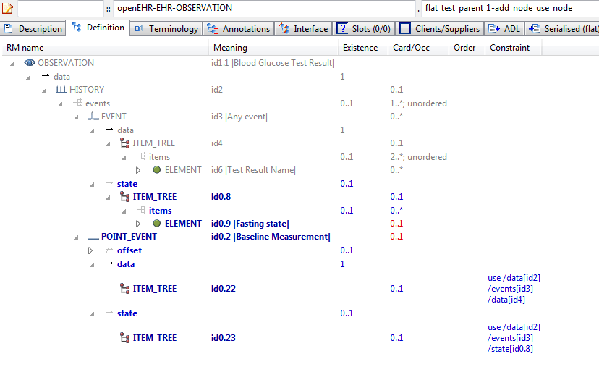

#### Flat Test Parent 1 - Add Node Use Node v1 AML Diagram

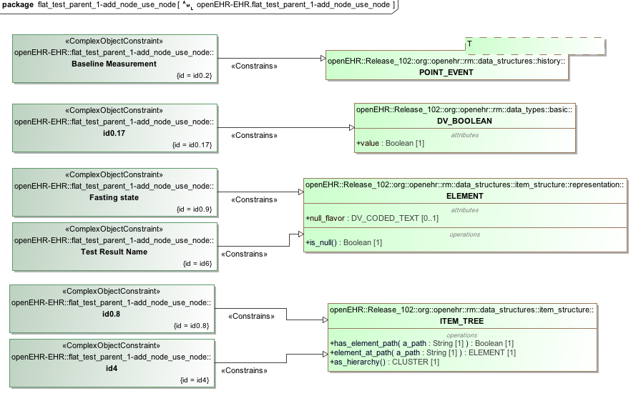

#### Flat Test Parent 1 - Add Node Use Node v1 AML Associations Diagram

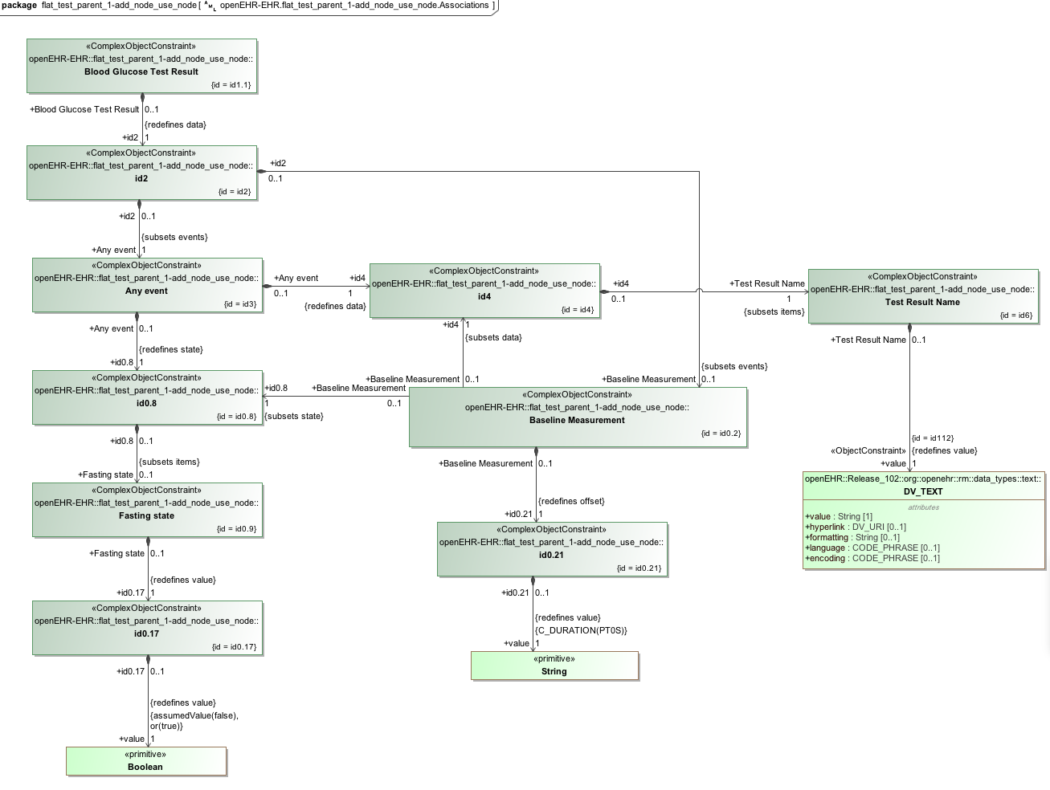

### Flat Test Parent 1 v1 Example

Parent of archetypes for flattening tests

#### Flat Test Parent 1 v1 ADL

archetype (adl_version=2.0.5; rm_release=1.0.2)

openEHR-EHR-OBSERVATION.flat_test_parent_1.v1.0.0

language

original_language = <[ISO_639-1::en]>

description

custodian_namespace = <"org.openehr">

custodian_organisation = <"openEHR Foundation <http://www.openEHR.org>">

original_author = <

["name"] = <"Ian McNicoll">

["email"] = <"ian.mcnicoll@oceaninformatics.com">

["organisation"] = <"Ocean Informatics UK <http://www.oceaninformatics.com>">

["date"] = <"2009-11-07">

>

details = <

["en"] = <

language = <[ISO_639-1::en]>

purpose = <"Parent of archetypes for flattening tests">

keywords = <"ADL", "flattening", "test">

>

>

lifecycle_state = <"published">

other_details = <

["regression"] = <"PASS">

>

copyright = <"Copyright © 2009 openEHR Foundation <http://www.openEHR.org>">

licence = <"Creative Commons CC-BY-SA <https://creativecommons.org/licenses/by-sa/3.0/>">

definition

OBSERVATION[id1] matches { -- Pathology Test Result

data matches {

HISTORY[id2] matches {

events cardinality matches {1..*; unordered} matches {

EVENT[id3] matches { -- Any event

data matches {

ITEM_TREE[id4] matches {

items cardinality matches {2..*; unordered} matches {

ELEMENT[id6] matches { -- Test Result Name

value matches {

DV_TEXT[id112]

}

}

}

}

}

}

}

}

}

}

terminology

term_definitions = <

["en"] = <

["id1"] = <

text = <"Pathology Test Result">

description = <"The findings and interpretation of pathology tests performed on patient-related specimens.">

>

["id3"] = <

text = <"Any event">

description = <"Any event.">

>

["id6"] = <

text = <"Test Result Name">

description = <"Identification of the pathology test performed, sometimes including specimen type and patient state.">

>

>

>

#### Flat Test Parent 1 v1 ADL Diagram

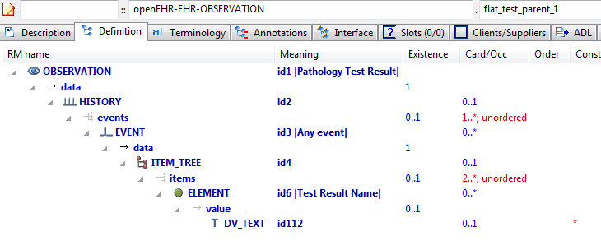

#### Flat Test Parent 1 v1 AML Diagram

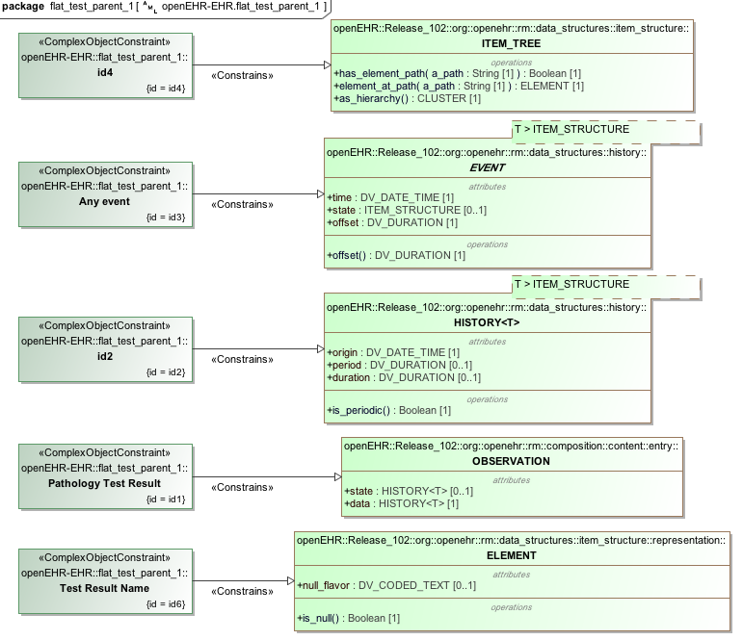

#### Flat Test Parent 1 v1 AML Associations Diagram

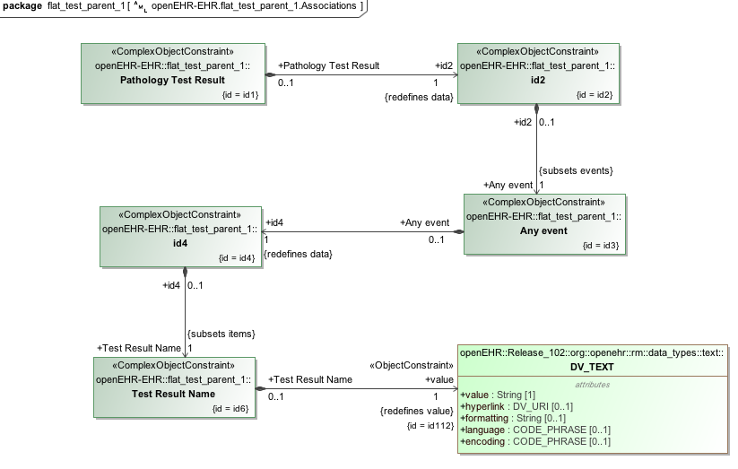

### Flattening Parent 1 v1 Example

Overwrite parent 'matches-any' node (id13) with 2 child nodes.

#### Flattening Parent 1 v1 ADL

archetype (adl_version=2.0.5; rm_release=1.0.2)

openEHR-EHR-OBSERVATION.flattening_parent_1.v1.0.0

language

original_language = <[ISO_639-1::en]>

description

custodian_namespace = <"org.openehr">

custodian_organisation = <"openEHR Foundation <http://www.openEHR.org>">

original_author = <

["name"] = <"Thomas Beale">

["email"] = <"thomas.beale@openEHR.org">

["organisation"] = <"openEHR Foundation <http://www.openEHR.org>">

["date"] = <"2009-05-06">

>

details = <

["en"] = <

language = <[ISO_639-1::en]>

purpose = <"Overwrite parent 'matches-any' node (id13) with 2 child nodes.">

keywords = <"ADL", "flattening", "test">

>

>

lifecycle_state = <"published">

other_details = <

["regression"] = <"PASS">

>

copyright = <"Copyright © 2009 openEHR Foundation <http://www.openEHR.org>">

licence = <"Creative Commons CC-BY-SA <https://creativecommons.org/licenses/by-sa/3.0/>">

definition

OBSERVATION[id1] matches { -- Substance Use

data matches {

HISTORY[id2] matches {

events cardinality matches {1..*; unordered} matches {

EVENT[id3] occurrences matches {0..1} matches { -- Any event

data matches {

ITEM_TREE[id4] matches {

items matches {

ELEMENT[id5] occurrences matches {0..1} matches { -- Substance

value matches {

DV_TEXT[id20]

}

}

CLUSTER[id11] occurrences matches {0..1} matches { -- Consumption details

items matches {

ELEMENT[id12] occurrences matches {0..1} matches { -- Form

value matches {

DV_TEXT[id21]

}

}

ELEMENT[id19] occurrences matches {0..1} matches { -- Method of use

value matches {

DV_TEXT[id22]

}

}

ELEMENT[id6] occurrences matches {0..1} matches { -- Frequency

value matches {

DV_CODED_TEXT[id23] matches {

defining_code matches {[ac1]} -- Frequency

}

}

}

ELEMENT[id13] occurrences matches {0..*} -- Amount

}

}

ELEMENT[id14] occurrences matches {0..1} matches { -- Triggers

value matches {

DV_TEXT[id24]

}

}

allow_archetype CLUSTER[id15] occurrences matches {0..*} matches { -- Readiness for change

include

archetype_id/value matches {/openEHR-EHR-CLUSTER\.change\.v1/}

}

ELEMENT[id17] occurrences matches {0..1} matches { -- Evidence of dependence

value matches {

DV_TEXT[id25]

}

}

}

}

}

}

}

}

}

}

terminology

term_definitions = <

["en"] = <

["id1"] = <

text = <"Substance Use">

description = <"Generic archetype to record the actual use or consumption of a defined substance at the present time, a specific time or over a period of time. ">

>

["id3"] = <

text = <"Any event">

description = <"Any event">

>

["id5"] = <

text = <"Substance">

description = <"Identification of substance ">

>

["id6"] = <

text = <"Frequency">

description = <"Frequency of use of substance">

>

["at7"] = <

text = <"Daily use">

description = <"Used every day">

>

["at8"] = <

text = <"Weekly use">

description = <"Used at least weekly">

>

["at9"] = <

text = <"Irregular use">

description = <"Used irregularly">

>

["at10"] = <

text = <"No use">

description = <"Not used at all">

>

["id11"] = <

text = <"Consumption details">

description = <"Details about the consumption of the substance">

>

["id12"] = <

text = <"Form">

description = <"Form of the substance used">

>

["id13"] = <

text = <"Amount">

description = <"Amount of substance consumed. Data type can be further specified in specialised archetypes or in templates">

>

["id14"] = <

text = <"Triggers">

description = <"Identified triggers which stimulate or cause use">

>

["id15"] = <

text = <"Readiness for change">

description = <"Details about the readiness to change use or consumption of substance">

>

["id17"] = <

text = <"Evidence of dependence">

description = <"Description of any evidence of dependence on the substance">

>

["id19"] = <

text = <"Method of use">

description = <"Method of use or consumption of the substance">

>

["ac1"] = <

text = <"Frequency">

description = <"Frequency of use of substance">

>

>

>

value_sets = <

["ac1"] = <

id = <"ac1">

members = <"at7", "at8", "at9", "at10">

>

>

#### Flattening Parent 1 v1 ADL Diagram

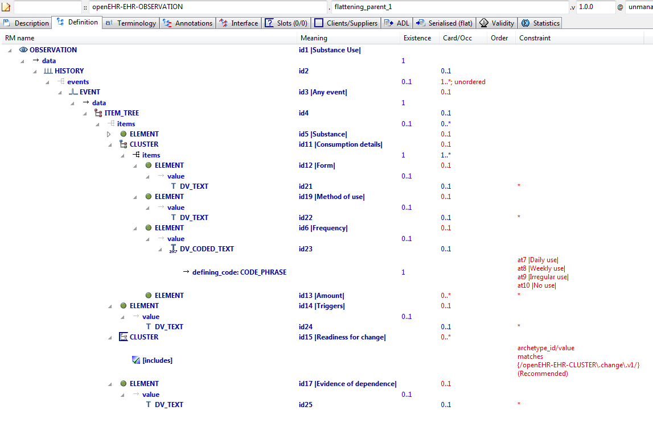

#### Flattening Parent 1 v1 AML Diagram

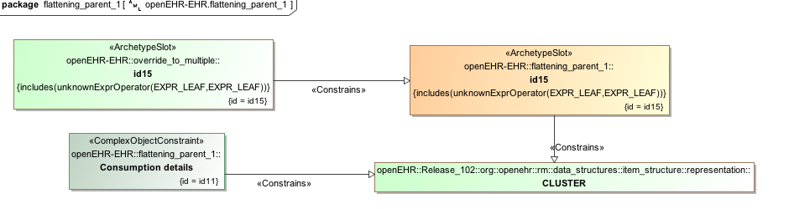

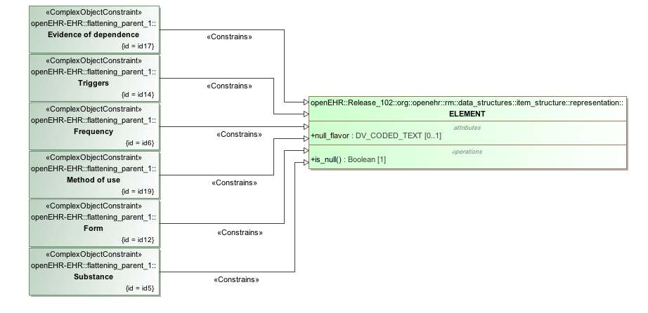

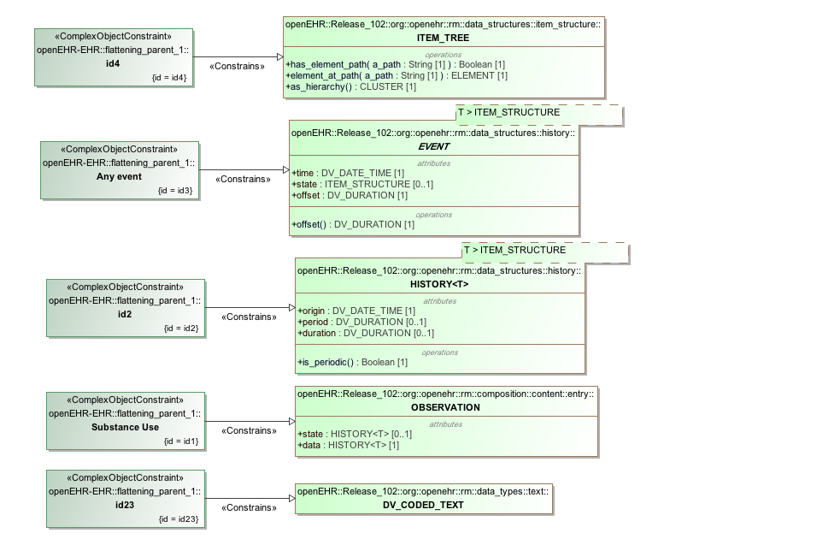

#### Flattening Parent 1 v1 AML Associations Diagram

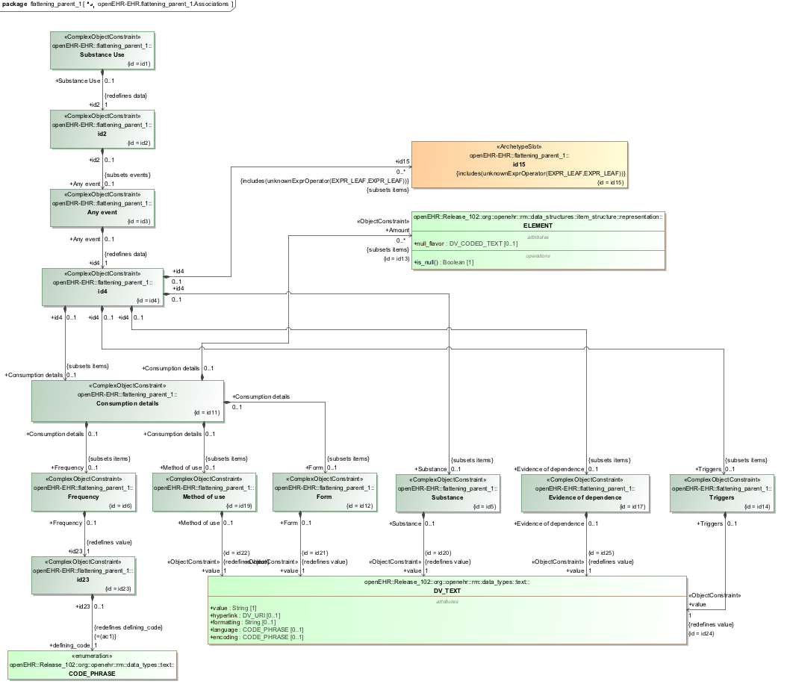

### Override To Multiple v1 Example

Parent of flattening example archetypes.

#### Override To Multiple v1 ADL

archetype (adl_version=2.0.5; rm_release=1.0.2)

openEHR-EHR-OBSERVATION.override_to_multiple.v1.0.0

specialize

openEHR-EHR-OBSERVATION.flattening_parent_1.v1

language

original_language = <[ISO_639-1::en]>

description

custodian_namespace = <"org.openehr">

custodian_organisation = <"openEHR Foundation <http://www.openEHR.org>">

original_author = <

["name"] = <"Thomas Beale">

["organisation"] = <"openEHR Foundation <http://www.openEHR.org>">

["email"] = <"thomas.beale@openEHR.org">

["date"] = <"2009-05-06">

>

details = <

["en"] = <

language = <[ISO_639-1::en]>

purpose = <"Parent of flattening example archetypes.">

keywords = <"ADL", "flattening", "test">

>

>

lifecycle_state = <"published">

other_details = <

["regression"] = <"PASS">

>

copyright = <"Copyright © 2009 openEHR Foundation <http://www.openEHR.org>">

licence = <"Creative Commons CC-BY-SA <https://creativecommons.org/licenses/by-sa/3.0/>">

definition

OBSERVATION[id1.1] matches { -- Tobacco Use

/data[id2]/events[id3]/data[id4]/items[id5]/value matches {

DV_CODED_TEXT[id20.1] matches {

defining_code matches {[at0.2]}

}

}

/data[id2]/events[id3]/data[id4]/items[id11]/items[id12]/value matches {

DV_CODED_TEXT[id21.1] matches {

defining_code matches {[ac0.1]} -- (added by post-parse processor)

}

}

/data[id2]/events[id3]/data[id4]/items[id11]/items matches {

ELEMENT[id13.1] matches { -- Number smoked

value matches {

DV_QUANTITY[id0.5] matches {

property matches {[at0.7]}

units matches {"/h", "/d", "/wk"}

}

}

}

ELEMENT[id13.2] matches { -- Grams of tobacco

value matches {

DV_QUANTITY[id0.6] matches {

property matches {[at0.8]}

units matches {"gm/d", "gm/wk"}

}

}

}

}

}

terminology

term_definitions = <

["en"] = <

["at0.2"] = <

text = <"Tobacco">

description = <"Tobacco used">

>

["at0.3"] = <

text = <"Cigarettes - manufactured">

description = <"Commercial, manufactured cigarettes">

>

["at0.4"] = <

text = <"Cigarettes - roll-your-own">

description = <"Home-made, roll-your-own cigarettes">

>

["at0.5"] = <

text = <"Cigars">

description = <"Commercial cigars">

>

["at0.6"] = <

text = <"Pipe">

description = <"Tobacco smoked within a pipe">

>

["id1.1"] = <

text = <"Tobacco Use">

description = <"Archetype to record the actual use or consumption of a tobacco at the present time, a specific time or over a period of time. ">

>

["id13.1"] = <

text = <"Number smoked">

description = <"Number of units containing tobacco consumed eg cigarettes or cigars">

>

["id13.2"] = <

text = <"Grams of tobacco">

description = <"Weight of tobacco consumed eg in a pipe">

>

["ac0.1"] = <

text = <"(added by post-parse processor)">

description = <"(added by post-parse processor)">

>

["ac0.2"] = <

text = <"(added by post-parse processor)">

description = <"(added by post-parse processor)">

>

["at0.7"] = <

text = <"Frequency">

description = <"Frequency">

>

["at0.8"] = <

text = <"Flow rate, mass">

description = <"Flow rate, mass">

>

>

>

term_bindings = <

["openehr"] = <

["at0.7"] = <http://openehr.org/id/382>

["at0.8"] = <http://openehr.org/id/347>

>

>

value_sets = <

["ac0.1"] = <

id = <"ac0.1">

members = <"at0.3", "at0.4", "at0.5", "at0.6">

>

["ac0.2"] = <

id = <"ac0.2">

members = <"at7", "at8", "at9", "at10">

>

>

#### Override To Multiple v1 ADL Diagram

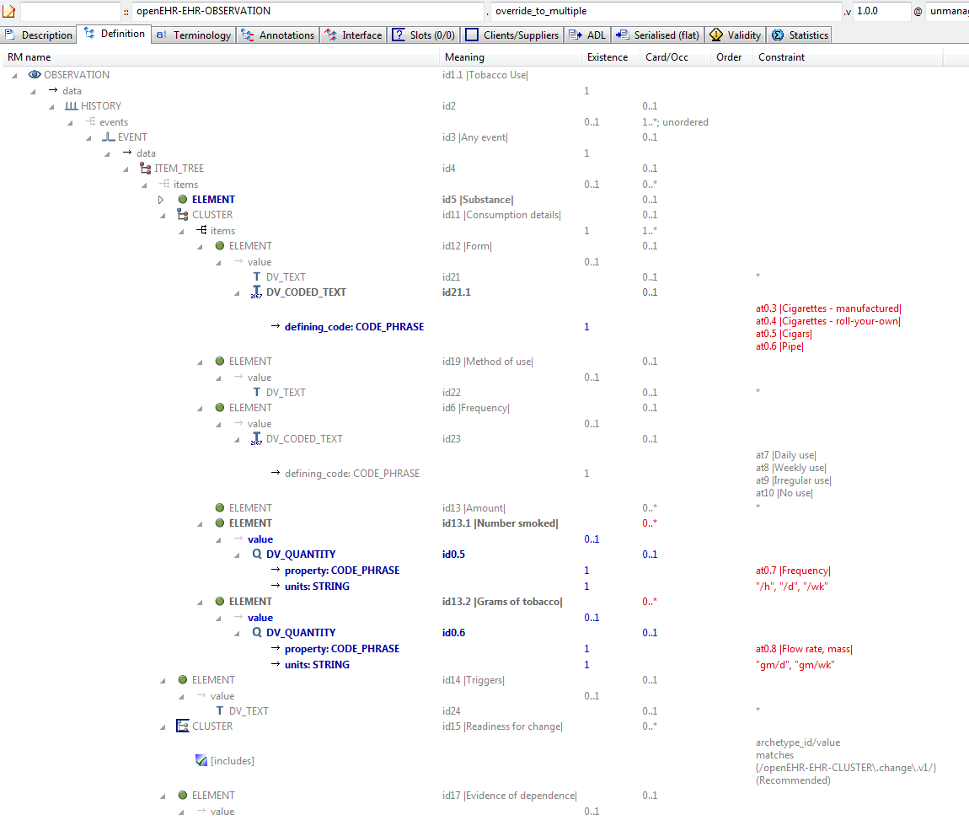

#### Override To Multiple v1 AML Diagram

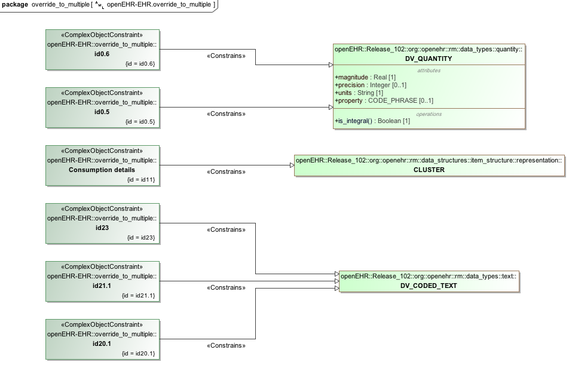

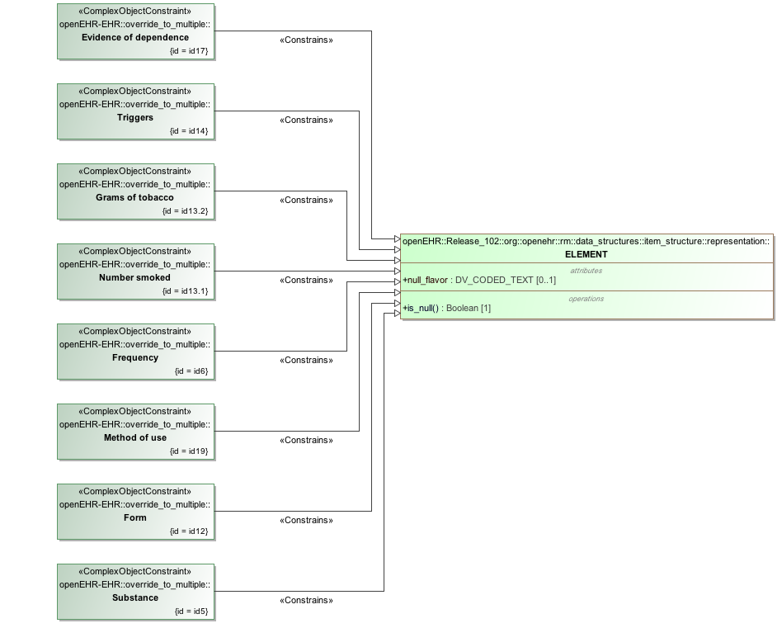

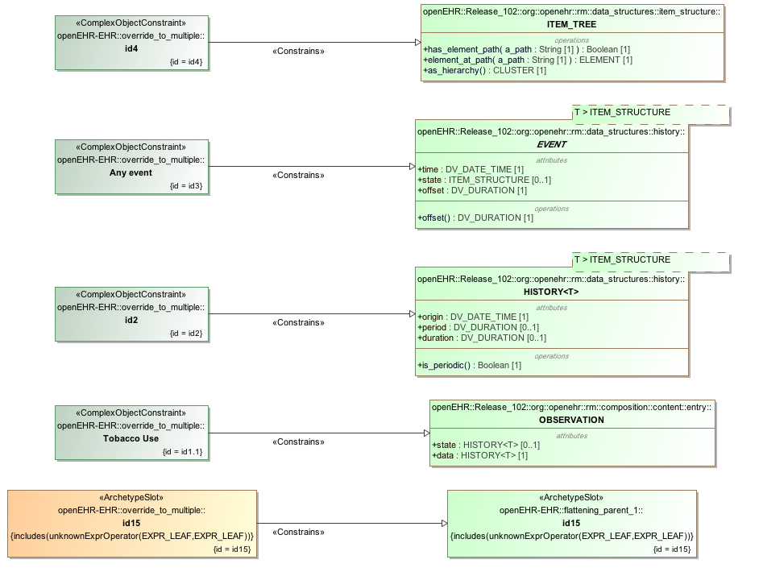

#### Override To Multiple v1 AML Associations Diagram

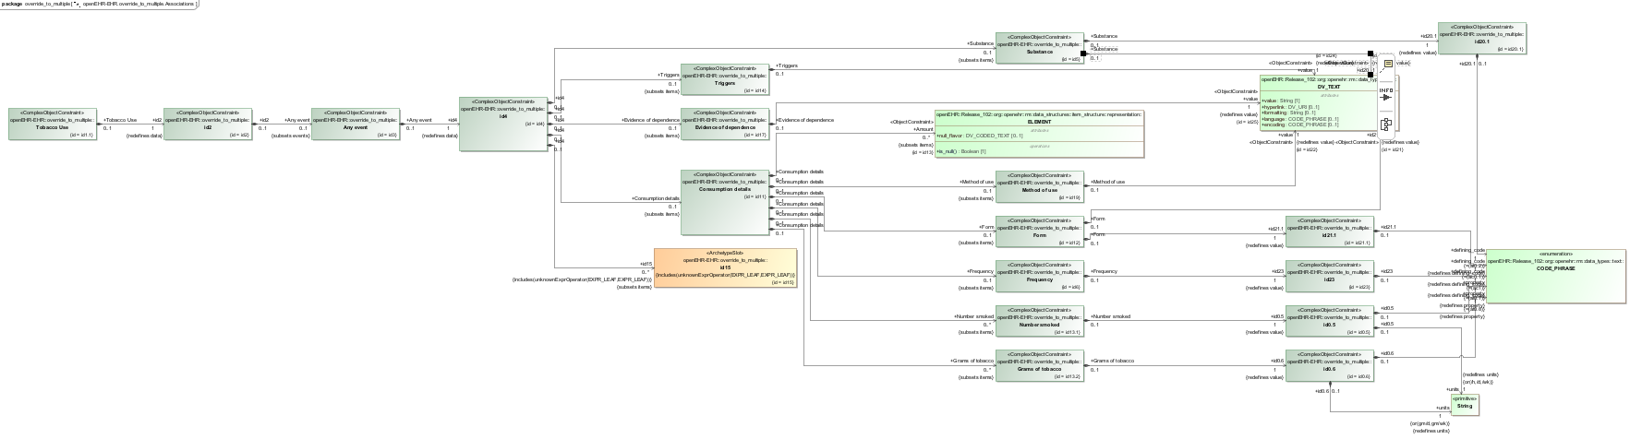

## Reference_model Enumeration_types Examples

### Audiogram v1 Example

Illustrate enumerated type constraints. In this archetype, the DV_PROPORTION.type field has integer values that are actually the values of a declared enumeration type PROPORTION_KIND based on the Integer primitive type.

#### Audiogram v1 ADL

archetype (adl_version=2.0.5; rm_release=1.0.2)

openEHR-EHR-OBSERVATION.audiogram.v1.0.0

language

original_language = <[ISO_639-1::en]>

description

custodian_namespace = <"org.openehr">

custodian_organisation = <"openEHR Foundation <http://www.openEHR.org>">

original_author = <

["name"] = <"Thomas Beale">

["email"] = <"thomas.beale@openEHR.org">

["organisation"] = <"openEHR Foundation <http://www.openEHR.org>">

["date"] = <"2014-06-10">

>

details = <

["en"] = <

language = <[ISO_639-1::en]>

purpose = <"Illustrate enumerated type constraints. In this archetype, the DV_PROPORTION.type field has integer values that are actually the values of a declared enumeration type PROPORTION_KIND based on the Integer primitive type.">

keywords = <"ADL", "test", "enumerated types">

>

>

lifecycle_state = <"published">

other_details = <

["regression"] = <"PASS">

>

copyright = <"Copyright © 2014 openEHR Foundation <http://www.openEHR.org>">

licence = <"Creative Commons CC-BY-SA <https://creativecommons.org/licenses/by-sa/3.0/>">

definition

OBSERVATION[id1] matches { -- Enumeration test

data matches {

HISTORY[id2] matches {

events cardinality matches {1..*; unordered} matches {

POINT_EVENT[id3] occurrences matches {0..1} matches { -- Any event

data matches {

ITEM_TREE[id4] matches {

items cardinality matches {1..*; unordered} matches {

ELEMENT[id5] occurrences matches {0..1} matches { -- test enum 1

value matches {

DV_PROPORTION[id6] matches {

numerator matches {|0.0..1.0|; 0.0}

is_integral matches {False}

type matches {1}

}

}

}

ELEMENT[id7] occurrences matches {0..1} matches { -- test enum 2

value matches {

DV_PROPORTION[id8] matches {

numerator matches {|0.0..1.0|; 0.0}

is_integral matches {False}

type matches {2, 3}

}

}

}

}

}

}

}

}

}

}

}

terminology

term_definitions = <

["en"] = <

["id1"] = <

text = <"Enumeration test">

description = <"Enumeration test">

>

["id3"] = <

text = <"Any event">

description = <"Any unspecified point in time or interval event.">

>

["id5"] = <

text = <"test enum 1">

description = <"test enum 1">

>

["id7"] = <

text = <"test enum 2">

description = <"test enum 2">

>

>

>

#### Audiogram v1 ADL Diagram

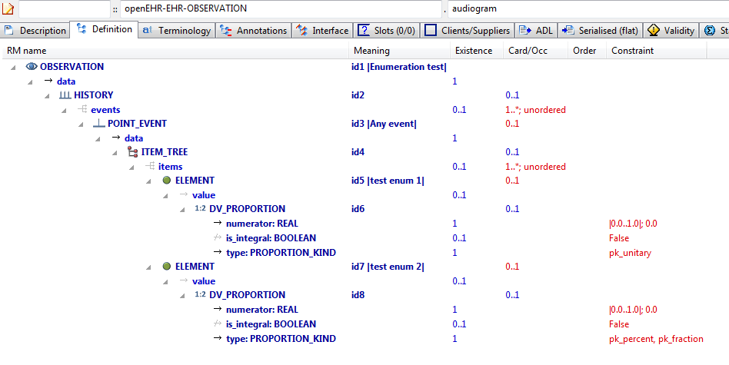

#### Audiogram v1 AML Diagram

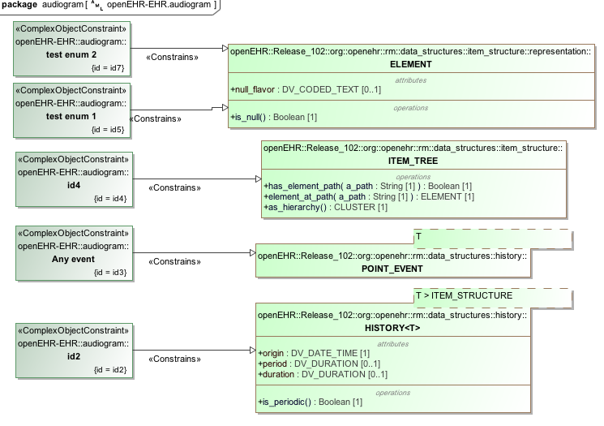

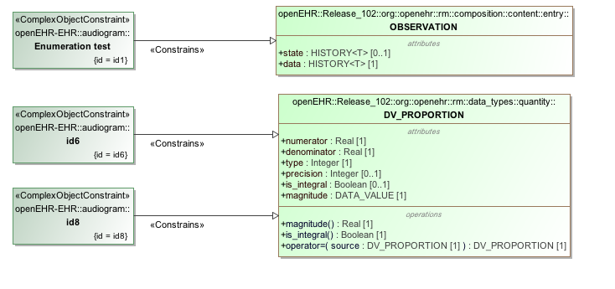

#### Audiogram v1 AML Associations Diagram

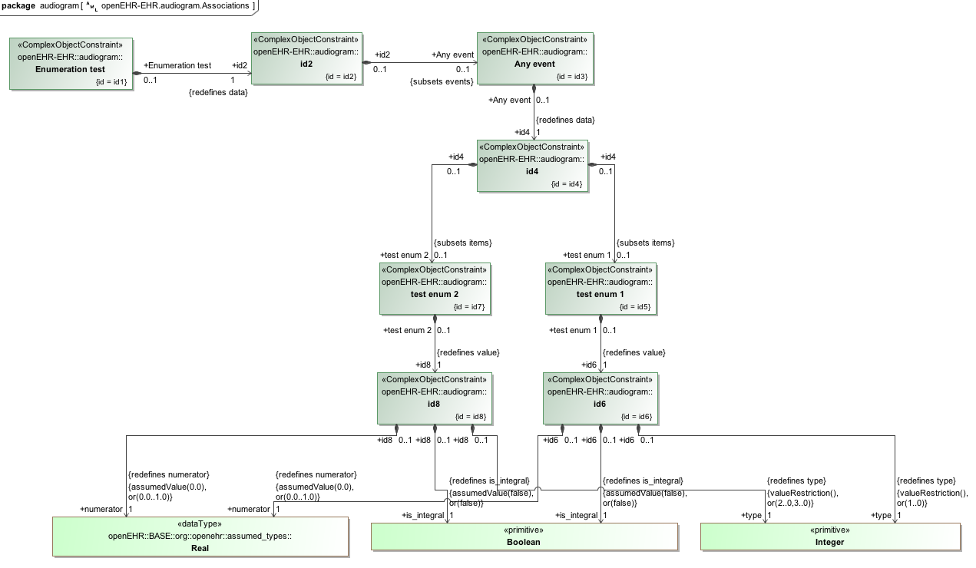

## Reference_model Generic_types Examples

### Rm Conforming Rm Subtype v1 Example

Test for conformance of RM subtype (here: POINT_EVENT) to statically declared RM type (EVENT). This archetype should pass validation.

#### Rm Conforming Rm Subtype v1 ADL

archetype (adl_version=2.0.5; rm_release=1.0.2)

openEHR-EHR-OBSERVATION.rm_conforming_rm_subtype.v1.0.0

language

original_language = <[ISO_639-1::en]>

description

custodian_namespace = <"org.openehr">

custodian_organisation = <"openEHR Foundation <http://www.openEHR.org>">

original_author = <

["name"] = <"Thomas Beale">

["email"] = <"thomas.beale@openEHR.org">

["organisation"] = <"openEHR Foundation <http://www.openEHR.org>">

["date"] = <"2009-03-18">

>

details = <

["en"] = <

language = <[ISO_639-1::en]>

purpose = <"Test for conformance of RM subtype (here: POINT_EVENT) to statically declared RM type (EVENT). This archetype should pass validation.">

keywords = <"ADL", "test", "RM checking">

>

>

lifecycle_state = <"published">

other_details = <

["regression"] = <"PASS">

>

copyright = <"Copyright © 2009 openEHR Foundation <http://www.openEHR.org>">

licence = <"Creative Commons CC-BY-SA <https://creativecommons.org/licenses/by-sa/3.0/>">

definition

OBSERVATION[id1] matches { -- An Observation

data matches {

HISTORY[id5] matches {

events cardinality matches {1..*; unordered} matches {

POINT_EVENT[id2] occurrences matches {0..1} matches { -- A Point_event

offset matches {

DV_DURATION[id6] matches {

value matches {PT1M}

}

}

data matches {

ITEM_LIST[id7] matches {

items cardinality matches {1..6; ordered} matches {

ELEMENT[id3] occurrences matches {0..1} -- Element #1

ELEMENT[id4] occurrences matches {0..1} -- Element #2

}

}

}

}

}

}

}

}

terminology

term_definitions = <

["en"] = <

["id1"] = <

text = <"An Observation">

description = <"An Observation">

>

["id2"] = <

text = <"A Point_event">

description = <"A Point_event">

>

["id3"] = <

text = <"Element #1">

description = <"Element #1">

>

["id4"] = <

text = <"Element #2">

description = <"Element #2">

>

>

>

#### Rm Conforming Rm Subtype v1 ADL Diagram

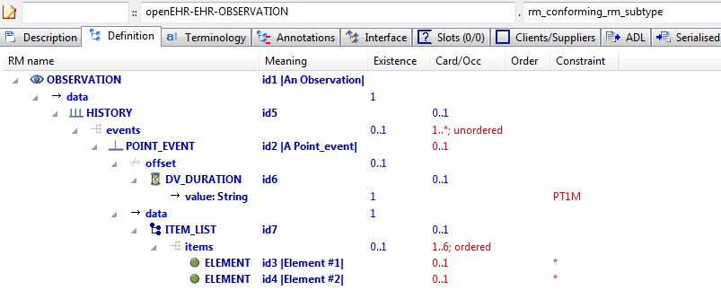

#### Rm Conforming Rm Subtype v1 AML Diagram

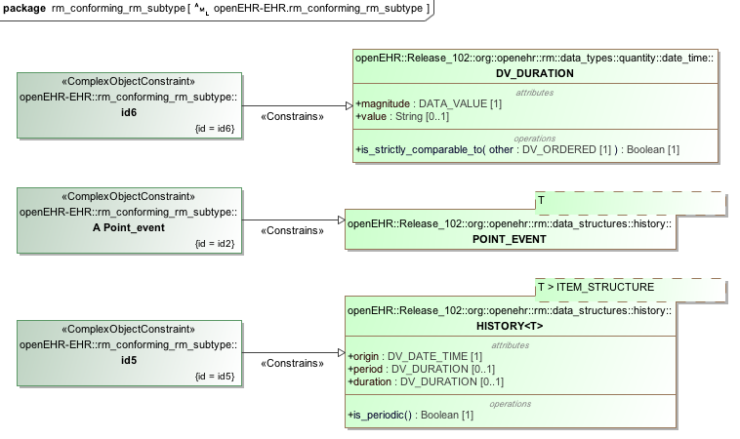

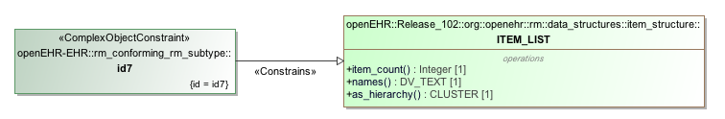

#### Rm Conforming Rm Subtype v1 AML Associations Diagram

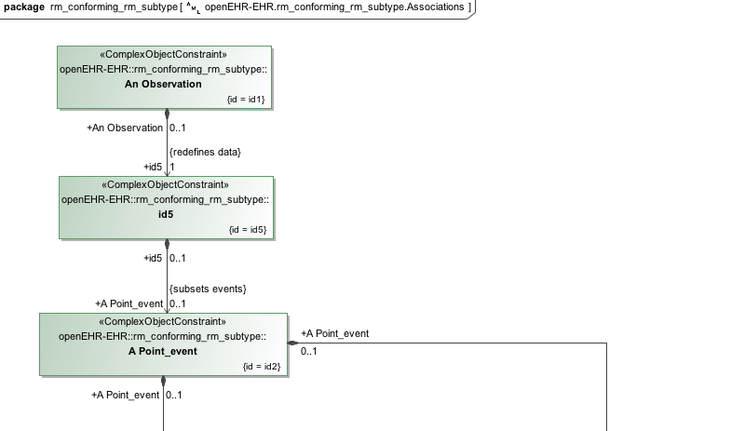

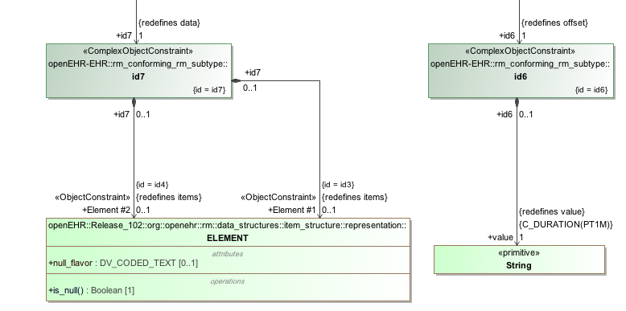

### Rm Correct Non Generic v1 Example

Example containing properly constraints conforming to the RM, with no RM type overrides or generic type markers, even though one type (HISTORY) is declared generic in the RM.

#### Rm Correct Non Generic v1 ADL

archetype (adl_version=2.0.5; rm_release=1.0.2)

openEHR-EHR-OBSERVATION.rm_correct_non_generic.v1.0.0

language

original_language = <[ISO_639-1::en]>

description

custodian_namespace = <"org.openehr">

custodian_organisation = <"openEHR Foundation <http://www.openEHR.org>">

original_author = <

["name"] = <"Thomas Beale">

["organisation"] = <"Ocean Informatics">

["email"] = <"thomas.beale@oceaninformatics.com">

["date"] = <"12/03/2009">

>

details = <

["en"] = <

language = <[ISO_639-1::en]>

purpose = <"Example containing properly constraints conforming to the RM, with no RM type overrides or generic type markers, even though one type (HISTORY) is declared generic in the RM.">

keywords = <"ADL", "test", "RM checker">

>

>

lifecycle_state = <"published">

other_details = <

["regression"] = <"PASS">

>

copyright = <"Copyright © 2009 openEHR Foundation <http://www.openEHR.org>">

licence = <"Creative Commons CC-BY-SA <https://creativecommons.org/licenses/by-sa/3.0/>">

definition

OBSERVATION[id1] matches { -- an Observation

data matches {

HISTORY[id4] matches {

events cardinality matches {1..*; unordered} matches {

EVENT[id3] occurrences matches {0..*} matches { -- some Event

data matches {

ITEM_LIST[id5]

}

}

}

}

}

}

terminology

term_definitions = <

["en"] = <

["id1"] = <

text = <"an Observation">

description = <"an Observation">

>

["id3"] = <

text = <"some Event">

description = <"some Event">

>

>

>

#### Rm Correct Non Generic v1 ADL Diagram

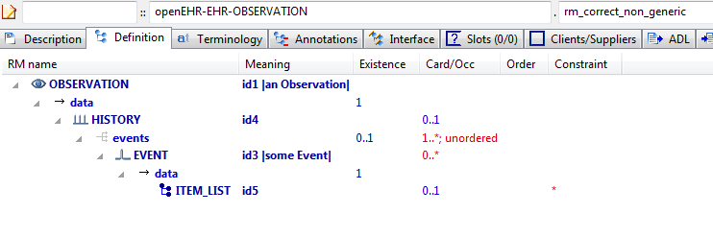

#### Rm Correct Non Generic v1 AML Diagram

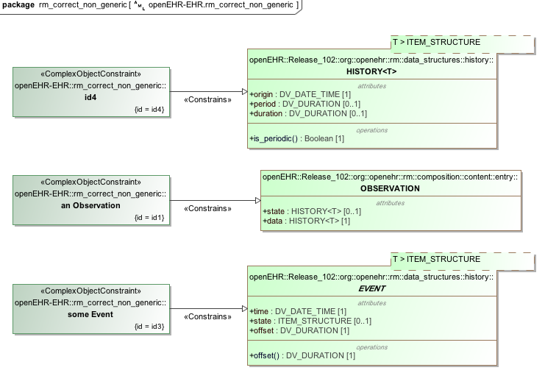

#### Rm Correct Non Generic v1 AML Associations Diagram

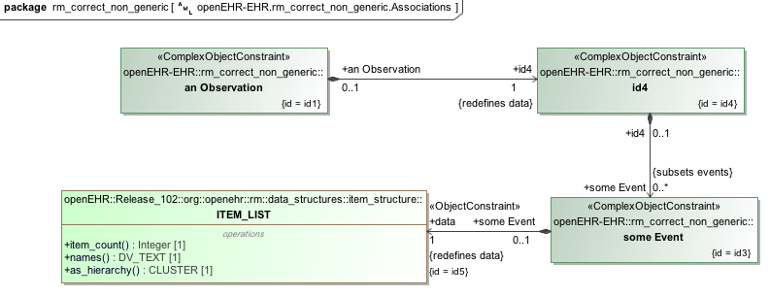

## Specialisation Examples

### Code List Constrained v1 Example

Example of narrowing constraint of code list inherited from parent.

#### Code List Constrained v1 ADL

archetype (adl_version=2.0.5; rm_release=1.0.2)

openEHR-EHR-EVALUATION.code_list_constrained.v1.0.0

specialize

openEHR-EHR-EVALUATION.code_list_parent.v1

language

original_language = <[ISO_639-1::en]>

description

custodian_namespace = <"org.openehr">

custodian_organisation = <"openEHR Foundation <http://www.openEHR.org>">

original_author = <

["name"] = <"Thomas Beale">

["email"] = <"thomas.beale@openEHR.org">

["organisation"] = <"openEHR Foundation <http://www.openEHR.org>">

["date"] = <"2012-02-20">

>

details = <

["en"] = <

language = <[ISO_639-1::en]>

purpose = <"Example of narrowing constraint of code list inherited from parent.">

keywords = <"ADL", "test", "specialisation">

>

>

lifecycle_state = <"published">

other_details = <

["regression"] = <"PASS">

>

copyright = <"Copyright © 2013 openEHR Foundation <http://www.openEHR.org>">

licence = <"Creative Commons CC-BY-SA <https://creativecommons.org/licenses/by-sa/3.0/>">

definition

EVALUATION[id1.1] matches { -- Adverse reaction exclusions

/data[id2]/items[id3]/value/defining_code matches {[ac1.1]}

}

terminology

term_definitions = <

["en"] = <

["id1.1"] = <

text = <"Adverse reaction exclusions">

description = <"A category of conditions or states which have been excluded as cause of adverse reaction">

>

["ac1.1"] = <

text = <"Specific exclusions">

description = <"Reduced set of exclusions">

>

>

>

value_sets = <

["ac1.1"] = <

id = <"ac1.1">

members = <"at6", "at7", "at10", "at13">

>

>

#### Code List Constrained v1 ADL Diagram

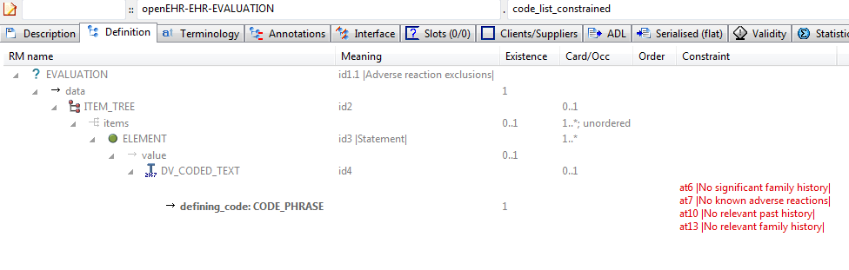

#### Code List Constrained v1 AML Diagram

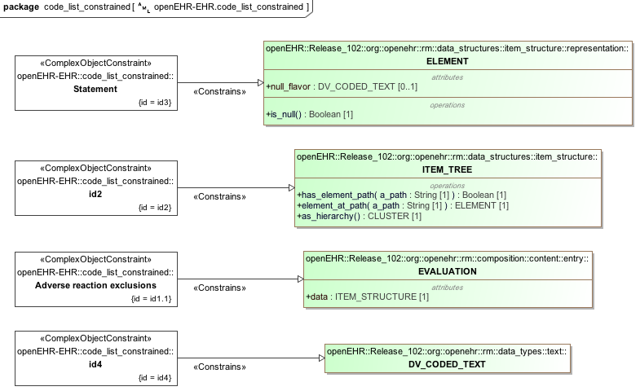

#### Code List Constrained v1 AML Associations Diagram

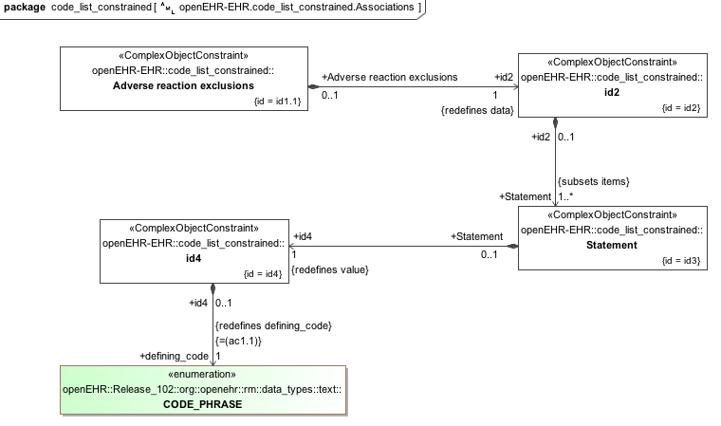

### Code List Parent v1 Example

Archetype containing a C_TERMINOLOGY_CODE list which can be further constrained in child archetypes.

#### Code List Parent v1 ADL

archetype (adl_version=2.0.5; rm_release=1.0.2)

openEHR-EHR-EVALUATION.code_list_parent.v1.0.0

language

original_language = <[ISO_639-1::en]>

description

custodian_namespace = <"org.openehr">

custodian_organisation = <"openEHR Foundation <http://www.openEHR.org>">

original_author = <

["name"] = <"Thomas Beale">

["email"] = <"thomas.beale@openEHR.org">

["organisation"] = <"openEHR Foundation <http://www.openEHR.org>">

["date"] = <"2013-02-20">

>

details = <

["en"] = <

language = <[ISO_639-1::en]>

purpose = <"Archetype containing a C_TERMINOLOGY_CODE list which can be further constrained in child archetypes.">

keywords = <"ADL", "test", "specialisation">

>

>

lifecycle_state = <"published">

other_details = <

["regression"] = <"PASS">

>

copyright = <"Copyright © 2013 openEHR Foundation <http://www.openEHR.org>">

licence = <"Creative Commons CC-BY-SA <https://creativecommons.org/licenses/by-sa/3.0/>">

definition

EVALUATION[id1] matches { -- General statement of exclusions or states

data matches {

ITEM_TREE[id2] matches {

items cardinality matches {1..*; unordered} matches {

ELEMENT[id3] occurrences matches {1..*} matches { -- Statement

value matches {

DV_CODED_TEXT[id4] matches {

defining_code matches {[ac1]} -- Statement

}

}

}

}

}

}

}

terminology

term_definitions = <

["en"] = <

["id1"] = <

text = <"General statement of exclusions or states">

description = <"A category of conditions or states which have been excluded">

>

["id3"] = <

text = <"Statement">

description = <"The statement about what is excluded">

>

["at4"] = <

text = <"No significant illness">

description = <"The person has no significant medical condition">

>

["at5"] = <

text = <"No significant past history">

description = <"The person has no significant past medical history">

>

["at6"] = <

text = <"No significant family history">

description = <"The person has no relatives with significant health problems">

>

["at7"] = <

text = <"No known adverse reactions">

description = <"The person has had no adverse reactions, including intolerances, sensitivities or allergies, to medications, food, animals or chemicals">

>

["at8"] = <

text = <"No known sensitivities">

description = <"No sensitivity to any medications, foods or substances">

>

["at9"] = <

text = <"No known intolerances">

description = <"No known or recorded intolerances to medications, foods or other substances">

>

["at10"] = <

text = <"No relevant past history">

description = <"No past problems or procedures relevant to the current situation">

>

["at11"] = <

text = <"No hospitalisations">

description = <"No admissions to hospital">

>

["at12"] = <

text = <"No major surgery">

description = <"No major operations or procedures">

>

["at13"] = <

text = <"No relevant family history">

description = <"No family history relevant to the current situation">

>

["at14"] = <

text = <"No known allergies">

description = <"No allergies known to any medications, foods or substances">

>

["ac1"] = <

text = <"Statement">

description = <"The statement about what is excluded">

>

>

>

value_sets = <

["ac1"] = <

id = <"ac1">

members = <"at4", "at5", "at6", "at7", "at10", "at13", "at14", "at11", "at12", "at8", "at9">

>

>

#### Code List Parent v1 ADL Diagram

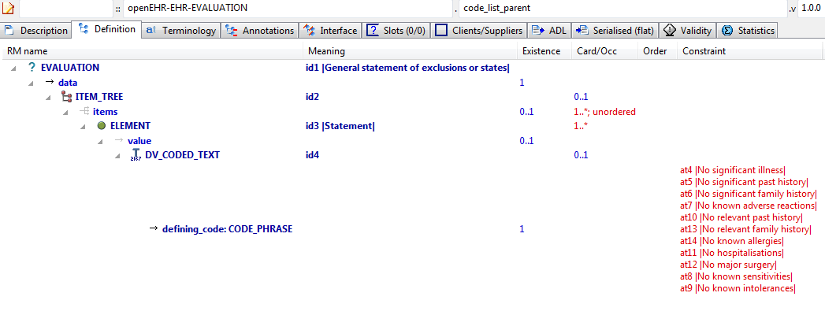

#### Code List Parent v1 AML Diagram

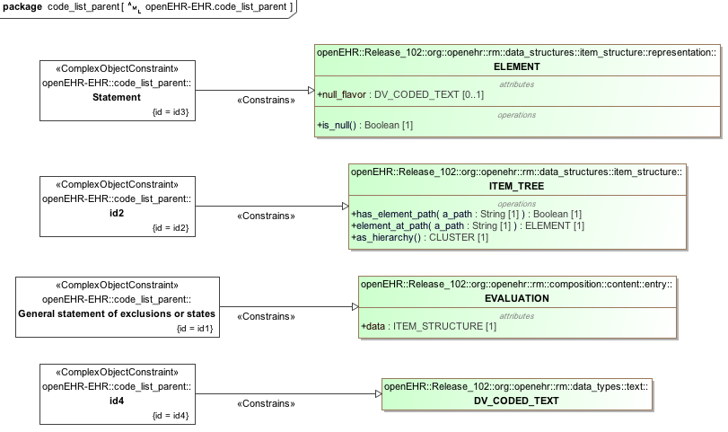

#### Code List Parent v1 AML Associations Diagram

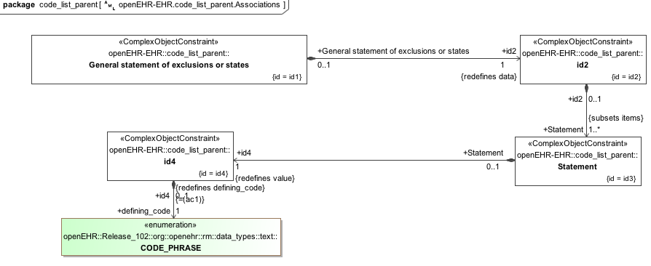

### Body Temp Test v1 Example

A parent archetype for testing various child refinements, including occurrences matches {0}.

#### Body Temp Test v1 ADL

archetype (adl_version=2.0.5; rm_release=1.0.2)

openEHR-EHR-OBSERVATION.body_temp_test.v1.0.0

language

original_language = <[ISO_639-1::en]>

description

custodian_namespace = <"org.openehr">

custodian_organisation = <"openEHR Foundation <http://www.openEHR.org>">

original_author = <

["name"] = <"Thomas Beale">

["email"] = <"thomas.beale@openEHR.org">

["organisation"] = <"openEHR Foundation <http://www.openEHR.org>">

["date"] = <"2012-04-18">

>

details = <

["en"] = <

language = <[ISO_639-1::en]>

purpose = <"A parent archetype for testing various child refinements, including occurrences matches {0}.">

keywords = <"ADL", "test", "specialisation">

>

>

lifecycle_state = <"published">

other_details = <

["regression"] = <"PASS">

>

copyright = <"Copyright © 2012 openEHR Foundation <http://www.openEHR.org>">

licence = <"Creative Commons CC-BY-SA <https://creativecommons.org/licenses/by-sa/3.0/>">

definition

OBSERVATION[id1] matches { -- Body temperature

data matches {

HISTORY[id3] matches {

events cardinality matches {1..*; unordered} matches {

EVENT[id4] occurrences matches {0..*} matches { -- Any event

data matches {

ITEM_TREE[id2] matches {

items cardinality matches {1; unordered} matches {

ELEMENT[id5] matches { -- Temperature

value matches {

DV_QUANTITY[id61] matches {

property matches {[at57]}

[units, precision] matches {

[{"°C"}, {1}],

[{"°F"}, {1}]

}

}

}

}

}

}

}

state matches {

ITEM_TREE[id30] matches { -- State

items matches {

ELEMENT[id31] occurrences matches {0..1} matches { -- Body exposure

value matches {

DV_CODED_TEXT[id62] matches {

defining_code matches {[ac1; at34]} -- Body exposure

}

}

}

allow_archetype CLUSTER[id57] occurrences matches {0..1} matches { -- Environmental Conditions

include

archetype_id/value matches {/openEHR-EHR-CLUSTER\.environmental_conditions\.v1/}

}

allow_archetype CLUSTER[id58] occurrences matches {0..1} matches { -- Exertion

include

archetype_id/value matches {/openEHR-EHR-CLUSTER\.level_of_exertion\.v1/}

}

allow_archetype ELEMENT[id59] occurrences matches {0..1} matches { -- Menstrual Cycle

include

archetype_id/value matches {/openEHR-EHR-ELEMENT\.last_normal_menstrual_period\.v1|openEHR-EHR-ELEMENT\.menstrual_cycle_day\.v1/}

}

ELEMENT[id42] occurrences matches {0..1} matches { -- Description of thermal stress

value matches {

DV_TEXT[id63]

}

}

}

}

}

}

}

}

}

protocol matches {

ITEM_TREE[id21] matches {

items matches {

ELEMENT[id22] occurrences matches {0..1} matches { -- Site of measurement

value matches {

DV_CODED_TEXT[id64] matches {

defining_code matches {[ac2]} -- Site of measurement

}

}

}

allow_archetype CLUSTER[id60] occurrences matches {0..1} matches { -- Device

include

archetype_id/value matches {/openEHR-EHR-CLUSTER\.device\.v1/}

}

}

}

}

}

terminology

term_definitions = <

["en"] = <

["id1"] = <

text = <"Body temperature">

description = <"A measurement of the body temperature, which is a surrogate for the whole body temperature of the person.">

>

["id4"] = <

text = <"Any event">

description = <"Any event">

>

["id5"] = <

text = <"Temperature">

description = <"The measured body temperature (as a surrogate for the whole body).">

>

["id22"] = <

text = <"Site of measurement">

description = <"The anatomical site of measurement of the temperature.">

>

["at23"] = <

text = <"Mouth">

description = <"Temperature is measured within the mouth.">

>

["at24"] = <

text = <"Ear canal">

description = <"Temperature is measured from within the external auditory canal.">

>

["at25"] = <

text = <"Axilla">

description = <"Temperature is measured from the skin of the axilla with the arm positioned down by the side.">

>

["at26"] = <

text = <"Rectum">

description = <"Temperature measured within the rectum.">

>

["at27"] = <

text = <"Nasopharynx">

description = <"Temperature is measured within the nasopharynx.">

>

["at28"] = <

text = <"Urinary bladder">

description = <"Temperature is measured in the urinary bladder.">

>

["at29"] = <

text = <"Intravascular">

description = <"Temperature is measured within the vascular system.">

>

["id30"] = <

text = <"State">

description = <"State information about the patient.">

>

["id31"] = <

text = <"Body exposure">

description = <"The thermal situation of the person who is having the temperature taken.">

>

["at32"] = <

text = <"Naked">

description = <"No clothing, bedding or covering.">

>

["at33"] = <

text = <"Reduced clothing/bedding">

description = <"The person is covered by a lesser amount of clothing or bedding than deemed appropriate for the environmental circumstances.">

>

["at34"] = <

text = <"Appropriate clothing/bedding">

description = <"The person is covered by an amount of clothing or bedding deemed appropriate for the environmental circumstances.">

>

["at35"] = <

text = <"Increased clothing/bedding">

description = <"The person is covered by an increased amount of clothing or bedding than deemed appropriate for the environmental circumstances.">

>

["id42"] = <

text = <"Description of thermal stress">

description = <"Description of the conditions applied to the subject that might influence their measured body temperature.">

>

["at44"] = <

text = <"Skin">

description = <"Temperature is measured from exposed skin.">

>

["at52"] = <

text = <"Vagina">

description = <"Temperature is measured within the vagina.">

>

["at55"] = <

text = <"Oesophagus">

description = <"Temperatue is measured within the oesophagus.">

>

["at56"] = <

text = <"Inguinal skin crease">

description = <"Temperature is measured in the inguinal skin crease between the leg and abdominal wall.">

>

["id57"] = <

text = <"Environmental Conditions">

description = <"Details about the environmental conditions at the time of temperature measurement.">

>

["id58"] = <

text = <"Exertion">

description = <"Details about the exertion of the person at the time of temperature measurement.">

>

["id59"] = <

text = <"Menstrual Cycle">

description = <"Details about the menstrual cycle of a woman.">

>

["id60"] = <

text = <"Device">

description = <"Details about the device use to measure body temperature.">

>

["ac1"] = <

text = <"Body exposure">

description = <"The thermal situation of the person who is having the temperature taken.">

>

["ac2"] = <

text = <"Site of measurement">

description = <"The anatomical site of measurement of the temperature.">

>

["at57"] = <

text = <"Temperature">

description = <"Temperature">

>

>

>

term_bindings = <

["LNC205"] = <

["/data[id3]/events[id4]/data[id2]/items[id5]"] = <http://LNC205.org/id/8310-5>

>

["openehr"] = <

["at57"] = <http://openehr.org/id/127>

>

>

value_sets = <

["ac1"] = <

id = <"ac1">

members = <"at32", "at33", "at34", "at35">

>

["ac2"] = <

id = <"ac2">

members = <"at23", "at24", "at25", "at26", "at27", "at28", "at29", "at44", "at52", "at55", "at56">

>

>

#### Body Temp Test v1 ADL Diagram

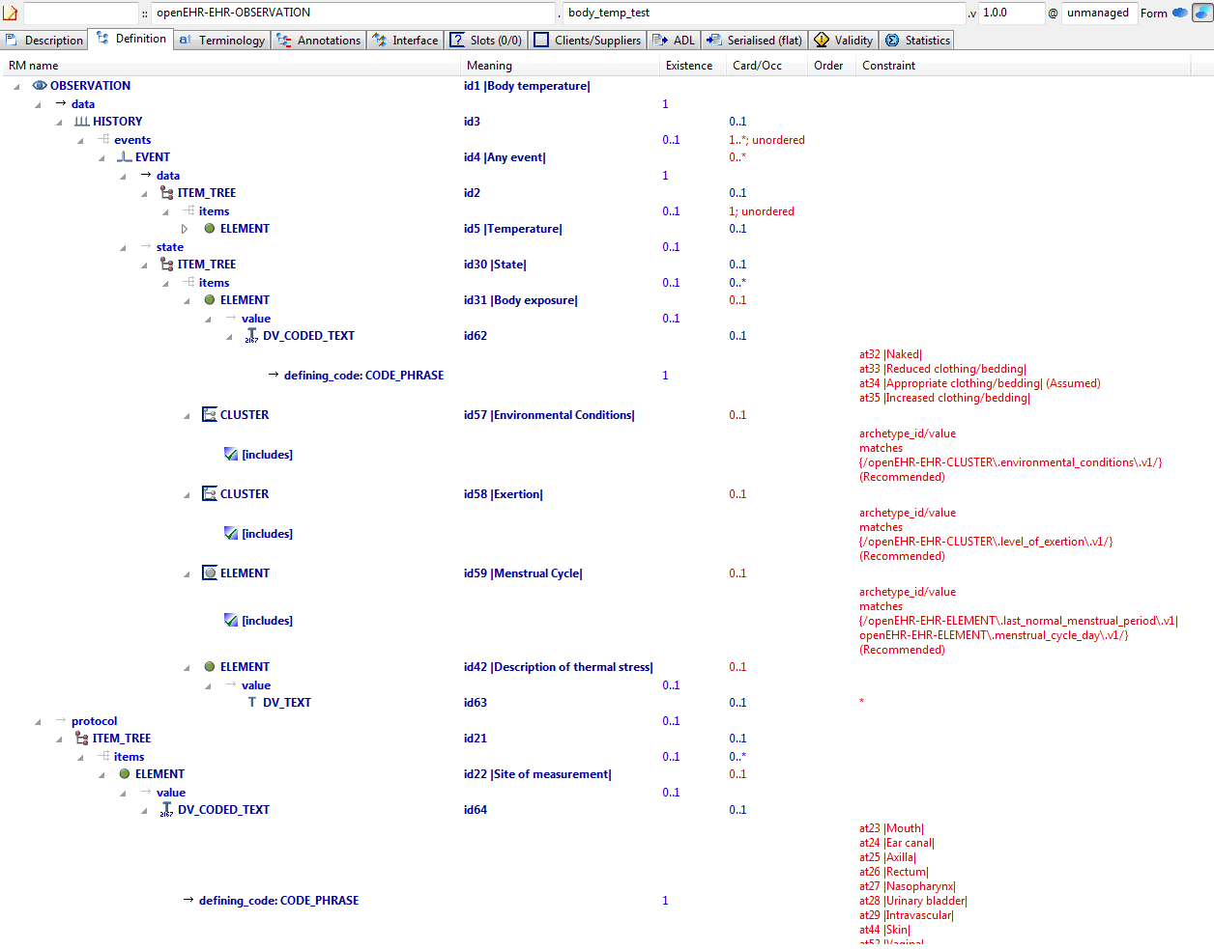

#### Body Temp Test v1 AML Diagram

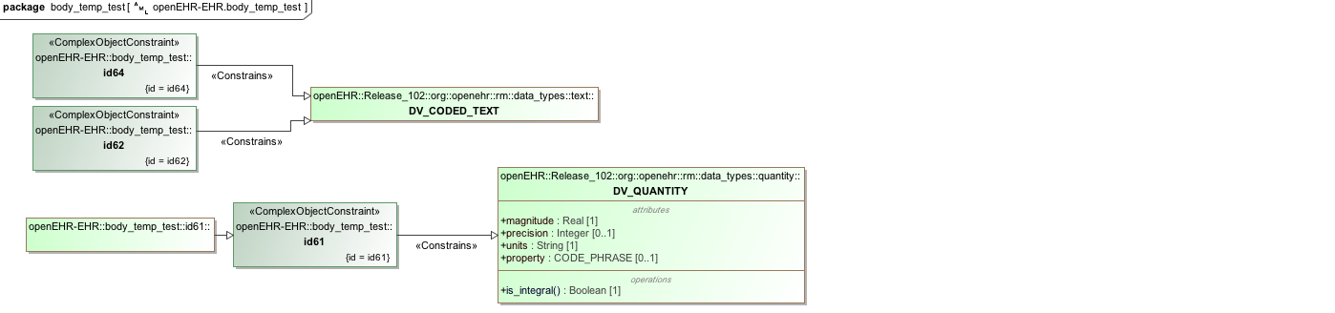

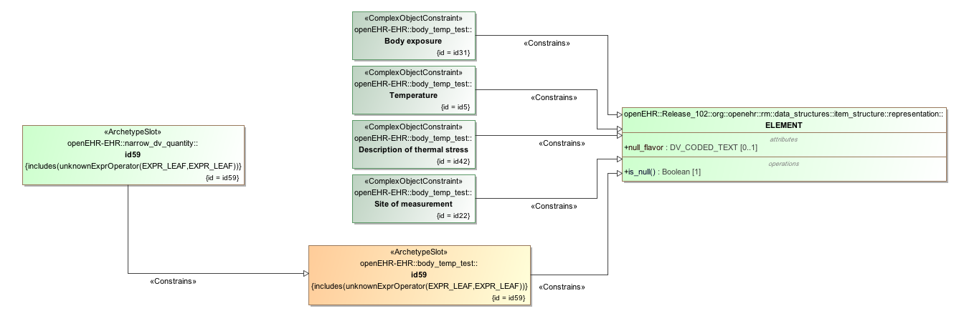

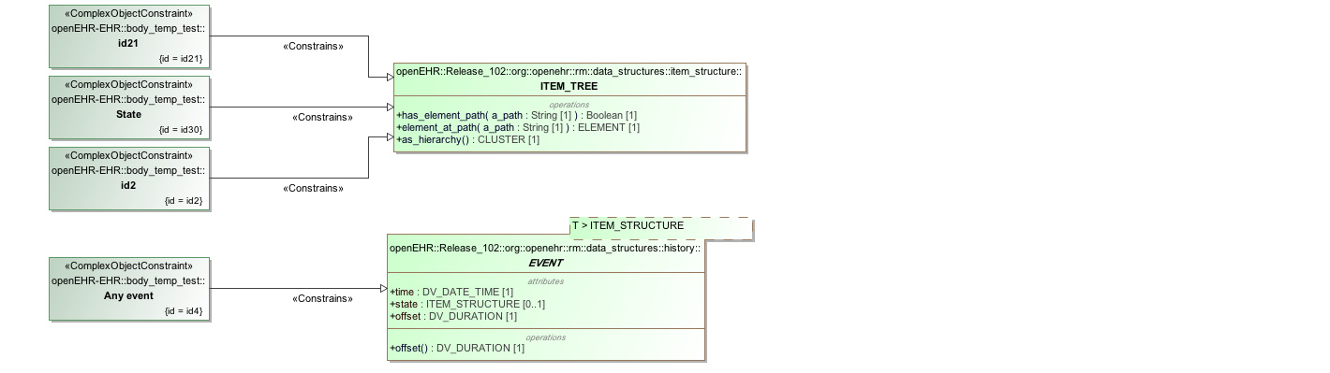

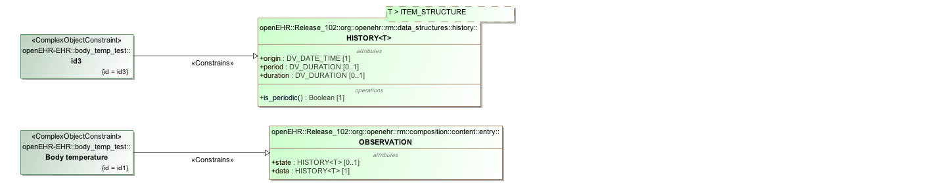

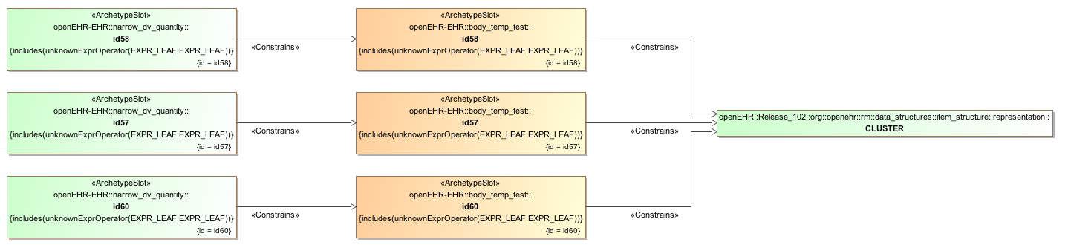

#### Body Temp Test v1 AML Associations Diagram

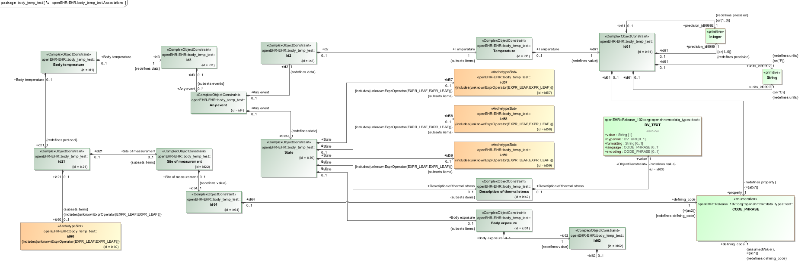

### Ordering Added Nodes v1 Example

Example specialised archetype containing additional nodes and ordering markers within a container attribute defined in the parent. The parent container already includes member ELEMENTs, so the 'after' and 'before' markers in this descendant are used to obtain the intended overall order in the flattened result.

#### Ordering Added Nodes v1 ADL

archetype (adl_version=2.0.5; rm_release=1.0.2)

openEHR-EHR-OBSERVATION.ordering_added_nodes.v1.0.0

specialize

openEHR-EHR-OBSERVATION.spec_test_parent.v1

language

original_language = <[ISO_639-1::en]>

description

custodian_namespace = <"org.openehr">

custodian_organisation = <"openEHR Foundation <http://www.openEHR.org>">

original_author = <

["name"] = <"Thomas Beale">

["email"] = <"thomas.beale@openEHR.org">

["organisation"] = <"openEHR Foundation <http://www.openEHR.org>">

["date"] = <"2008-08-11">

>

details = <

["en"] = <

language = <[ISO_639-1::en]>

purpose = <"Example specialised archetype containing additional nodes and ordering markers within a container attribute defined in the parent. The parent container already includes member ELEMENTs, so the 'after' and 'before' markers in this descendant are used to obtain the intended overall order in the flattened result.">

keywords = <"ADL", "test", "specialisation">

>

>

lifecycle_state = <"published">

other_details = <

["regression"] = <"PASS">

>

copyright = <"Copyright © 2008 openEHR Foundation <http://www.openEHR.org>">

licence = <"Creative Commons CC-BY-SA <https://creativecommons.org/licenses/by-sa/3.0/>">

definition

OBSERVATION[id1.1] matches { -- specialisation containing ordered extension nodes

/data/events[id3]/data/items matches {

after [id5]

ELEMENT[id0.1] matches { -- Text field 2

value matches {

DV_TEXT[id0.3] -- Text field 3

}

}

ELEMENT[id0.2] matches { -- Quantity 2

value matches {

DV_QUANTITY[id0.4]

}

}

before [id8]

ELEMENT[id0.3] matches { -- Text field 3

value matches {

DV_TEXT[id0.5]

}

}

}

}

terminology

term_definitions = <

["en"] = <

["id0.1"] = <

text = <"Text field 2">

description = <"*">

>

["id0.2"] = <

text = <"Quantity 2">

description = <"*">

>

["id0.3"] = <

text = <"Text field 3">

description = <"*">

>

["id1.1"] = <

text = <"specialisation containing ordered extension nodes">

description = <"specialisation containing ordered extension nodes">

>

>

>

#### Ordering Added Nodes v1 ADL Diagram

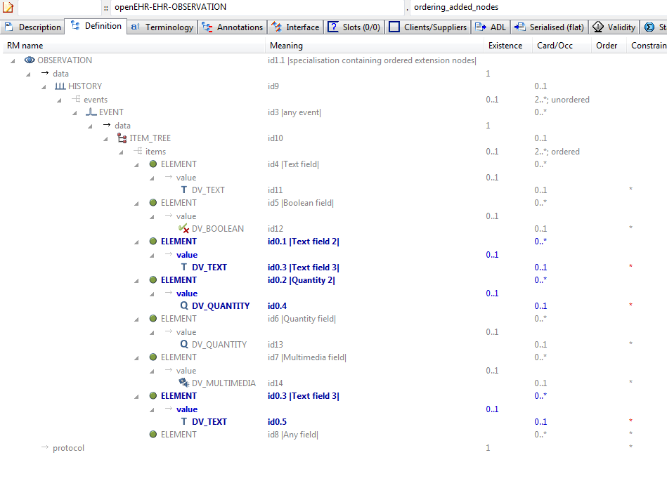

#### Ordering Added Nodes v1 AML Diagram

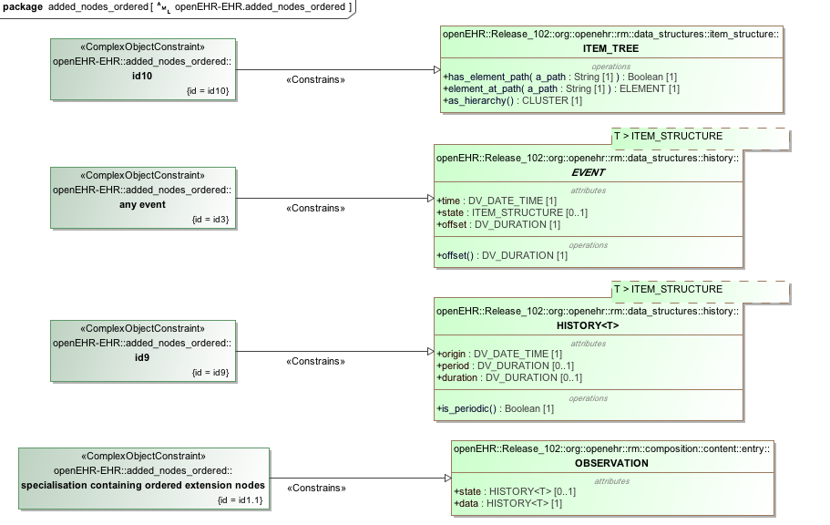

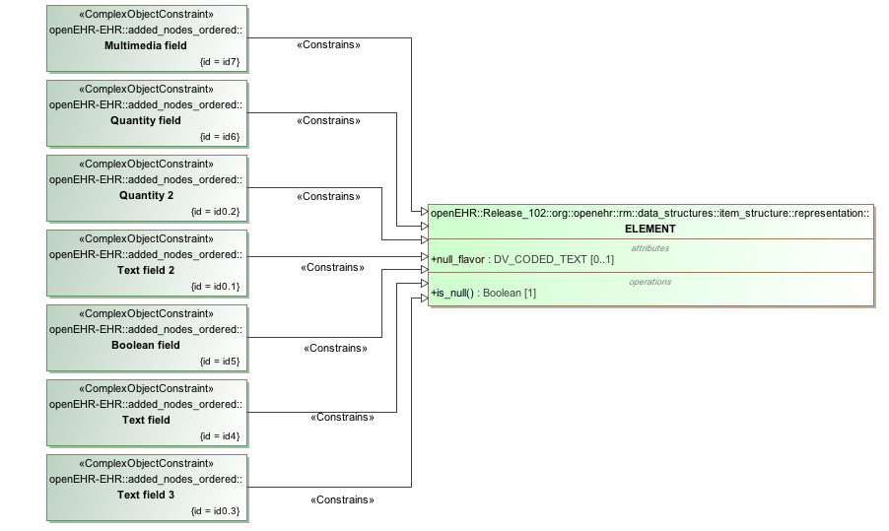

#### Ordering Added Nodes v1 AML Associations Diagram

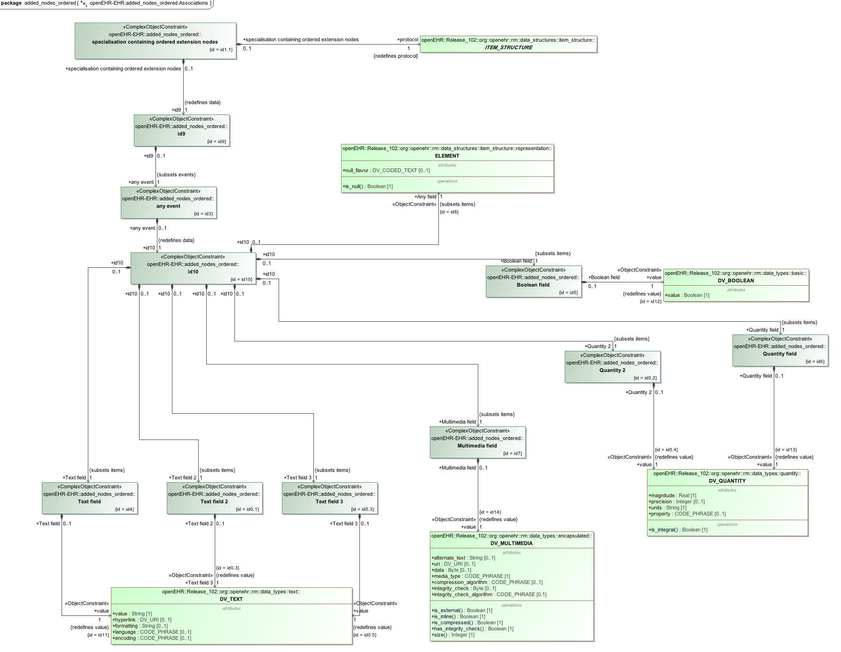

### Ordering Parent v1 Example

Parent for child that redefines and adds nodes, marked for a certain location in flat, using 'before' keyword.

#### Ordering Parent v1 ADL

archetype (adl_version=2.0.5; rm_release=1.0.2)

openEHR-EHR-OBSERVATION.ordering_parent.v1.0.0

language

original_language = <[ISO_639-1::en]>

description

custodian_namespace = <"org.openehr">

custodian_organisation = <"openEHR Foundation <http://www.openEHR.org>">

original_author = <

["name"] = <"Dr Ian McNicoll">

["organisation"] = <"Ocean Informatics UK <http://www.oceaninformatics.com>">

["email"] = <"ian.mcnicoll@oceaninformatics.com">

["date"] = <"2009-11-07">

>

details = <

["en"] = <

language = <[ISO_639-1::en]>

purpose = <"Parent for child that redefines and adds nodes, marked for a certain location in flat, using 'before' keyword.">

keywords = <"ADL", "test", "specialisation">

>

>

lifecycle_state = <"published">

other_details = <

["regression"] = <"PASS">

>

copyright = <"Copyright © 2009 openEHR Foundation <http://www.openEHR.org>">

licence = <"Creative Commons CC-BY-SA <https://creativecommons.org/licenses/by-sa/3.0/>">

definition

OBSERVATION[id1] matches { -- Laboratory test

data matches {

HISTORY[id2] matches {

events cardinality matches {1..*; unordered} matches {

EVENT[id3] occurrences matches {0..*} matches { -- Any event

data matches {

ITEM_TREE[id4] matches {

items matches {

ELEMENT[id6] occurrences matches {0..1} matches { -- Test name

value matches {

DV_TEXT[id20]

}

}

ELEMENT[id7] occurrences matches {0..1} matches { -- Diagnostic service

value matches {

DV_TEXT[id21]

}

}

ELEMENT[id8] occurrences matches {0..1} matches { -- Test status

value matches {

DV_CODED_TEXT[id22] matches {

defining_code matches {[ac1]} -- Test status (synthesised)

}

}

}

allow_archetype CLUSTER[id9] occurrences matches {0..*} matches { -- Specimen detail

include

archetype_id/value matches {/openEHR-EHR-CLUSTER\.specimen\.v1/}

exclude

archetype_id/value matches {/.*/}

}

ITEM[id10] occurrences matches {0..*} -- Result

allow_archetype CLUSTER[id11] occurrences matches {0..*} matches { -- Per-result annotation

include

archetype_id/value matches {/openEHR-EHR-CLUSTER\.lab_result_annotation(-a-zA-Z0-9_]+)*\.v1/}

exclude

archetype_id/value matches {/.*/}

}

ELEMENT[id12] occurrences matches {0..1} matches { -- Overall interpretation

value matches {

DV_TEXT[id23]

}

}

ELEMENT[id13] occurrences matches {0..*} matches { -- Multimedia representation

value matches {

DV_MULTIMEDIA[id24]

}

}

}

}

}

}

}

}

}

}

terminology

term_definitions = <

["en"] = <

["id1"] = <

text = <"Laboratory test">

description = <"To record the result of a laboratory test which may be used to record a single valued test but will often be specialised or templated to represent multiple value or 'panel' tests.

This archetype also acts as the parent for specialisations appropriate for more specific laboratory tests microbiology, histopathology.">

>

["id3"] = <

text = <"Any event">

description = <"Any event.">

>

["id6"] = <

text = <"Test name">

description = <"Specific identifier for this lab test. e.g. Full blood count , blood glucose, urine microbiology. May equate to the result name for a single value result. Commonly a coded term e.g from LOINC or SNOMED-CT.">

>

["id7"] = <

text = <"Diagnostic service">

description = <"The type of high-level diagnostic service e.g. biochemistry, haematology.">

>

["id8"] = <

text = <"Test status">

description = <"The status of the lab test as a whole.">

>

["id9"] = <

text = <"Specimen detail">

description = <"Details of the specimen being reported where all individual results are derived from the same specimen.">

>

["id10"] = <

text = <"Result">

description = <"The result of the test.">

>

["id11"] = <

text = <"Per-result annotation">

description = <"Slot to allow an annotation to be added to a particular test result at run-time.">

>

["id12"] = <

text = <"Overall interpretation">

description = <"An overall interpretative comment on this test.">

>

["id13"] = <

text = <"Multimedia representation">

description = <"Representations of the whole test in mutlimedia e.g image, audio, video.">

>

["ac1"] = <

text = <"Test status (synthesised)">

description = <"The status of the lab test as a whole. (synthesised)">

>

["at38"] = <

text = <"Interim">

description = <"This is an initial or interim result - further updates are anticipated.">

>

["at39"] = <

text = <"Final">

description = <"This is the final result. No further alterations are anticipated.">

>

["at40"] = <

text = <"Supplementary">

description = <"This is a supplementary result ehich should be appended to a previous result.">

>

["at41"] = <

text = <"Corrected (amended)">

description = <"This is a correction which should completely replace any previous results.">

>

["at75"] = <

text = <"Aborted">

description = <"The test was aborted and never completed.">

>

["at80"] = <

text = <"Never performed">

description = <"The test was never performed.">

>

>

>

value_sets = <

["ac1"] = <

id = <"ac1">

members = <"at38", "at39", "at40", "at41", "at75", "at80">

>

>

#### Ordering Parent v1 ADL Diagram

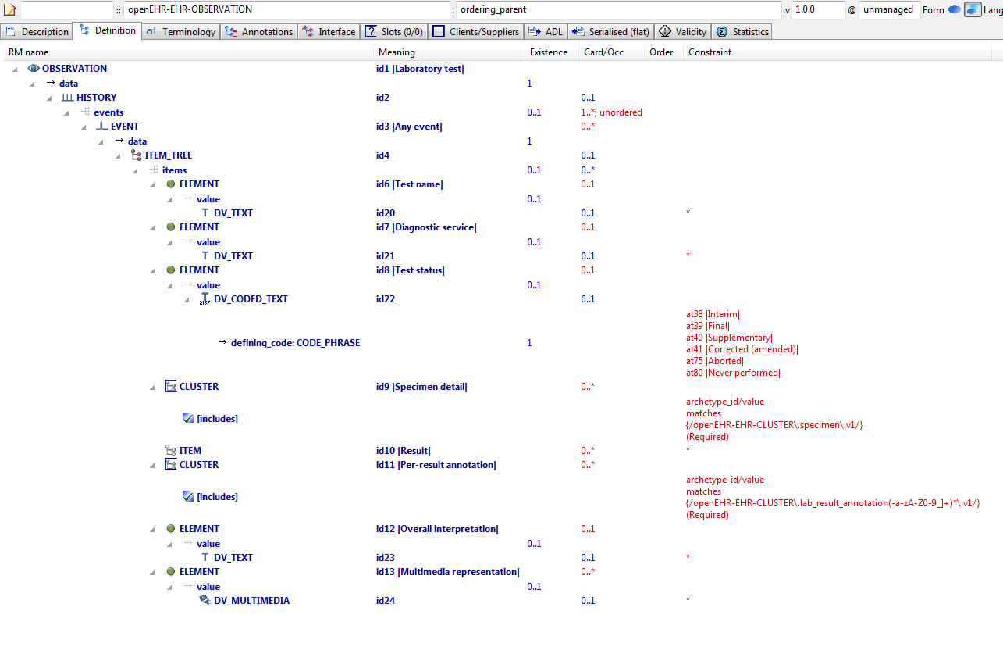

#### Ordering Parent v1 AML Diagram

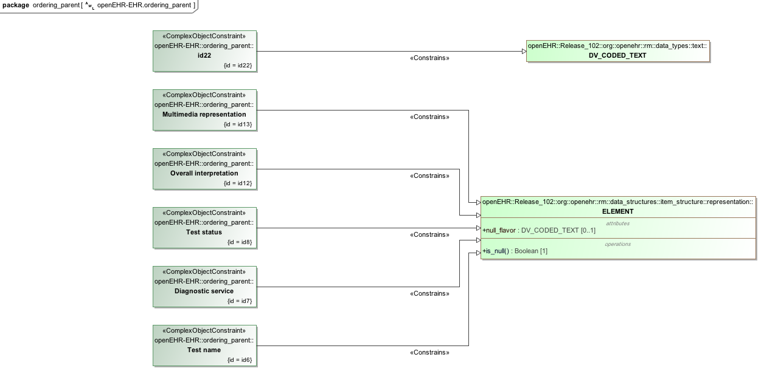

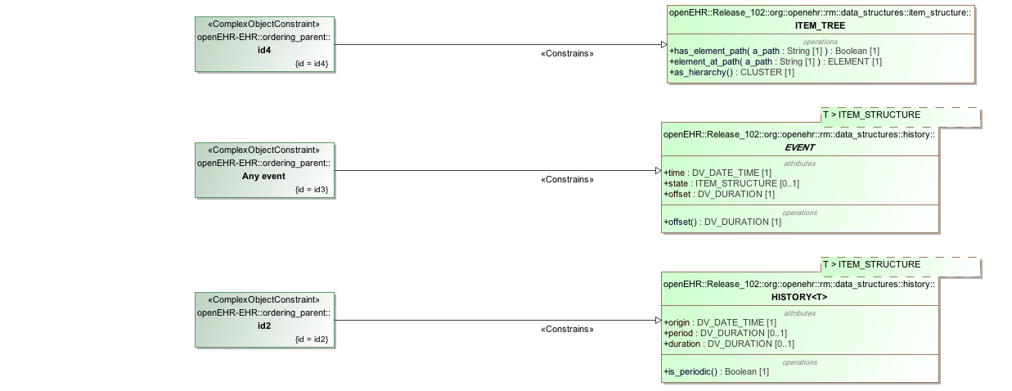

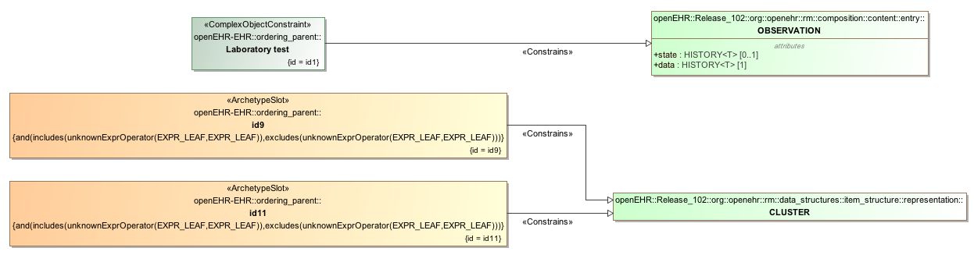

#### Ordering Parent v1 AML Associations Diagram

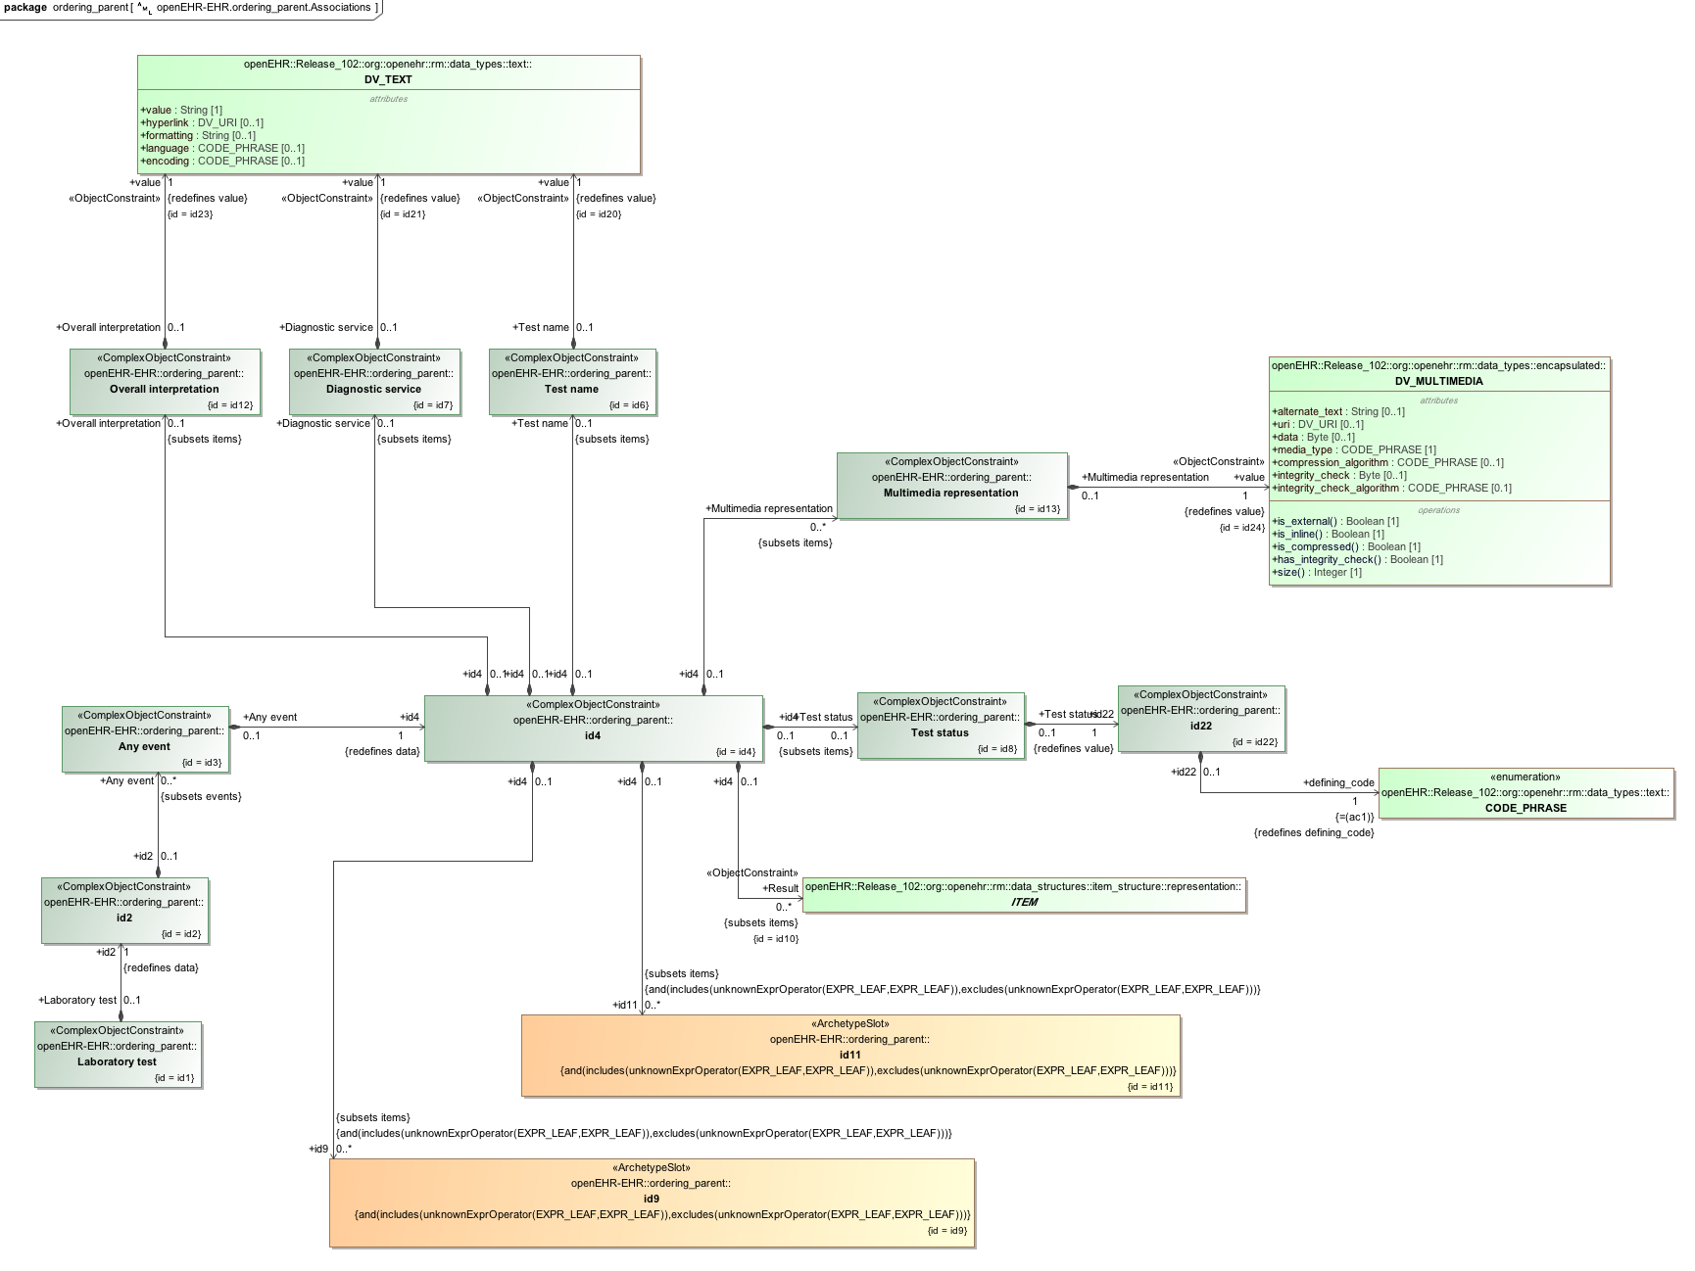

### Redefine 1 Value v1 Example

Example of redefinition of a value set into a narrower subset of the original.

#### Redefine 1 Value v1 ADL

archetype (adl_version=2.0.5; rm_release=1.0.2)

openEHR-EHR-OBSERVATION.redefine_1_value.v1.0.0

specialize

openEHR-EHR-OBSERVATION.spec_test_parent.v1

language

original_language = <[ISO_639-1::en]>

description

custodian_namespace = <"org.openehr">

custodian_organisation = <"openEHR Foundation <http://www.openEHR.org>">

original_author = <

["name"] = <"Thomas Beale">

["email"] = <"thomas.beale@openEHR.org">

["organisation"] = <"openEHR Foundation <http://www.openEHR.org>">

["date"] = <"2008-08-11">

>

details = <

["en"] = <

language = <[ISO_639-1::en]>

purpose = <"Example of redefinition of a value set into a narrower subset of the original.">

keywords = <"ADL", "test", "specialisation">

>

>

lifecycle_state = <"published">

other_details = <

["regression"] = <"PASS">

>

copyright = <"Copyright © 2008 openEHR Foundation <http://www.openEHR.org>">

licence = <"Creative Commons CC-BY-SA <https://creativecommons.org/licenses/by-sa/3.0/>">

definition

OBSERVATION[id1.1] matches { -- first level specialisation archetype

/data/events[id3]/data/items matches {

ELEMENT[id4.1] matches { -- Redefined text field

value matches {

DV_CODED_TEXT[id0.6] matches {

defining_code matches {[ac0.1]} -- (added by post-parse processor)

}

}

}

}

}

terminology

term_definitions = <

["en"] = <

["at0.1"] = <

text = <"internal code A">

description = <"internal code A description">

>

["at0.2"] = <

text = <"internal code B">

description = <"internal code B description">

>

["id1.1"] = <

text = <"first level specialisation archetype">

description = <"first level specialisation test archetype">

>

["id4.1"] = <

text = <"Redefined text field">

description = <"redefined text field">

>

["ac0.1"] = <

text = <"(added by post-parse processor)">

description = <"(added by post-parse processor)">

>

>

>

value_sets = <

["ac0.1"] = <

id = <"ac0.1">

members = <"at0.1", "at0.2">

>

>

#### Redefine 1 Value v1 ADL Diagram

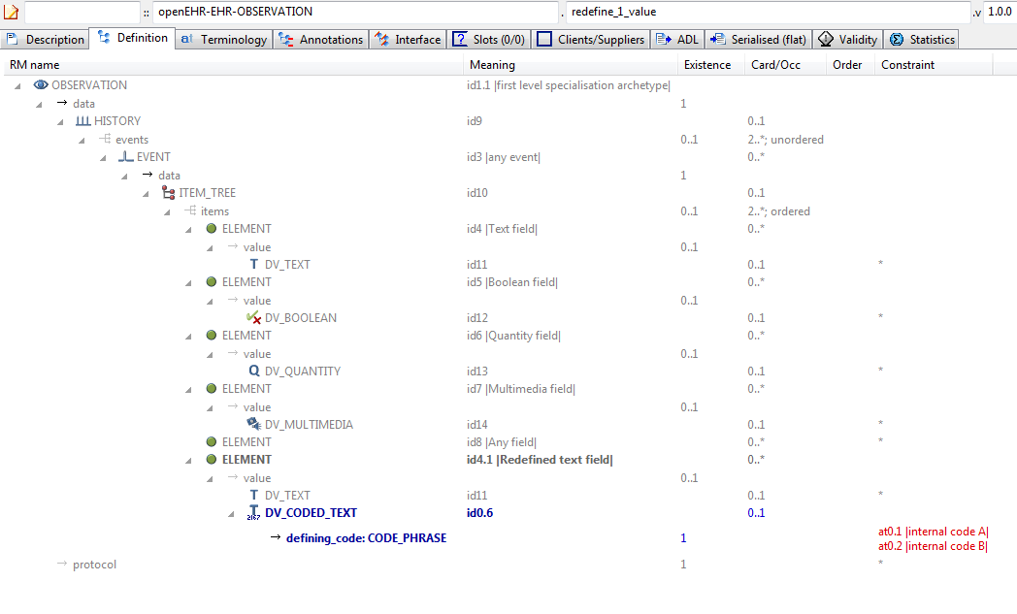

#### Redefine 1 Value v1 AML Diagram

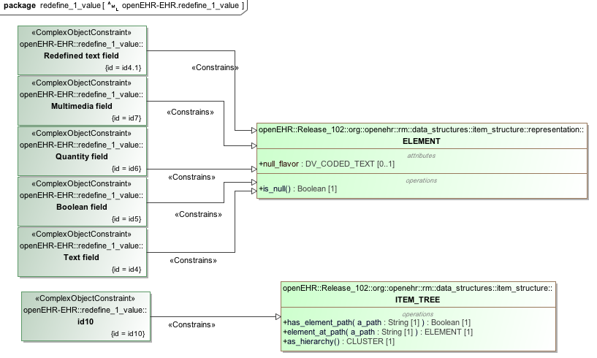

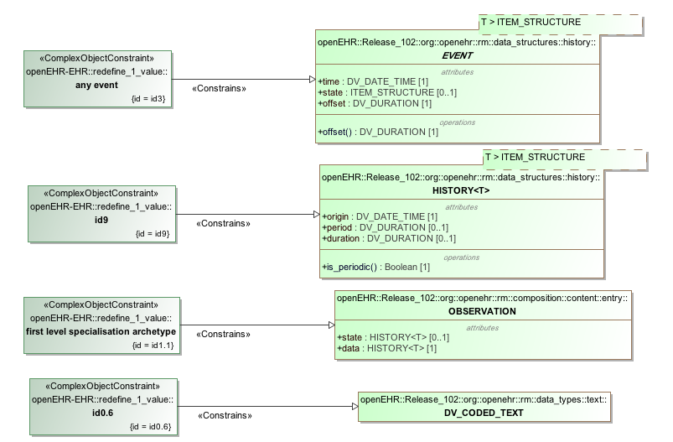

#### Redefine 1 Value v1 AML Associations Diagram

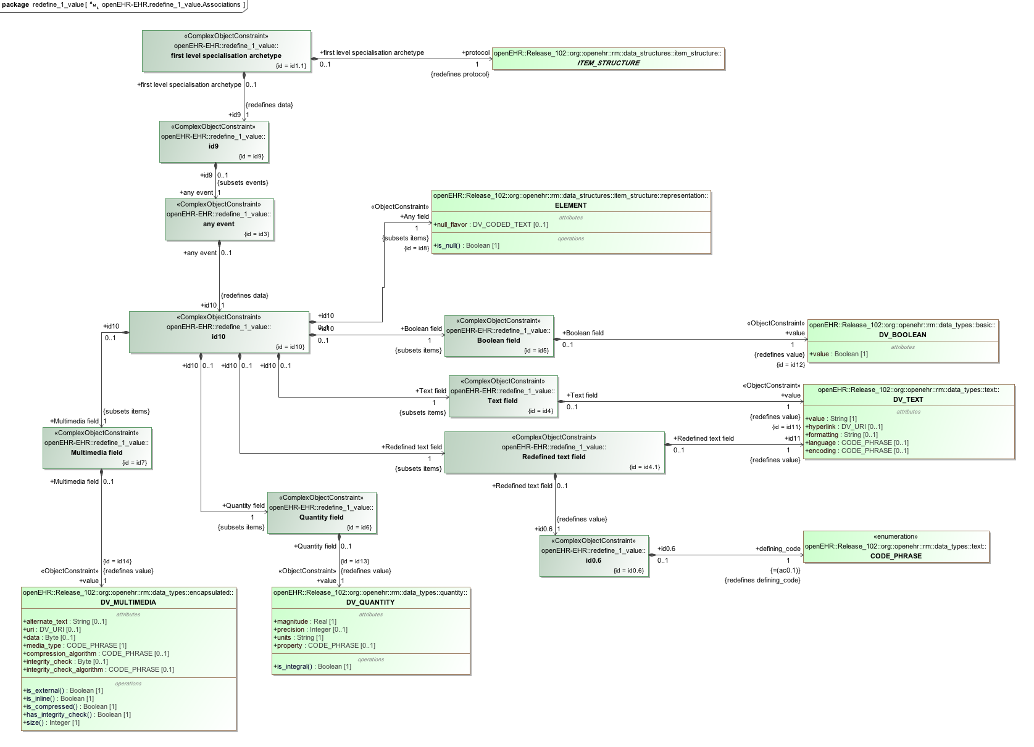

### Redefine Cardinality v1 Example

Example showing narrowing of cardinality in specialised archetype. The narrower cardinality replaces the cardinality from the parent in the computed flat form.

#### Redefine Cardinality v1 ADL

archetype (adl_version=2.0.5; rm_release=1.0.2)

openEHR-EHR-OBSERVATION.redefine_cardinality.v1.0.0

specialize

openEHR-EHR-OBSERVATION.spec_test_parent.v1

language

original_language = <[ISO_639-1::en]>

description

custodian_namespace = <"org.openehr">

custodian_organisation = <"openEHR Foundation <http://www.openEHR.org>">

original_author = <

["name"] = <"Thomas Beale">

["email"] = <"thomas.beale@openEHR.org">

["organisation"] = <"openEHR Foundation <http://www.openEHR.org>">

["date"] = <"2008-08-11">

>

details = <

["en"] = <

language = <[ISO_639-1::en]>

purpose = <"Example showing narrowing of cardinality in specialised archetype. The narrower cardinality replaces the cardinality from the parent in the computed flat form.">

keywords = <"ADL", "test", "specialisation", "cardinality">

>

>

lifecycle_state = <"published">

other_details = <

["regression"] = <"PASS">

>

copyright = <"Copyright © 2008 openEHR Foundation <http://www.openEHR.org>">

licence = <"Creative Commons CC-BY-SA <https://creativecommons.org/licenses/by-sa/3.0/>">

definition

OBSERVATION[id1.1] matches { -- specialised archetype

/data/events cardinality matches {2..8; ordered}

}

terminology

term_definitions = <

["en"] = <

["id1.1"] = <

text = <"specialised archetype">

description = <"">

>

>

>

#### Redefine Cardinality v1 ADL Diagram

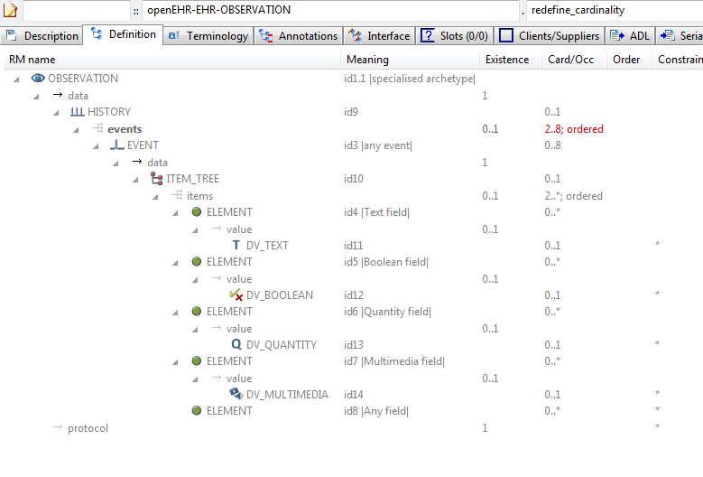

#### Redefine Cardinality v1 AML Diagram

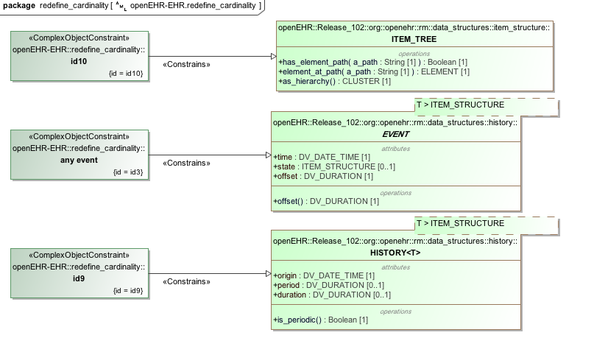

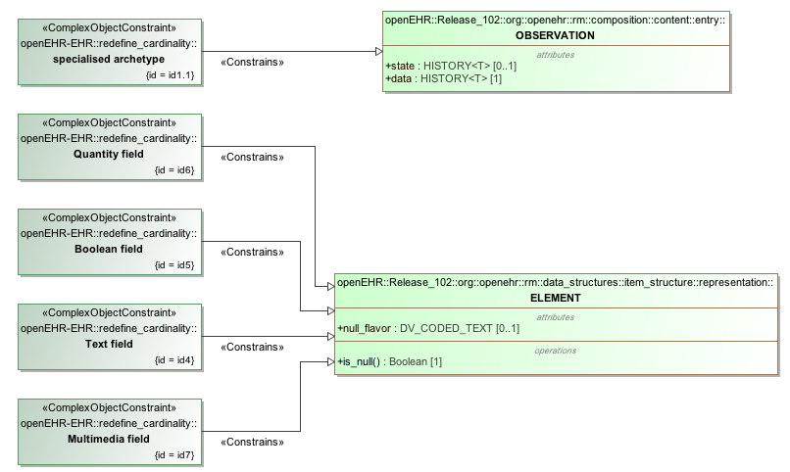

#### Redefine Cardinality v1 AML Associations Diagram

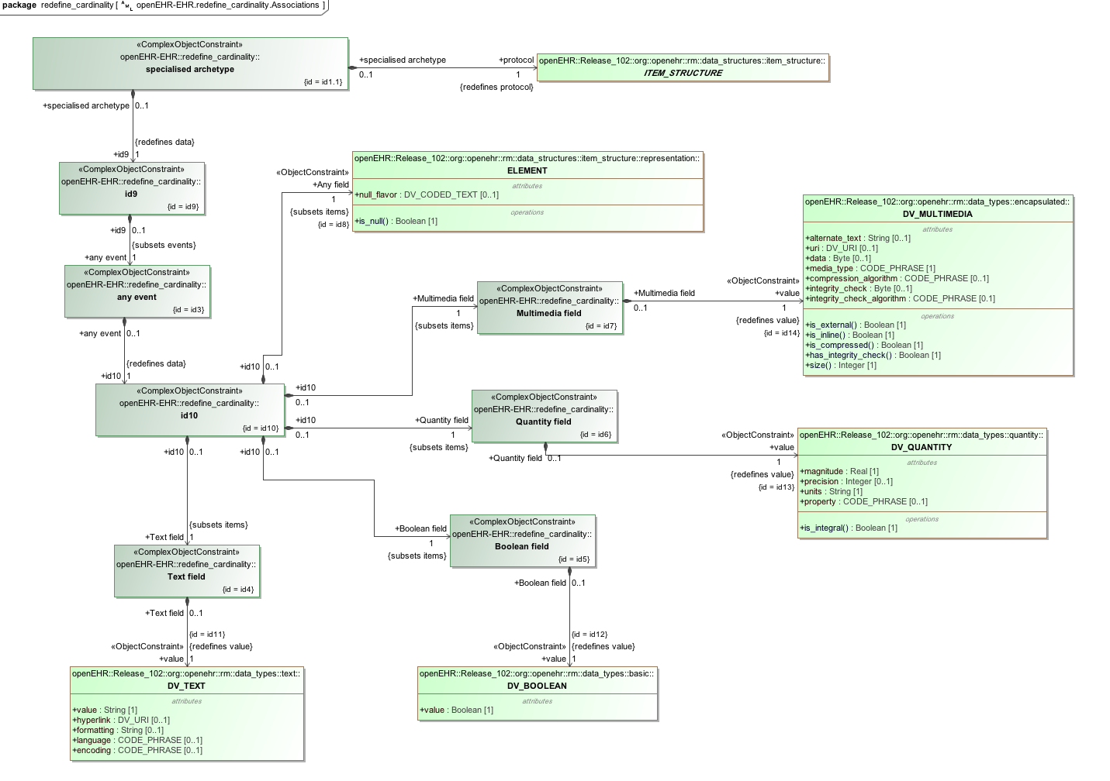

### Redefine Occurrences v1 Example

Example of refinement of occurrences to {0..1} from {0..*}.

#### Redefine Occurrences v1 ADL

archetype (adl_version=2.0.5; rm_release=1.0.2)

openEHR-EHR-OBSERVATION.redefine_occurrences.v1.0.0

specialise

openEHR-EHR-OBSERVATION.spec_test_parent.v1

language

original_language = <[ISO_639-1::en]>

description

custodian_namespace = <"org.openehr">

custodian_organisation = <"openEHR Foundation <http://www.openEHR.org>">

original_author = <

["name"] = <"Thomas Beale">

["email"] = <"thomas.beale@openEHR.org">

["organisation"] = <"openEHR Foundation <http://www.openEHR.org>">

["date"] = <"2008-08-11">

>

details = <

["en"] = <

language = <[ISO_639-1::en]>

purpose = <"Example of refinement of occurrences to {0..1} from {0..*}.">

keywords = <"ADL", "test", "specialisation">

>

>

lifecycle_state = <"published">

other_details = <

["regression"] = <"PASS">

>

copyright = <"Copyright © 2008 openEHR Foundation <http://www.openEHR.org>">

licence = <"Creative Commons CC-BY-SA <https://creativecommons.org/licenses/by-sa/3.0/>">

definition

OBSERVATION[id1.1] matches {

/data[id9]/events matches {

EVENT[id3.1] occurrences matches {0..1}

}

}

ontology

term_definitions = <

["en"] = <

["id1.1"] = <

text = <"specialised archetype">

description = <"">

>

["id3.1"] = <

text = <"any event - occurrences specialised">

description = <"">

>

>

>

#### Redefine Occurrences v1 ADL Diagram

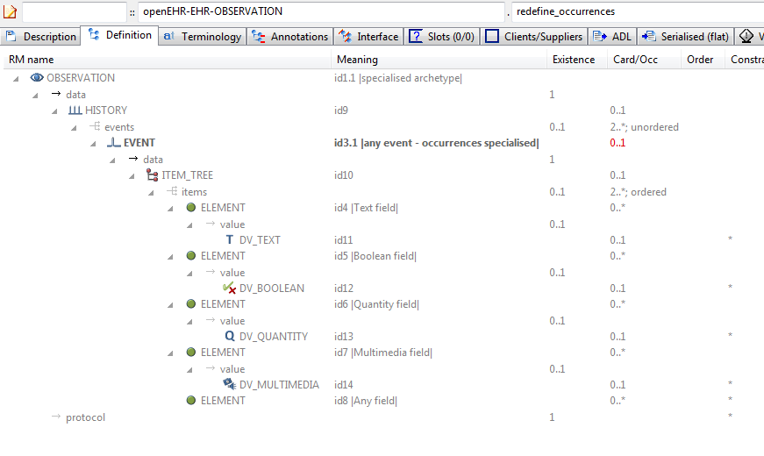

#### Redefine Occurrences v1 AML Diagram

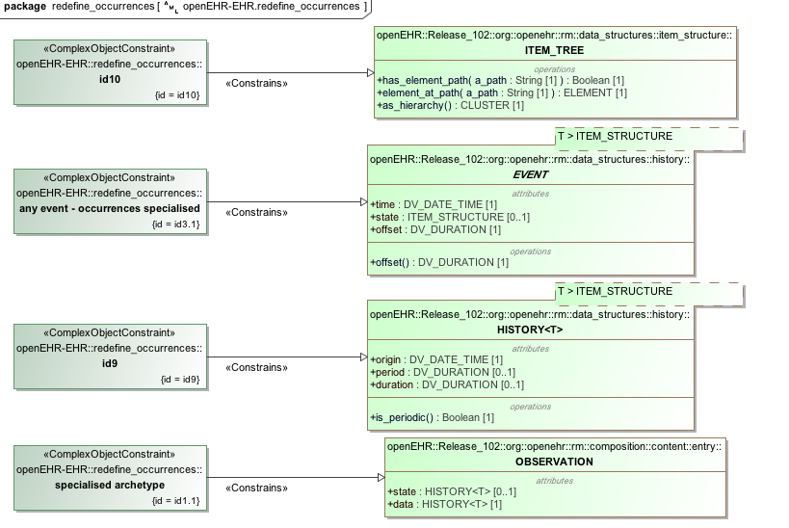

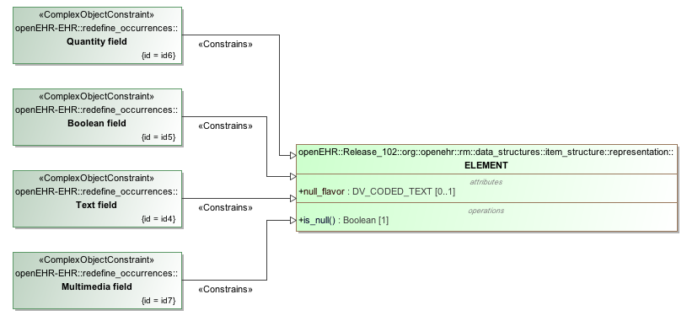

#### Redefine Occurrences v1 AML Associations Diagram

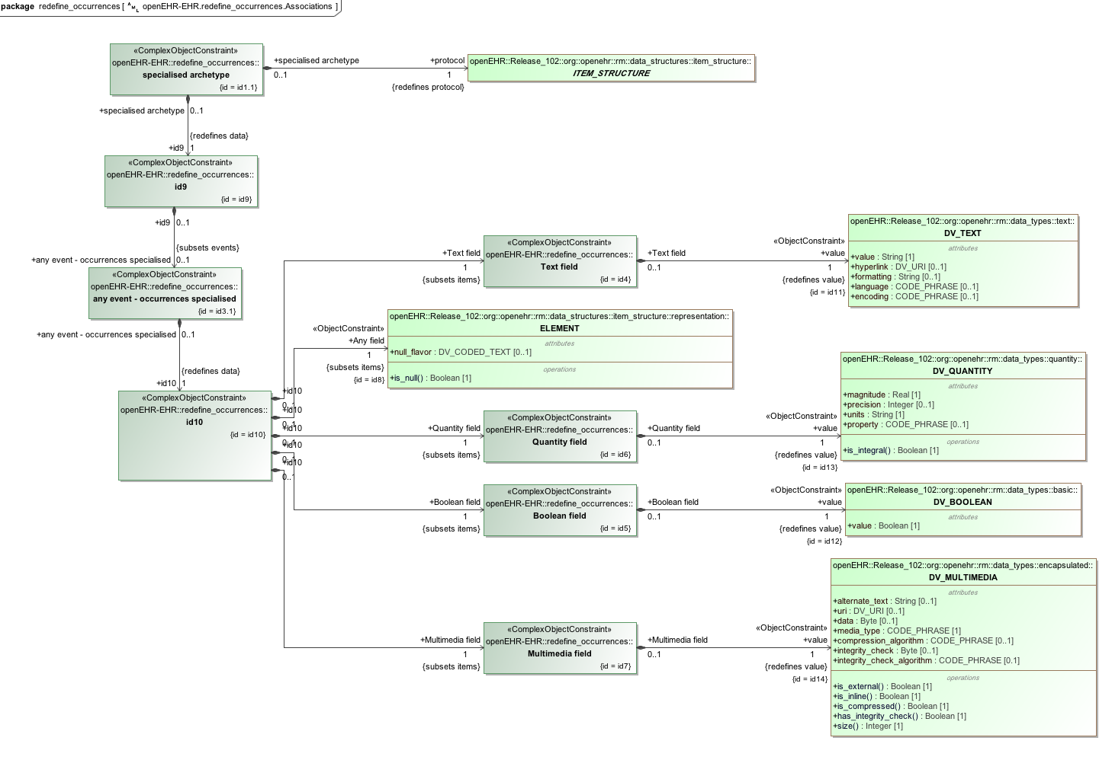

### Spec Test Obs v1 Example

Test OBSERVATION specialisation parent archetype.

#### Spec Test Obs v1 ADL

archetype (adl_version=2.0.5; rm_release=1.0.2)

openEHR-EHR-OBSERVATION.spec_test_obs.v1.0.0

language

original_language = <[ISO_639-1::en]>

description

custodian_namespace = <"org.openehr">

custodian_organisation = <"openEHR Foundation <http://www.openEHR.org>">

original_author = <

["name"] = <"Thomas Beale">

["email"] = <"thomas.beale@openEHR.org">

["organisation"] = <"openEHR Foundation <http://www.openEHR.org>">

["date"] = <"2008-08-11">

>

details = <

["en"] = <

language = <[ISO_639-1::en]>

purpose = <"Test OBSERVATION specialisation parent archetype.">

keywords = <"ADL", "test", "specialisation">

>

>

lifecycle_state = <"published">

other_details = <

["regression"] = <"PASS">

>

copyright = <"Copyright © 2008 openEHR Foundation <http://www.openEHR.org>">

licence = <"Creative Commons CC-BY-SA <https://creativecommons.org/licenses/by-sa/3.0/>">

definition

OBSERVATION[id1] matches { -- top-level archetype

data matches {

HISTORY[id9] matches {

events cardinality matches {2..*; unordered} matches {

EVENT[id3] matches { -- any event

data matches {

ITEM_TREE[id10] matches {

items cardinality matches {2..*; ordered} matches {

ELEMENT[id4] matches { -- Text field

value matches {

DV_TEXT[id11]

}

}

ELEMENT[id5] matches { -- Boolean field

value matches {

DV_BOOLEAN[id12]

}

}

ELEMENT[id6] matches { -- Quantity field

value matches {

DV_QUANTITY[id13]

}

}

ELEMENT[id7] matches { -- Multimedia field

value matches {

DV_MULTIMEDIA[id14]

}

}

ELEMENT[id8] -- Any field

}

}

}

}

}

}

}

protocol existence matches {1}

}

terminology

term_definitions = <

["en"] = <

["id1"] = <

text = <"top-level archetype">

description = <"top level test archetype for specialisation lineage">

>

["id3"] = <

text = <"any event">

description = <"*">

>

["id4"] = <

text = <"Text field">

description = <"test text field">

>

["id5"] = <

text = <"Boolean field">

description = <"test boolean field">

>

["id6"] = <

text = <"Quantity field">

description = <"test quantity field">

>

["id7"] = <

text = <"Multimedia field">

description = <"test multimedia field">

>

["id8"] = <

text = <"Any field">

description = <"test any-value field">

>

>

>

#### Spec Test Obs v1 ADL Diagram

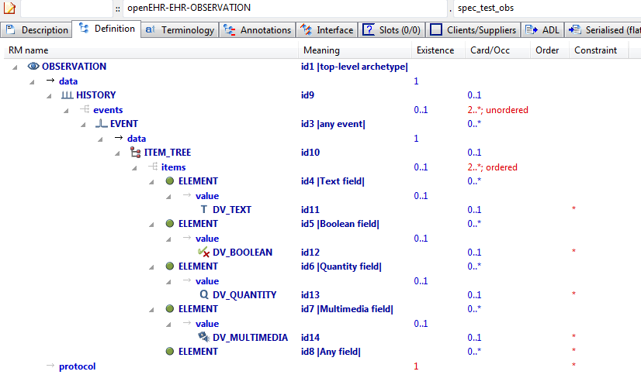

#### Spec Test Obs v1 AML Diagram

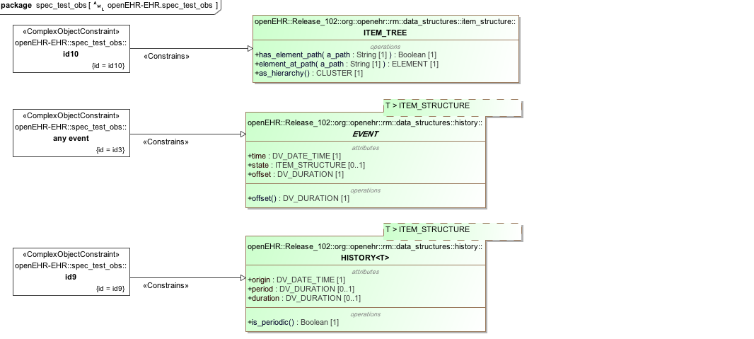

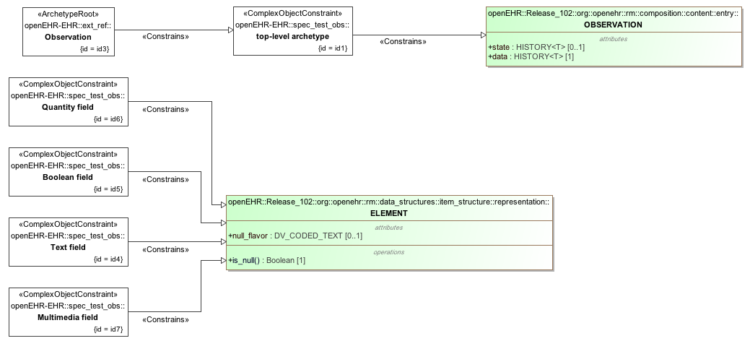

#### Spec Test Obs v1 AML Associations Diagram

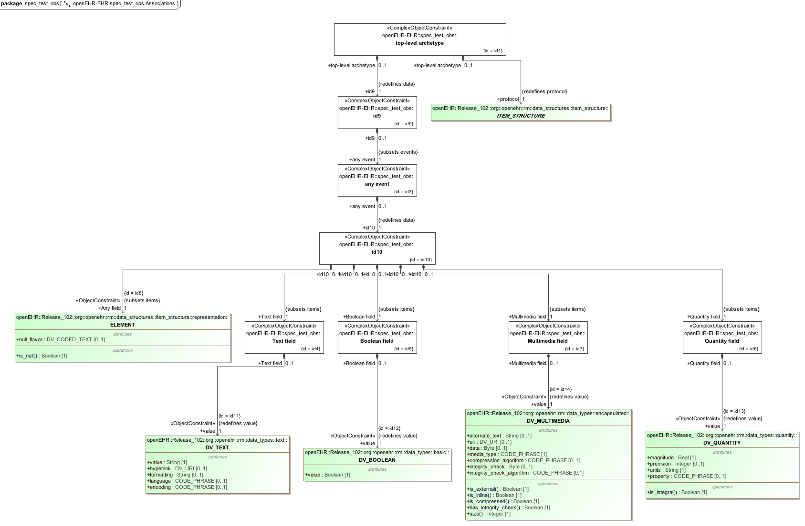

### Spec Test Parent v1 Example

Test OBSERVATION specialisation parent archetype.

#### Spec Test Parent v1 ADL

archetype (adl_version=2.0.5; rm_release=1.0.2)

openEHR-EHR-OBSERVATION.spec_test_parent.v1.0.0

language

original_language = <[ISO_639-1::en]>

description

original_author = <

["organisation"] = <"Ocean Informatics">

["name"] = <"Thomas Beale">

["date"] = <"11/8/2008">

>

details = <

["en"] = <

language = <[ISO_639-1::en]>

purpose = <"Test OBSERVATION specialisation parent archetype.">

>

>

lifecycle_state = <"unmanaged">

other_details = <

["regression"] = <"PASS">

>

definition

OBSERVATION[id1] matches { -- top-level archetype

data matches {

HISTORY[id9] matches {

events cardinality matches {2..*; unordered} matches {

EVENT[id3] matches { -- any event

data matches {

ITEM_TREE[id10] matches {

items cardinality matches {2..*; ordered} matches {

ELEMENT[id4] matches { -- Text field

value matches {

DV_TEXT[id11]

}

}

ELEMENT[id5] matches { -- Boolean field

value matches {

DV_BOOLEAN[id12]

}

}

ELEMENT[id6] matches { -- Quantity field

value matches {

DV_QUANTITY[id13]

}

}

ELEMENT[id7] matches { -- Multimedia field

value matches {

DV_MULTIMEDIA[id14]

}

}

ELEMENT[id8] -- Any field

}

}

}

}

}

}

}

protocol existence matches {1}

}

terminology

term_definitions = <

["en"] = <

["id1"] = <

text = <"top-level archetype">

description = <"top level test archetype for specialisation lineage">

>

["id3"] = <

text = <"any event">

description = <"*">

>

["id4"] = <

text = <"Text field">

description = <"test text field">

>

["id5"] = <

text = <"Boolean field">

description = <"test boolean field">

>

["id6"] = <

text = <"Quantity field">

description = <"test quantity field">

>

["id7"] = <

text = <"Multimedia field">

description = <"test multimedia field">

>

["id8"] = <

text = <"Any field">

description = <"test any-value field">

>

>

>

#### Spec Test Parent v1 ADL Diagram

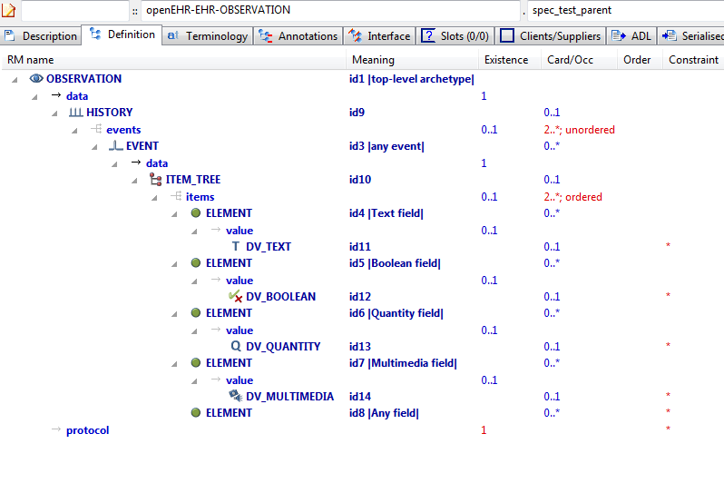

#### Spec Test Parent v1 AML Diagram

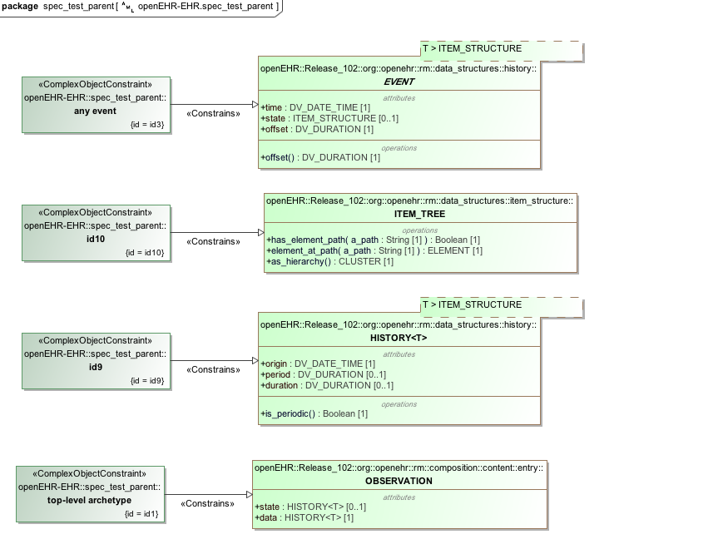

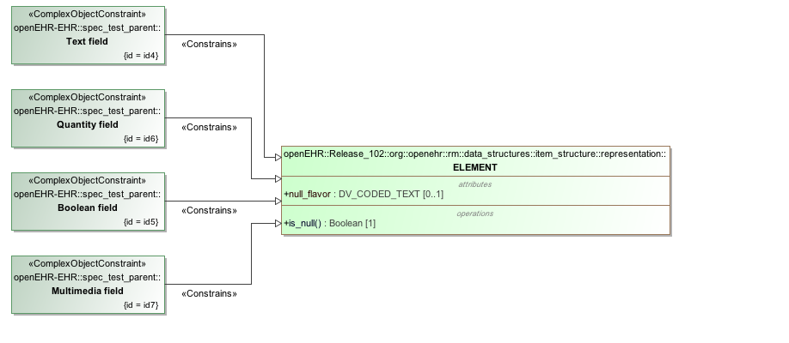

#### Spec Test Parent v1 AML Associations Diagram

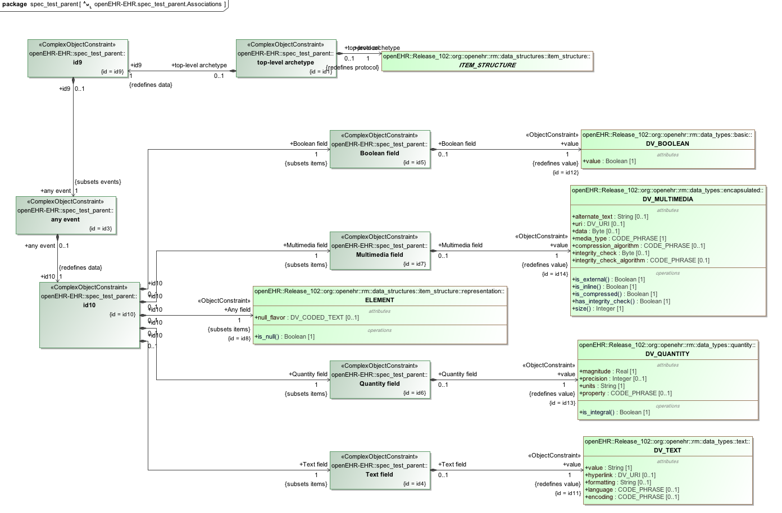

### Tuple Redefine To Single v1 Example

Illustrate redefinition of tuple to narrower tuple consisting of one item only.

#### Tuple Redefine To Single v1 ADL

archetype (adl_version=2.0.5; rm_release=1.0.2)

openEHR-EHR-OBSERVATION.tuple_redefine_to_single.v1.0.0

specialize

openEHR-EHR-OBSERVATION.tuple_parent.v1

...

definition

OBSERVATION[id1.1] matches { -- Intravascular pressure redefined

/data[id2]/events[id3]/data[id4]/items[id6]/value matches {

DV_QUANTITY[id42] matches {

[magnitude, units, precision] matches {

[{|>=0.0|}, {"cm[H20]"}, {2}]

}

}

}

}

terminology

term_definitions = <

["en"] = <

["id1.1"] = <

text = <"Intravascular pressure redefined">

description = <"The pressure in a specific location, blood vessel or heart cavity, at a specific phase of the heart or an average over the heart cycle.">

>

>

>

#### Tuple Redefine To Single v1 ADL Diagram

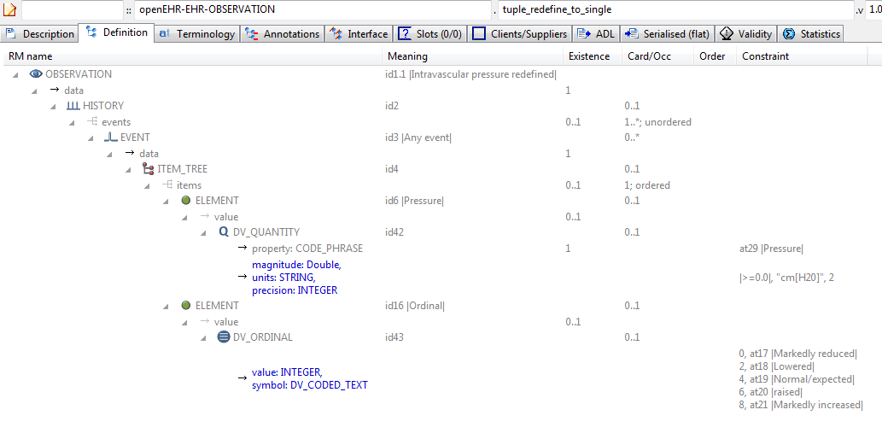

#### Tuple Redefine To Single v1 AML Diagram

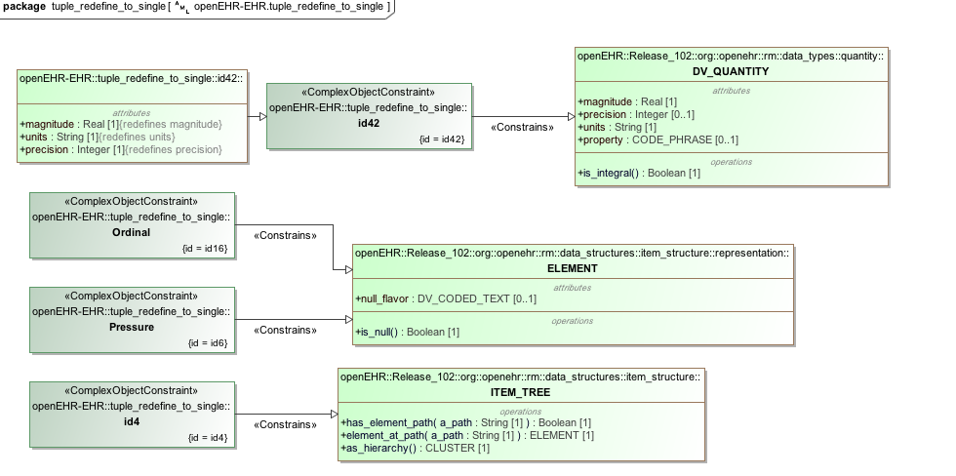

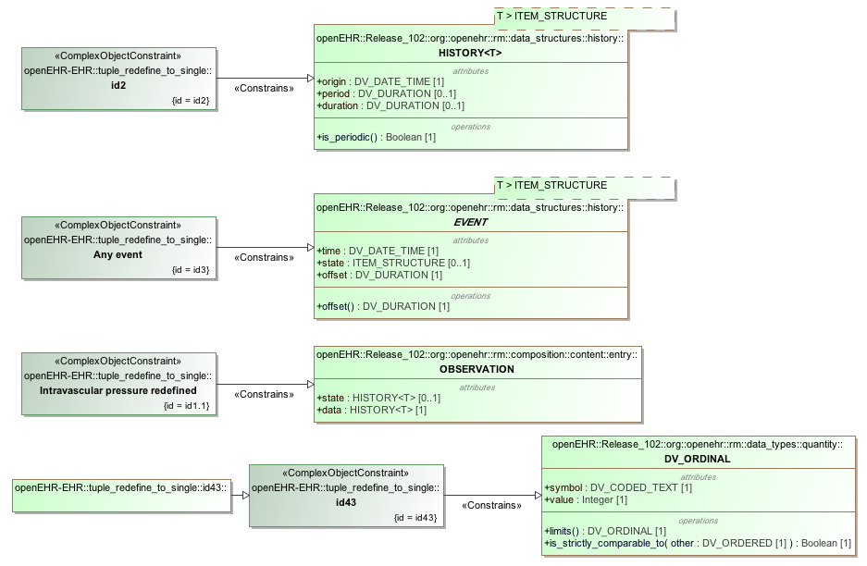

#### Tuple Redefine To Single v1 AML Associations Diagram

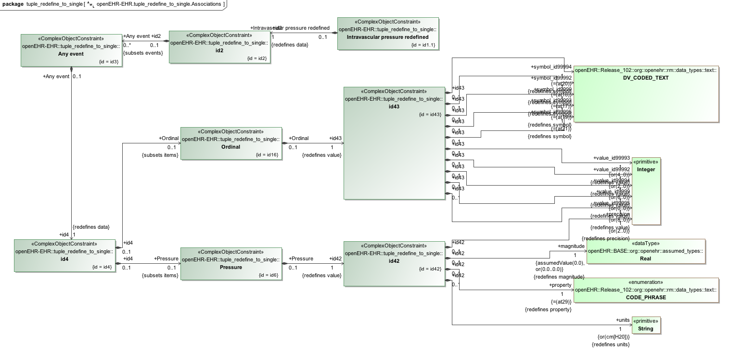

### Simple node identification

The example below assigns an identifier (id1) and a name/description to a reference model SECTION class. The «Resource_Translation» carries the link between the identifier, the text ("Physical examination") and the description, which is modeled as a UML Comment.

#### Section Parent v1 ADL

archetype (adl_version=2.0.5; rm_release=1.0.2)

openEHR-EHR-SECTION.section_parent.v1.0.0

definition

SECTION[**id1**] -- Physical examination

terminology

term_definitions = <

["en"] = <

**["id1"] = <**

**text = <"Physical examination">**

**description = <"An open section for recording physical examination findings">**

**>**

>

>

#### ADL Diagram

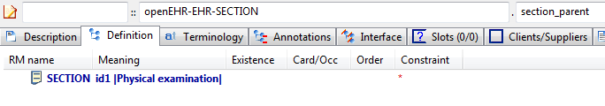

#### AML Diagrams

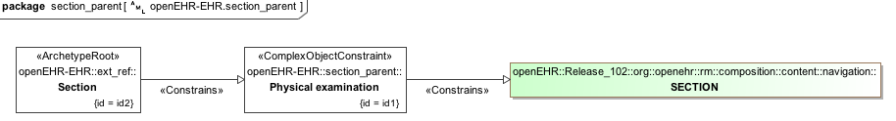

## 

## Terminology Binding

### Basic Term Bindings Example

Simple example of LOINC terminology bindings to id-codes, where *id5*, the 5 minute Apgar score (*id7*) is bound to the LOINC code 9271-8 and the Total (*id5*) to 9271-8.

#### ADL

archetype (adl_version=2.0.5; rm_release=1.0.2)

openEHR-EHR-OBSERVATION.term_bindings_basic.v1.0.0

definition

OBSERVATION[id1] matches { -- Apgar score

data matches {

HISTORY[id3] matches {

events cardinality matches {1..*; unordered} matches {

POINT_EVENT[id4] occurrences matches {0..1} matches { -- 1 minute

data matches {

ITEM_LIST[id2] matches {

items cardinality matches {1..6; ordered} matches {

ELEMENT[id5] occurrences matches {0..1} **-- Total**

}

}

}

}

POINT_EVENT[id7] occurrences matches {0..1} matches { **-- 5 minute**

...

}

}

}

}

}

terminology

term_definitions = <

["en"] = <

["id1"] = <

text = <"Apgar score">

description = <"Clinical score derived from assessment of respiratory effort, heart rate, reflex irritability, muscle tone and skin colour.">

>

["id4"] = <

text = <"1 minute">

description = <"Apgar score 1 minute after birth">

>

**["id5"] = <**

**text = <"Total">**

**description = <"The sum of the 5 ordinal scores for each component parameter.">**

**>**

**["id7"] = <**

**text = <"5 minute">**

**description = <"Apgar score 5 minutes after birth">**

**>**

>

>

term_bindings = <

["LNC205"] = <

**["id5"] = <http://loinc.org/id/9272-6>**

**["id7"] = <http://loinc.org/id/9271-8>**

>

>

#### ADL Diagram

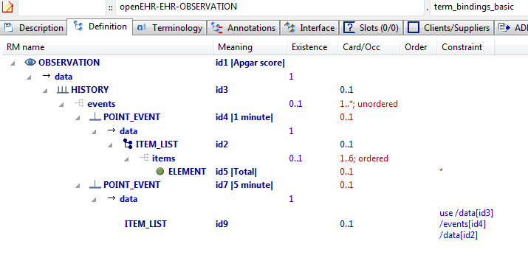

#### AML Diagrams

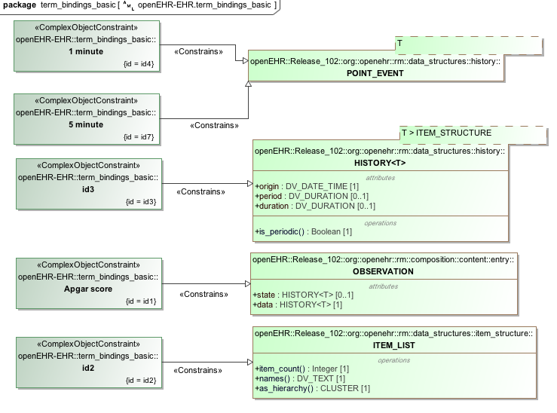

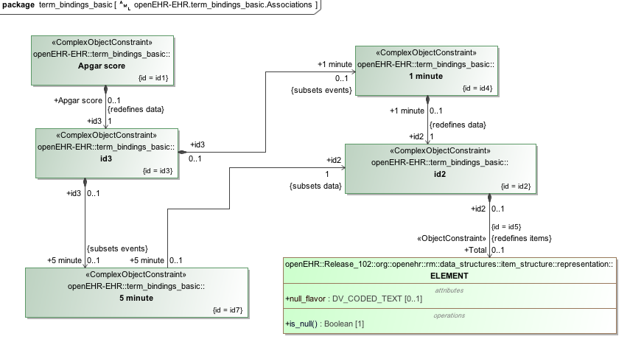

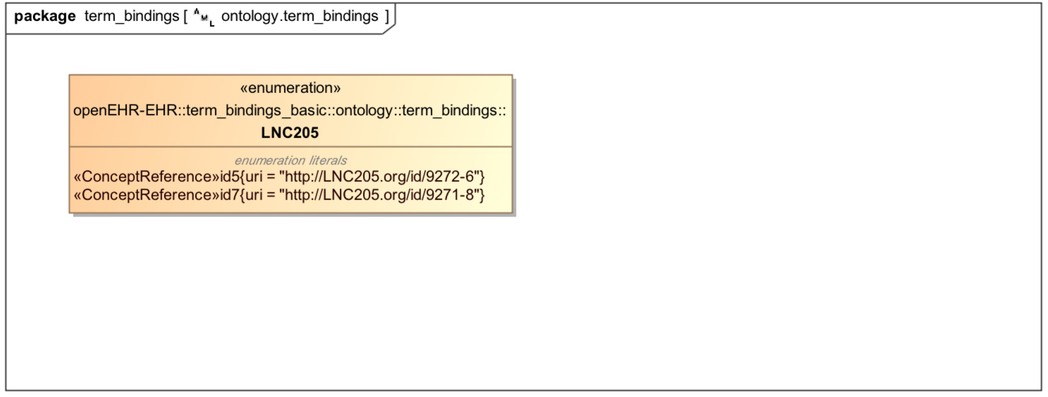

### Term Bindings With Paths

Simple example of a term binding to a path rather than a code. The meaning of this is that the binding only relates to the node at the path, whereas with a code-only binding, it relates to every location where that node appears (e.g. due to use_node internal references) or that the code appears (due to static definition).

#### Term Bindings Paths ADL

archetype (adl_version=2.0.5; rm_release=1.0.2)

openEHR-EHR-OBSERVATION.term_bindings_paths.v1.0.0

definition

OBSERVATION[id1] matches { -- Apgar score

data matches {

HISTORY[id3] matches {

events cardinality matches {1..*; unordered} matches {

POINT_EVENT[id4] occurrences matches {0..1} matches { -- 1 minute

data matches {

ITEM_LIST[id2] matches {

items cardinality matches {1..6; ordered} matches {

**ELEMENT[id5] occurrences matches {0..1} -- Total**

}

}

}

}

POINT_EVENT[id7] occurrences matches {0..1} matches { -- 5 minute

data matches {

use_node ITEM_LIST[id9] /data[id3]/events[id4]/data[id2]

}

}

}

}

}

}

terminology

term_definitions = <

["en"] = <

["id1"] = <

text = <"Apgar score">

description = <"Clinical score derived from assessment of respiratory effort, heart rate, reflex irritability, muscle tone and skin colour.">

>

["id4"] = <

text = <"1 minute">

description = <"Apgar score 1 minute after birth">

>

["id5"] = <

text = <"Total">

description = <"The sum of the 5 ordinal scores for each component parameter.">

>

...

>

>

**term_bindings = <**

**["LNC205"] = <**

**["/data[id3]/events[id4]/data[id2]/items[id5]"] = <http://loinc.org/id/9274-6>**

**>**

**>**

#### Term Bindings Paths ADL Diagram

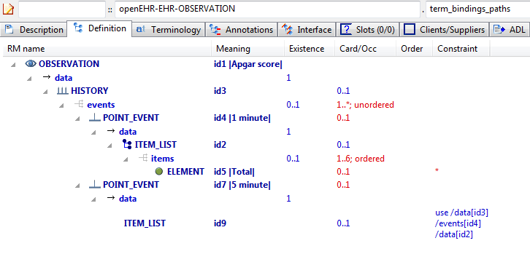

#### Term Bindings Paths AML Diagram

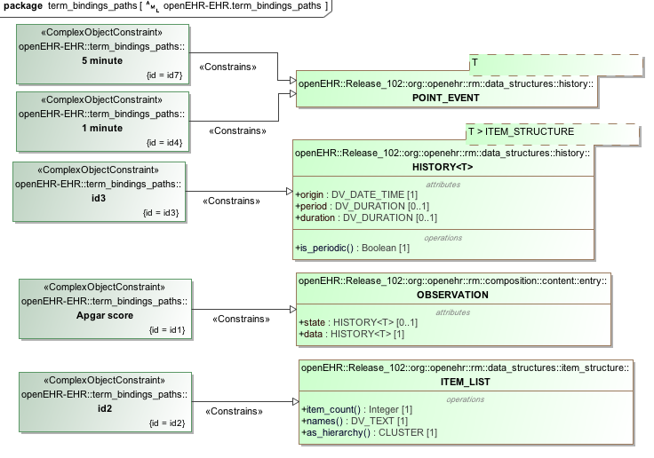

#### Term Bindings Paths AML Associations Diagram

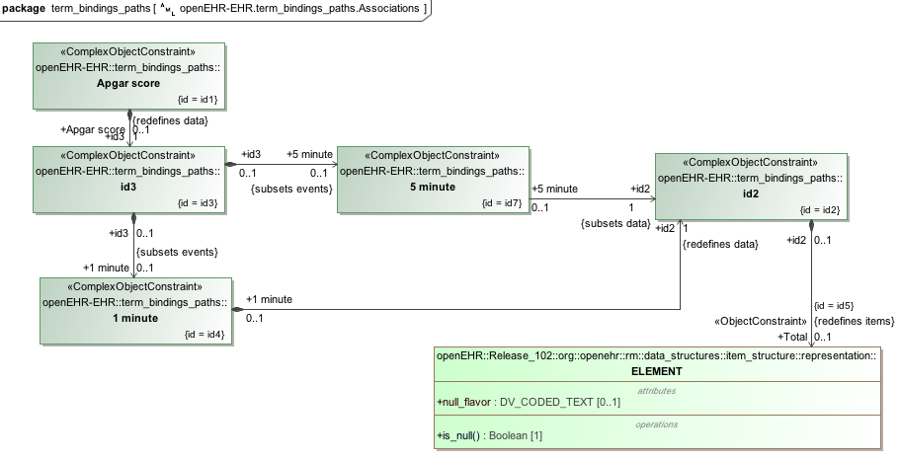

### Term Bindings Paths Use Refs v1 Example

Example of bindings to paths that traverse use_node references, i.e. paths that are computed when taking a use_node internal reference into account.

#### Term Bindings Paths Use Refs v1 ADL

archetype (adl_version=2.0.5; rm_release=1.0.2)

openEHR-EHR-OBSERVATION.term_bindings_paths_use_refs.v1.0.0

language

original_language = <[ISO_639-1::en]>

description

custodian_namespace = <"org.openehr">

custodian_organisation = <"openEHR Foundation <http://www.openEHR.org>">

original_author = <

["name"] = <"Thomas Beale">

["email"] = <"thomas.beale@openEHR.org">

["organisation"] = <"openEHR Foundation <http://www.openEHR.org>">

["date"] = <"2012-10-21">

>

details = <

["en"] = <

language = <[ISO_639-1::en]>

purpose = <"Example of bindings to paths that traverse use_node references, i.e. paths that are computed when taking a use_node internal reference into account.">

keywords = <"ADL", "test", "terminology bindings">

>

>

lifecycle_state = <"published">

other_details = <

["regression"] = <"PASS">

>

copyright = <"Copyright © 2012 openEHR Foundation <http://www.openEHR.org>">

licence = <"Creative Commons CC-BY-SA <https://creativecommons.org/licenses/by-sa/3.0/>">

definition

OBSERVATION[id1] matches { -- Apgar score

data matches {

HISTORY[id3] matches {

events cardinality matches {1..*; unordered} matches {

POINT_EVENT[id4] occurrences matches {0..1} matches { -- 1 minute

offset matches {

DV_DURATION[id46] matches {

value matches {PT1M}

}

}

data matches {

ITEM_LIST[id2] matches {

items cardinality matches {1..6; ordered} matches {

ELEMENT[id10] occurrences matches {0..1} matches { -- Respiratory effort

value matches {

DV_ORDINAL[id47] matches {

[value, symbol] matches {

[{0}, {[at11]}],

[{1}, {[at12]}],

[{2}, {[at13]}]

}

}

}

}

ELEMENT[id6] occurrences matches {0..1} matches { -- Heart Rate

value matches {

DV_ORDINAL[id48] matches {

[value, symbol] matches {

[{0}, {[at7]}],

[{1}, {[at8]}],

[{2}, {[at9]}]

}

}

}

}

ELEMENT[id14] occurrences matches {0..1} matches { -- Muscle tone

value matches {

DV_ORDINAL[id49] matches {

[value, symbol] matches {

[{0}, {[at15]}],

[{1}, {[at16]}],

[{2}, {[at17]}]

}

}

}

}

ELEMENT[id18] occurrences matches {0..1} matches { -- Reflex irritability

value matches {

DV_ORDINAL[id50] matches {

[value, symbol] matches {

[{0}, {[at19]}],

[{1}, {[at20]}],

[{2}, {[at21]}]

}

}

}

}

ELEMENT[id22] occurrences matches {0..1} matches { -- Skin colour

value matches {

DV_ORDINAL[id51] matches {

[value, symbol] matches {

[{0}, {[at23]}],

[{1}, {[at24]}],

[{2}, {[at25]}]

}

}

}

}

ELEMENT[id26] occurrences matches {0..1} matches { -- Total

value matches {

DV_COUNT[id52] matches {

magnitude matches {|0..10|}

}

}

}

}

}

}

}

POINT_EVENT[id27] occurrences matches {0..1} matches { -- 2 minute

offset matches {

DV_DURATION[id53] matches {

value matches {PT2M}

}

}

data matches {

use_node ITEM_LIST[id41] /data[id3]/events[id4]/data[id2] -- /data[id3]/events[1 minute]/data[id2]

}

}

POINT_EVENT[id28] occurrences matches {0..1} matches { -- 3 minute

offset matches {

DV_DURATION[id54] matches {

value matches {PT3M}

}

}

data matches {

use_node ITEM_LIST[id42] /data[id3]/events[id4]/data[id2] -- /data[id3]/events[1 minute]/data[id2]

}

}

POINT_EVENT[id29] occurrences matches {0..1} matches { -- 5 minute

offset matches {

DV_DURATION[id55] matches {

value matches {PT5M}

}

}

data matches {

use_node ITEM_LIST[id43] /data[id3]/events[id4]/data[id2] -- /data[id3]/events[1 minute]/data[id2]

}

}

POINT_EVENT[id32] occurrences matches {0..1} matches { -- 10 minute

offset matches {

DV_DURATION[id56] matches {

value matches {PT10M}

}

}

data matches {

use_node ITEM_LIST[id44] /data[id3]/events[id4]/data[id2] -- /data[id3]/events[1 minute]/data[id2]

}

}

EVENT[id38] occurrences matches {0..*} matches { -- Any event

data matches {

use_node ITEM_LIST[id45] /data[id3]/events[id4]/data[id2] -- /data[id3]/events[1 minute]/data[id2]

}

}

}

}

}

protocol matches {

ITEM_LIST[id30] matches {

items matches {

ELEMENT[id31] occurrences matches {0..1} matches { -- Notes on measurement

value matches {

DV_TEXT[id57]

}

}

}

}

}

}

terminology

term_definitions = <

["en"] = <

["id1"] = <

text = <"Apgar score">

description = <"Clinical score derived from assessment of respiratory effort, heart rate, reflex irritability, muscle tone and skin colour.">

>

["id4"] = <

text = <"1 minute">

description = <"Apgar score 1 minute after birth.">

>

["id6"] = <

text = <"Heart Rate">

description = <"Recording of the infant's heart rate.">

>

["at7"] = <

text = <"Absent">

description = <"No heart beat is seen, felt or heard.">

>

["at8"] = <

text = <"<100 beats per minute">

description = <"Heart rate less than 100 beats per minute.">

>

["at9"] = <

text = <"≥100 beats per minute">

description = <"Heart rate greater than or equal to 100 beats per minute.">

>

["id10"] = <

text = <"Respiratory effort">

description = <"Observation of the infant's respiratory effort.">

>

["at11"] = <

text = <"Absent">

description = <"No effort to breath.">

>

["at12"] = <

text = <"Weak or irregular">

description = <"Some effort to breath, moving chest.">

>

["at13"] = <

text = <"Normal">

description = <"Breathing normally or crying.">

>

["id14"] = <

text = <"Muscle tone">

description = <"Observation of the infant's muscle tone.">

>

["at15"] = <

text = <"Limp or flaccid">

description = <"No spontaneous movement.">

>

["at16"] = <

text = <"Reduced tone">

description = <"Some flexion of extremities.">

>

["at17"] = <

text = <"Normal tone">

description = <"Normal, vigorous movements.">

>

["id18"] = <

text = <"Reflex irritability">

description = <"Observation of the response of the infant to an irritant stimulation, for example, suctioning the oropharynx and nares with a soft rubber catheter.">

>

["at19"] = <

text = <"No response">

description = <"No response to stimulation.">

>

["at20"] = <

text = <"Reduced response">

description = <"Grimace or feeble cry when stimulated.">

>

["at21"] = <

text = <"Normal response">

description = <"Grimace, sneeze, cough or pulls away when stimulated.">

>

["id22"] = <

text = <"Skin colour">

description = <"Observation of the skin colour of the infant.">

>

["at23"] = <

text = <"Completely blue">

description = <"Body and extremities are blue.">

>

["at24"] = <

text = <"Body pink; extremities blue">

description = <"Body is pink; extremities are blue.">

>

["at25"] = <

text = <"Completely pink">

description = <"Body and extremities are pink; no cyanosis.">

>

["id26"] = <

text = <"Total">

description = <"The sum of the 5 ordinal scores for each component parameter.">

>

["id27"] = <

text = <"2 minute">

description = <"Apgar score 2 minutes after birth.">

>

["id28"] = <

text = <"3 minute">

description = <"Apgar score 3 minutes after birth.">

>

["id29"] = <

text = <"5 minute">

description = <"Apgar score 5 minutes after birth.">

>

["id31"] = <

text = <"Notes on measurement">

description = <"Notes on measurement of the Apgar score.">

>

["id32"] = <

text = <"10 minute">

description = <"Apgar score 10 minutes after birth.">

>

["id38"] = <

text = <"Any event">

description = <"Apgar score at any additional time, as required.">

>

["ac1"] = <

text = <"Respiratory effort">

description = <"Observation of the infant's respiratory effort.">

>

["ac2"] = <

text = <"Heart Rate">

description = <"Recording of the infant's heart rate.">

>

["ac3"] = <

text = <"Muscle tone">

description = <"Observation of the infant's muscle tone.">

>

["ac4"] = <

text = <"Reflex irritability">

description = <"Observation of the response of the infant to an irritant stimulation, for example, suctioning the oropharynx and nares with a soft rubber catheter.">

>

["ac5"] = <

text = <"Skin colour">

description = <"Observation of the skin colour of the infant.">

>

["ac6"] = <

text = <"Respiratory effort (synthesised)">

description = <"Observation of the infant's respiratory effort. (synthesised)">

>

["ac7"] = <

text = <"Heart Rate (synthesised)">

description = <"Recording of the infant's heart rate. (synthesised)">

>

["ac8"] = <

text = <"Muscle tone (synthesised)">

description = <"Observation of the infant's muscle tone. (synthesised)">

>

["ac9"] = <

text = <"Reflex irritability (synthesised)">

description = <"Observation of the response of the infant to an irritant stimulation, for example, suctioning the oropharynx and nares with a soft rubber catheter. (synthesised)">

>

["ac10"] = <

text = <"Skin colour (synthesised)">

description = <"Observation of the skin colour of the infant. (synthesised)">

>

>

>

term_bindings = <

["SNOMED-CT"] = <

["/data[id3]/events[id4]/data[id2]/items[id26]"] = <http://snomedct.info/id/169895004>

["/data[id3]/events[id29]/data[id2]/items[id26]"] = <http://snomedct.info/id/169909004>

["/data[id3]/events[id32]/data[id2]/items[id26]"] = <http://snomedct.info/id/169922007>

["/data[id3]/events[id38]/data[id2]/items[id26]"] = <http://snomedct.info/id/364592005>

["id26"] = <http://snomedct.info/id/249228009>

>

["LOINC"] = <

["/data[id3]/events[id4]"] = <http://loinc.org/id/48334-7>

["/data[id3]/events[id4]/data[id2]/items[id6]"] = <http://loinc.org/id/32407-9>

["/data[id3]/events[id4]/data[id2]/items[id10]"] = <http://loinc.org/id/32410-3>

["/data[id3]/events[id4]/data[id2]/items[id14]"] = <http://loinc.org/id/32408-7>

["/data[id3]/events[id4]/data[id2]/items[id18]"] = <http://loinc.org/id/32409-5>

["/data[id3]/events[id4]/data[id2]/items[id22]"] = <http://loinc.org/id/32406-1>

["/data[id3]/events[id4]/data[id2]/items[id26]"] = <http://loinc.org/id/9272-6>

["/data[id3]/events[id27]/data[id2]/items[id26]"] = <http://loinc.org/id/9273-4>

["/data[id3]/events[id29]"] = <http://loinc.org/id/48333-9>

["/data[id3]/events[id29]/data[id2]/items[id6]"] = <http://loinc.org/id/32412-9>

["/data[id3]/events[id29]/data[id2]/items[id10]"] = <http://loinc.org/id/32415-2>

["/data[id3]/events[id29]/data[id2]/items[id14]"] = <http://loinc.org/id/32413-7>

["/data[id3]/events[id29]/data[id2]/items[id18]"] = <http://loinc.org/id/32414-5>

["/data[id3]/events[id29]/data[id2]/items[id22]"] = <http://loinc.org/id/32411-1>

["/data[id3]/events[id29]/data[id2]/items[id26]"] = <http://loinc.org/id/9274-2>

["/data[id3]/events[id32]"] = <http://loinc.org/id/48332-1>

["/data[id3]/events[id32]/data[id2]/items[id6]"] = <http://loinc.org/id/32402-0>

["/data[id3]/events[id32]/data[id2]/items[id10]"] = <http://loinc.org/id/32405-3>

["/data[id3]/events[id32]/data[id2]/items[id14]"] = <http://loinc.org/id/32403-8>

["/data[id3]/events[id32]/data[id2]/items[id18]"] = <http://loinc.org/id/32404-6>

["/data[id3]/events[id32]/data[id2]/items[id22]"] = <http://loinc.org/id/32401-2>

["/data[id3]/events[id32]/data[id2]/items[id26]"] = <http://loinc.org/id/9271-8>

["at7"] = <http://loinc.org/id/LA6716>

["at8"] = <http://loinc.org/id/LA6717>

["at9"] = <http://loinc.org/id/LA6718>

["at11"] = <http://loinc.org/id/LA6725>

["at12"] = <http://loinc.org/id/LA6726>

["at13"] = <http://loinc.org/id/LA6727>

["at15"] = <http://loinc.org/id/LA6713>

["at16"] = <http://loinc.org/id/LA6714>

["at17"] = <http://loinc.org/id/LA6715>

["at19"] = <http://loinc.org/id/LA6719>

["at20"] = <http://loinc.org/id/LA6720>

["at21"] = <http://loinc.org/id/LA6721>

["at23"] = <http://loinc.org/id/LA6722>

["at24"] = <http://loinc.org/id/LA6723>

["at25"] = <http://loinc.org/id/LA6724>

>

>

value_sets = <

["ac1"] = <

id = <"ac1">

members = <"at11", "at12", "at13">

>

["ac2"] = <

id = <"ac2">

members = <"at7", "at8", "at9">

>

["ac3"] = <

id = <"ac3">

members = <"at15", "at16", "at17">

>

["ac4"] = <

id = <"ac4">

members = <"at19", "at20", "at21">

>

["ac5"] = <

id = <"ac5">

members = <"at23", "at24", "at25">

>

["ac6"] = <

id = <"ac6">

members = <"at11", "at12", "at13">

>

["ac7"] = <

id = <"ac7">

members = <"at7", "at8", "at9">

>

["ac8"] = <

id = <"ac8">

members = <"at15", "at16", "at17">

>

["ac9"] = <

id = <"ac9">

members = <"at19", "at20", "at21">

>

["ac10"] = <

id = <"ac10">

members = <"at23", "at24", "at25">

>

>

#### Term Bindings Paths Use Refs v1 ADL Diagram

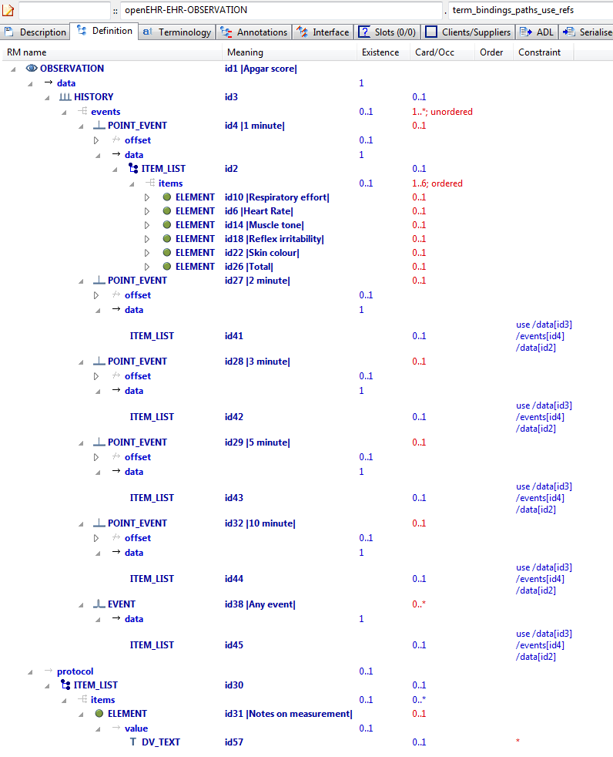

#### Term Bindings Paths Use Refs v1 AML Diagram

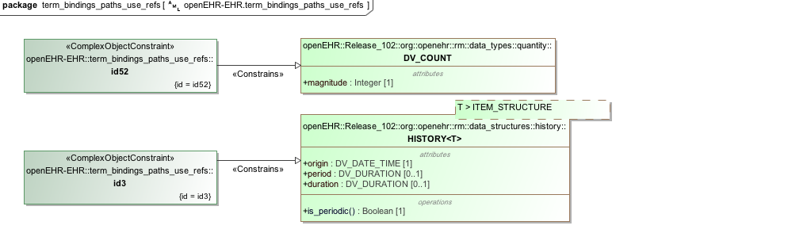

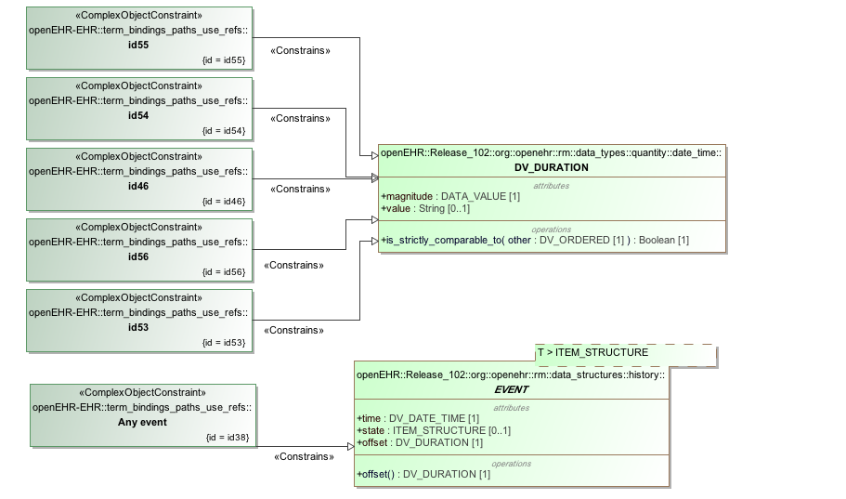

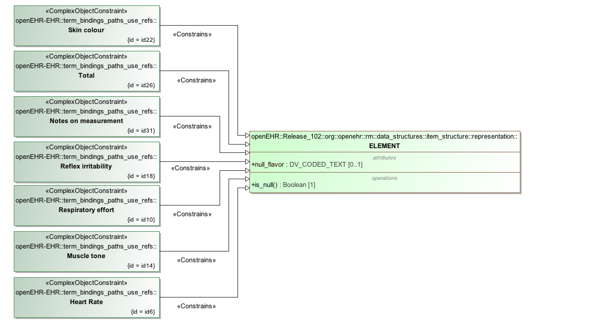

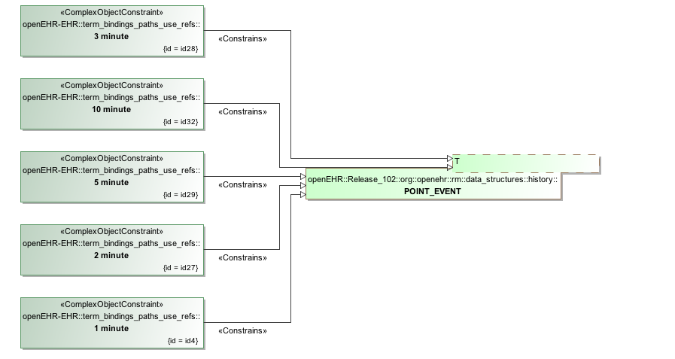

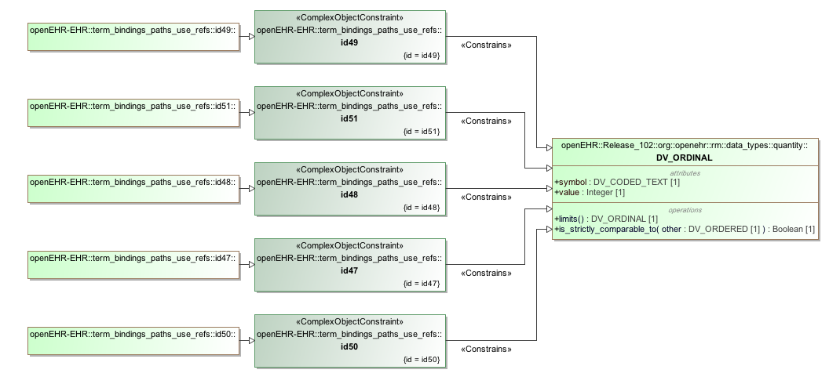

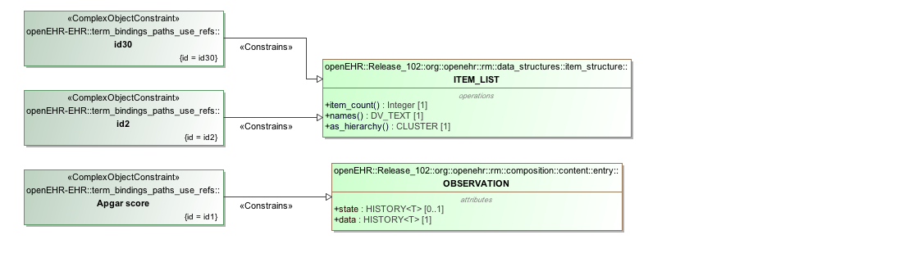

#### Term Bindings Paths Use Refs v1 AML Associations Diagram

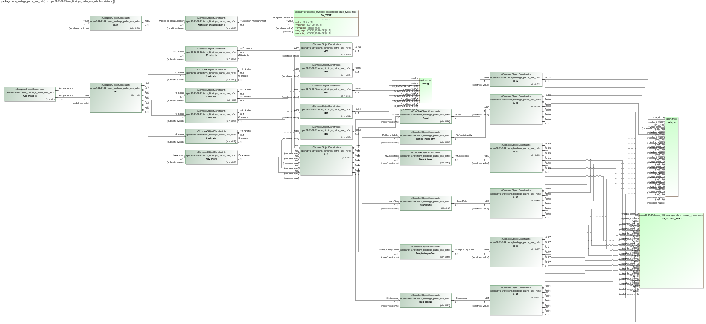

## Terminology Value Sets

### External Value Definition

The example below associates the value set *ac1* with the *defining_code* of the document state element. The permissible values for *defining_code* are *at1,* through *at6* with the default being *at1* . Each permissible value is assigned to an external concept reference (e.g. *at1 -->* http://openehr.org/id/251).

#### ADL

archetype (adl_version=2.0.5; rm_release=1.0.2)

openEHR-EHR-OBSERVATION.external_value_set.v1.0.0

...

definition

OBSERVATION[id1] matches { -- Test Obs

protocol matches {

ITEM_TREE[id2] matches {

items matches {

ELEMENT[id3] occurrences matches {0..1} matches { -- document state

value matches {

DV_CODED_TEXT[id4] matches {

defining_code matches {[ac1; at1]} -- document state

terminology

term_definitions = <

["en"] = <

["id1"] = <

text = <"Test Obs">

description = <"Test Obs">

>

["id3"] = <

text = <"document state">

description = <"document state">

>

["ac1"] = <

text = <"document state">

description = <"document state">

>

["at1"] = <

text = <"modification">

description = <"modification">

>

["at2"] = <

text = <"creation">

description = <"creation">

>

["at3"] = <

text = <"synthesis">

description = <"synthesis">

>

["at4"] = <

text = <"unknown">

description = <"unknown">

>

["at5"] = <

text = <"deleted">

description = <"deleted">

>

["at6"] = <

text = <"attestation">

description = <"attestation">

>

>

>

term_bindings = <

["openehr"] = <

["at1"] = <http://openehr.org/id/251>

["at2"] = <http://openehr.org/id/249>

["at3"] = <http://openehr.org/id/252>

["at4"] = <http://openehr.org/id/253>

["at5"] = <http://openehr.org/id/523>

["at6"] = <http://openehr.org/id/666>

>

>

value_sets = <

["ac1"] = <

id = <"ac1">

members = <"at2", "at1", "at3", "at4", "at5", "at6">

>

>

#### ADL Diagram

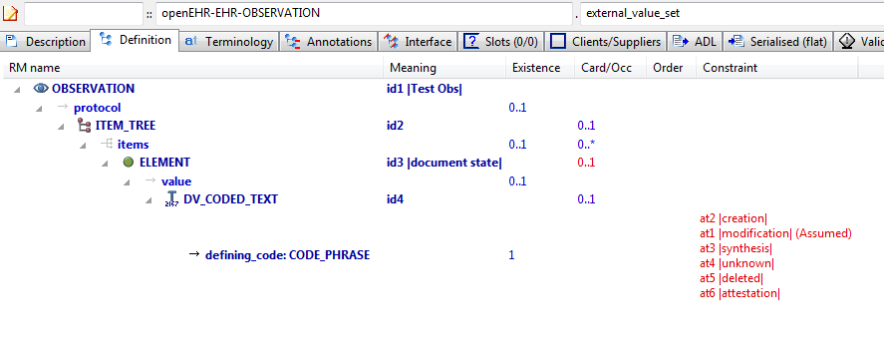

#### AML Diagrams

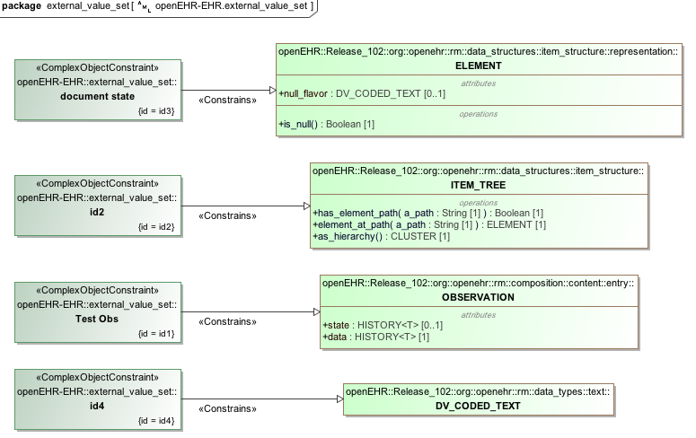

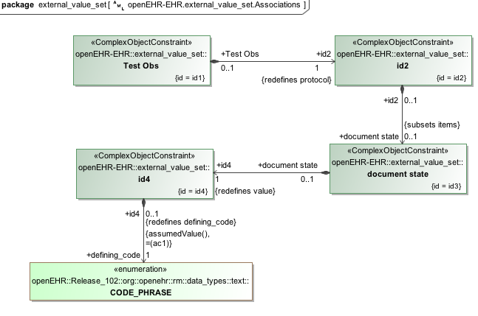

### Combination of internal and external value sets

This section has an example of a blood pressure measurement that defines multiple value sets, some with external bindings and some defined strictly with permissible values.

#### ADL

archetype (adl_version=2.0.5; rm_release=1.0.2)

openEHR-EHR-OBSERVATION.internal_value_set.v1.0.0

...

definition

OBSERVATION[id1] matches { -- Blood Pressure

data matches {

HISTORY[id2] matches { -- history

events cardinality matches {1..*; unordered} matches {

EVENT[id7] occurrences matches {0..*} matches { -- any event

state matches {

ITEM_TREE[id8] matches {

items matches {

ELEMENT[id9] occurrences matches {0..1} matches { -- Position

value matches {

DV_CODED_TEXT[id1045] matches {

**defining_code matches {[ac1; at1002]} -- Position**

}

}

}

ELEMENT[id1044] occurrences matches {0..1} matches { -- Sleep status

value matches {

DV_CODED_TEXT[id1046] matches {

**defining_code matches {[ac2; at1045]} -- Sleep status**

}

}

}

}

}

}

}

}

}

}

protocol matches {

ITEM_TREE[id12] matches { -- list structure

items matches {

ELEMENT[id14] occurrences matches {0..1} matches { -- Cuff size

value matches {

DV_CODED_TEXT[id1047] matches {

**defining_code matches {[ac3]} -- Cuff size**

}

}

}

CLUSTER[id1034] occurrences matches {0..1} matches { -- Location

items matches {

ELEMENT[id15] occurrences matches {0..1} matches { -- Location of measurement

value matches {

DV_CODED_TEXT[id1048] matches {

**defining_code matches {[ac4]} -- Location of measurement**

}

}

}

ELEMENT[id1035] occurrences matches {0..1} matches { -- Specific location

value matches {

DV_TEXT[id1049]

}

}

}

}

ELEMENT[id1036] occurrences matches {0..1} matches { -- Method

value matches {

DV_CODED_TEXT[id1050] matches {

**defining_code matches {[ac5]} -- Method**

}

}

}

ELEMENT[id1039] occurrences matches {0..1} matches { -- Mean Arterial Pressure Formula

value matches {

DV_TEXT[id1051]

}

}

ELEMENT[id1011] occurrences matches {0..1} matches { -- Diastolic endpoint

value matches {

DV_CODED_TEXT[id1052] matches {

**defining_code matches {[ac6]} -- Diastolic endpoint**

}

}

}

}

}

}

}

terminology

term_definitions = <

["en"] = <

...

["at4"] = <

text = <"blood pressure">

description = <"@ internal @">

>

["at5"] = <

text = <"Systolic">

description = <"Peak systemic arterial blood pressure - measured in systolic or contraction phase of the heart cycle.">

>

["at6"] = <

text = <"Diastolic">

description = <"Minimum systemic arterial blood pressure - measured in the diastolic or relaxation phase of the heart cycle.">

>

["id7"] = <

text = <"any event">

description = <"Default event">

>

["id9"] = <

text = <"Position">

description = <"The position of the subject at the time of measurement.">

>

["id12"] = <

text = <"list structure">

description = <"list structure">

>

["id14"] = <

text = <"Cuff size">

description = <"The size of the cuff used for blood pressure measurement. ">

>

["id15"] = <

text = <"Location of measurement">

description = <"Common body sites where blood pressure is recorded.">

>

["at16"] = <

text = <"Adult Thigh">

description = <"A cuff used for an adult thigh - bladder approx 20cm x 42cm.">

>

["at17"] = <

text = <"Large Adult">

description = <"A cuff for adults with larger arms - bladder approx 16cm x 38cm.">

>

["at18"] = <

text = <"Adult">

description = <"A cuff that is standard for an adult - bladder approx 13cm x 30cm.">

>

["at26"] = <

text = <"Right arm">

description = <"The right arm of the person.">

>

["at27"] = <

text = <"Left arm">

description = <"The left arm of the person.">

>

["at28"] = <

text = <"Right thigh">

description = <"The right thigh of the person.">

>

["at29"] = <

text = <"Left thigh">

description = <"The left thigh of the person.">

>

["at34"] = <

text = <"Comment">

description = <"Comment on blood pressure measurement.">

>

["at1001"] = <

text = <"Standing">

description = <"Standing at the time of blood pressure measurement.">

>

["at1002"] = <

text = <"Sitting">

description = <"Sitting (for example on bed or chair) at the time of blood pressure measurement.">

>

["at1003"] = <

text = <"Reclining">

description = <"Reclining at the time of blood pressure measurement.">

>

["at1004"] = <

text = <"Lying">

description = <"Lying flat at the time of blood pressure measurement.">

>

["at1006"] = <

text = <"Tilt">

description = <"The craniocaudal tilt of the surface on which the person is lying at the time of measurement.">

>

["at1007"] = <

text = <"Mean Arterial Pressure">

description = <"The average arterial pressure that occurs over the entire course of the heart contraction and relaxation cycle.">

>

["at1008"] = <

text = <"Pulse Pressure">

description = <"The difference between the systolic and diastolic pressure.">

>

["at1009"] = <

text = <"Small Adult">

description = <"A cuff used for a small adult - bladder approx 10cm x 24cm.">

>

["at1010"] = <

text = <"Paediatric/Child">

description = <"A cuff that is appropriate for a child or adult with a thin arm - bladder approx 8cm x 21cm.">

>

["id1011"] = <

text = <"Diastolic endpoint">

description = <"Record which Korotkoff sound is used for determining diastolic pressure using auscultative method.">

>

["at1012"] = <

text = <"Phase IV">

description = <"The fourth Korotkoff sound is identified as an abrupt muffling of sounds.">

>

["at1013"] = <

text = <"Phase V">

description = <"The fifth Korotkoff sound is identified by absence of sounds as the cuff pressure drops below the diastolic blood pressure.">

>

["at1015"] = <

text = <"Lying with tilt to left">

description = <"Lying flat with some lateral tilt, usually angled towards the left side. Commonly required in the last trimester of pregnancy to relieve aortocaval compression.">

>

["at1019"] = <

text = <"Infant">

description = <"A cuff used for infants - bladder approx 5cm x 15cm.">

>

["at1020"] = <

text = <"Neonatal">

description = <"A cuff used for a neonate, assuming cuff is the appropriate size for maturity and birthweight of the neonate.">

>

["at1021"] = <

text = <"Right wrist">

description = <"The right wrist of the subject.">

>

["at1022"] = <

text = <"Left wrist">

description = <"The left wrist of the subject.">

>

["at1026"] = <

text = <"Device">

description = <"Details about sphygmomanometer or other device used to measure the blood pressure.">

>

["at1027"] = <

text = <"Right ankle">

description = <"The right ankle of the subject.">

>

["at1031"] = <

text = <"Exertion ">

description = <"Details about physical activity undertaken at the time of blood pressure.measurement.">

>

["at1032"] = <

text = <"Left ankle">

description = <"The left ankle of the subject.">

>

["at1033"] = <

text = <"Finger">

description = <"A finger of the subject. Identification of the finger can be recorded in 'Specific Location' data element, if required.">

>

["id1034"] = <

text = <"Location">

description = <"Body location where blood pressure is measured. Use 'Location of measurement' to select from common sites. Use 'Specific location' to record more specific details or a site that is not in the common set or to refer to an external terminology.">

>

["id1035"] = <

text = <"Specific location">

description = <"Specific details about the body site where blood pressure is recorded.">

>

["id1036"] = <

text = <"Method">

description = <"Method of measurement of blood pressure.">

>

["at1037"] = <

text = <"Auscultation">

description = <"Method of measuring blood pressure externally, using a stethoscope and Korotkoff sounds.">

>

["at1038"] = <

text = <"Palpation">

description = <"Method of measuring blood pressure externally, using palpation (usually of the brachial or radial arteries).">

>

["id1039"] = <

text = <"Mean Arterial Pressure Formula">

description = <"Formula used to calculate the MAP (if recorded in data).">

>

["at1040"] = <

text = <"Machine">

description = <"Method of measuring blood pressure externally, using a blood pressure machine.">

>

["at1041"] = <

text = <"Invasive">

description = <"Method of measuring blood pressure internally ie involving penetration of the skin and measuring inside blood vessels.">

>

["at1043"] = <

text = <"24 hour average ">

description = <"Estimate of the average blood pressure over a 24 hour period.">

>

["id1044"] = <

text = <"Sleep status">

description = <"Sleep status - supports interpretation of 24 hour ambulatory blood pressure records. ">

>

["at1045"] = <

text = <"Alert & awake">

description = <"Subject is fully conscious.">

>

["at1046"] = <

text = <"Sleeping">

description = <"Subject is in the natural state of bodily rest.">

>

["at1052"] = <

text = <"Toe">

description = <"A toe of the subject. Identification of the toe can be recorded in 'Specific Location' data element, if required.">

>

["at1053"] = <

text = <"Confounding factors">

description = <"Comment on and record other incidental factors that may be contributing to the blood pressure measurement. For example, level of anxiety or 'white coat syndrome'; pain or fever; changes in atmospheric pressure etc.">

>

["at1054"] = <

text = <"Intra-arterial">

description = <"Invasive measurement via transducer access line within an artery. Location of the transducer can be recorded in 'Specific Location' data element, if required.">

>

["ac1"] = <

text = <"Position">

description = <"The position of the subject at the time of measurement.">

>

["ac2"] = <

text = <"Sleep status">

description = <"Sleep status - supports interpretation of 24 hour ambulatory blood pressure records. ">

>

["ac3"] = <

text = <"Cuff size">

description = <"The size of the cuff used for blood pressure measurement. ">

>

["ac4"] = <

text = <"Location of measurement">

description = <"Common body sites where blood pressure is recorded.">

>

["ac5"] = <

text = <"Method">

description = <"Method of measurement of blood pressure.">

>

["ac6"] = <

text = <"Diastolic endpoint">

description = <"Record which Korotkoff sound is used for determining diastolic pressure using auscultative method.">

>

>

>

term_bindings = <

["SNOMED-CT"] = <

["id1"] = <http://SNOMED-CT.info/id/163020007>

**["at5"] = <http://SNOMED-CT.info/id/163030003>**

**["at6"] = <http://SNOMED-CT.info/id/163031004>**

["id14"] = <http://SNOMED-CT.info/id/246153002>

>

>

**value_sets = <**

**["ac1"] = <**

**id = <"ac1">**

**members = <"at1001", "at1002", "at1003", "at1004", "at1015">**

**>**

**["ac2"] = <**

**id = <"ac2">**

**members = <"at1045", "at1046">**

**>**

**["ac3"] = <**

**id = <"ac3">**

**members = <"at16", "at17", "at18", "at1009", "at1010", "at1019", "at1020">**

**>**

**["ac4"] = <**

**id = <"ac4">**

**members = <"at26", "at27", "at28", "at29", "at1021", "at1022", "at1027", "at1032", "at1033", "at1052", "at1054">**

**>**

**["ac5"] = <**

**id = <"ac5">**

**members = <"at1037", "at1038", "at1040", "at1041">**

**>**

**["ac6"] = <**

**id = <"ac6">**

**members = <"at1012", "at1013">**

**>**

**>**

#### ADL Diagram

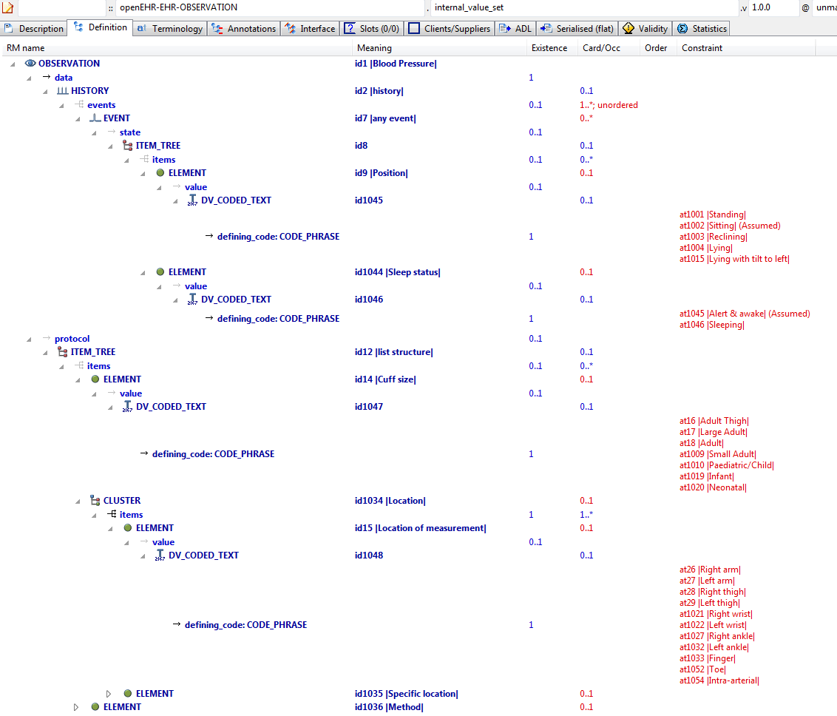

#### AML Diagrams

